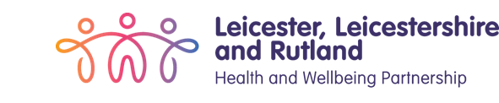


Leicester, Leicestershire and Rutland

Learning from lives and deaths –
‘People with a learning
disability and autistic people’ (LeDeR).

Contents

Introduction 3

What we learnt from the completed reviews: 5

What else we learned this year that could be done better: 8

Positive practice and what went well this year: 9

Recommendations from the completed reviews: 12

Introduction
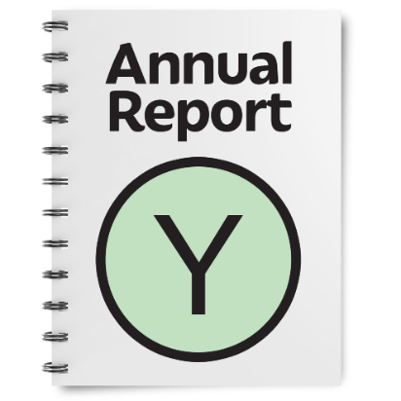 | NHS Leicester, Leicestershire and Rutland has to write a report every year looking into the deaths of people with learning disabilities and autistic people in our area.
  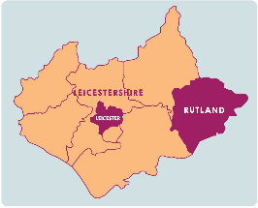  2023 | The LeDeR programme was set up in 2017. Every person in England who is over the age of 18 years, who has a learning disability and or autism and sadly dies, has their death looked at in the same way as long as the death is notified to the LeDeR programme.  LeDeR stands for learning from lives and deaths of people with a learning disability and autistic people.  There is a separate group who looks at the deaths of children in Leicester, Leicestershire and Rutland, called the Child Death Overview Panel.
 | We write the report to follow the LeDeR programme - this is a government plan to improve the lives of people with learning disabilities and autistic people by providing better care.
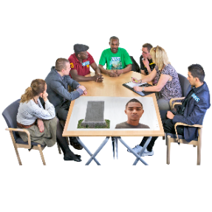 | The review is carried out by a person called a reviewer. They look at all the care the person who died received during their life.
 | We look at every death to see if anything could have been done better and take the learning from the reviews to make changes to the care we provide in our local areas.  This will help us to learn what we can do better in the future.
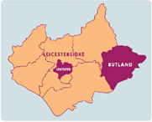 | This report tells you a little bit about people who have died in the Leicester, Leicestershire and Rutland area from 1st April 2023- 31st March 2024.  It also tells you about the learning we found and where we need to make things better from those reviews.

What we learnt from the completed reviews:
 | Deaths notified to the Leicester, Leicestershire and Rutland LeDeR programme.  We were told about the deaths of 94 people from 1st April 2023 – 31st March 2024.  This may not include every death of people with learning disabilities or autistic people because we are not always told when someone has died:  - 1 person was autistic.  - 22 were out of scope.  - 11 were adults with a learning disability & autism.  - 60 were adults with a learning disability.  The median age of death was 66yrs which is 4yrs older than last year.
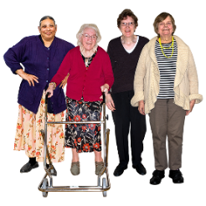  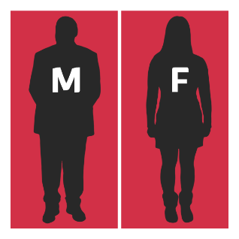 | Age and gender:  - 53 were male and 41 were female.  - Most people who died were aged between 71 and 80 years old.
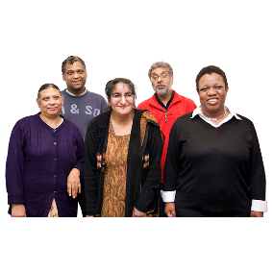  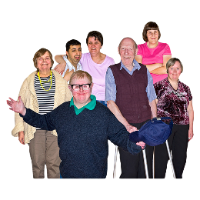 | Ethnicity:  - Ethnicity is your race or background. For example, Black, White, or Asian.  - The median age at death for those from a diverse ethnic background was 65yrs.  - Most people who died were White British. This is the same as last year’s report.  - We need to understand local cultures and look at areas that affect people differently so that we can make sure everyone has good health and care.
 | Cause of death:  - When a person dies, Part 1a of a Death Certificate tells you what the person died of; this is called the cause of death.
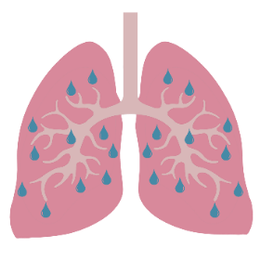 | - The leading cause of death was from respiratory illness. For example, illness to do with breathing, like pneumonia or lung cancer.  This is still the leading cause of death for those in Leicester, Leicestershire and Rutland.
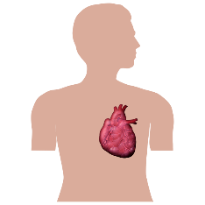 | - The second most common causes of death recorded were related to problems with people’s hearts.
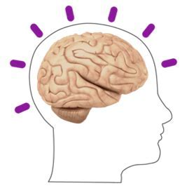 | - The third most common cause of death recorded were related to cancer and also neurological conditions, which are conditions affecting the brain and nerves.
 | - 0 people died from COVID-19.  - More people this year have had 5 or 6 COVID vaccinations.

What else we learned this year that could be done better:
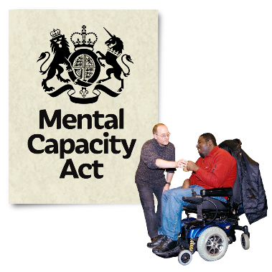 | - There was poor use of the Mental Capacity Act (MCA) (2005) for people with a learning disability and autistic people. These are tests to check if someone can understand and make their own decisions about their healthcare.  - Some professionals have not been applying the MCA fully when making decisions about a person’s care.
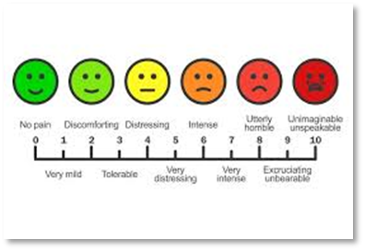 | - Some people were at risk because they could not tell others they were unwell or in pain. Staff did not look at the communication passport or DISDAT (disability distress assessment tool) to check what signs to look for.
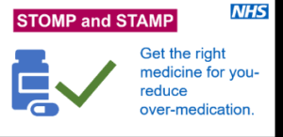 | - Some professionals do not understand the STOMP/STAMP agenda across  physical and mental health services.  - STOMP/STAMP is about everyone working together to make sure adults, children, and young people with a learning disability and/or autism get the right medicine when they need it.
 | - Some reviews showed end of life wishes are being missed because the information is not known before the person has passed away.
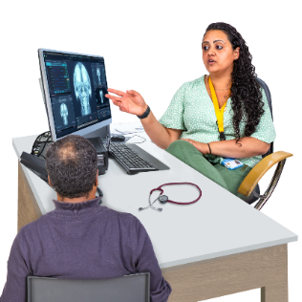 | - Not all people with a with learning disability and autistic people are attending screening that can help early diagnosis of health conditions.

Positive practice and what went well this year:
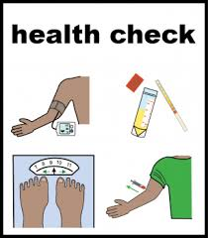 | - More people have been attending their learning disability annual health check.
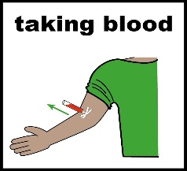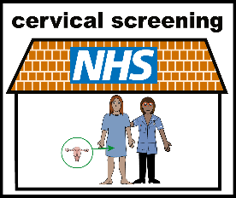 | - The learning disability service has set up a community phlebotomy team, to offer blood taking to people with a learning disability who have not had a blood test and need extra help and support to have one.  - There have been 2 cervical screening videos created to break down barriers and support people with learning disabilities and or autistic people to attend screening appointments.
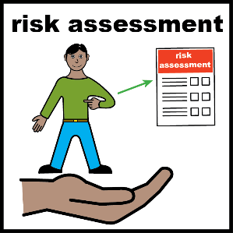 | - A risk assessment and care plan is being created to support people who are at risk of aspiration pneumonia, this is a lung infection from something going into the lungs like food, drink or something else. This helps staff to make reasonable adjustments to people’s care and support.
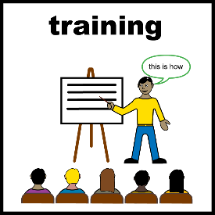 | - 80% of hospital staff have completed Oliver McGowan training.  - Training has been given to adult social care staff on advanced care planning including talking to people about their end-of-life wishes, making reasonable adjustments, creating hospital passports and the importance of medication reviews.
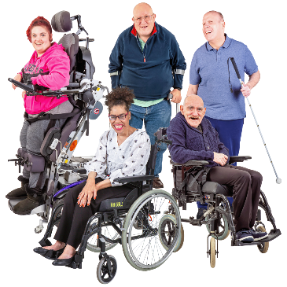 | - Care providers are helping more people to get weighed.
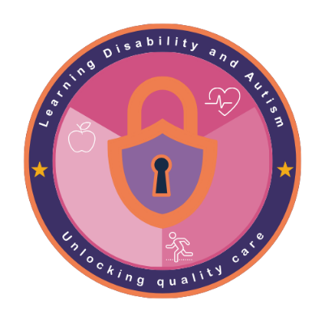 | - University Hospital Leicester has recruited a specialist learning disability nurse for children in hospital.  - The GP friendly practice award has been created to improve health outcomes for people with a learning disability to improve care quality and patient experience.

Recommendations from the completed reviews:
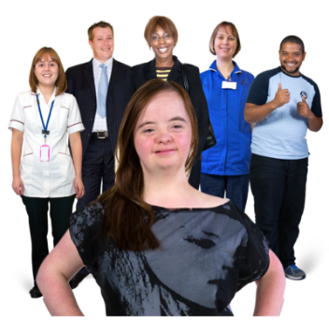 | - We need to make sure those supporting people with a learning disability and autistic people make all efforts to include them in conversations about their end-of-life wishes.  - ReSPECT documents should be put in place; this is a form that asks about what is important to you and the kinds of treatment you would want to have in an emergency.  - We need to make sure advanced care plans are discussed and put in place earlier. Including DNA/CPR (Do not attempt cardio-pulmonary resuscitation) decision making. This is where it is talked through about if the person would want staff to try and start their heart beating again if it stops beating.
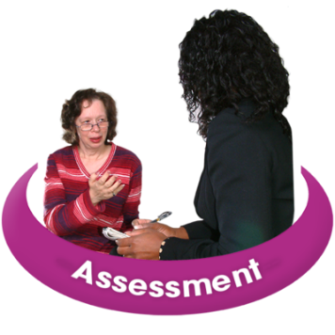 | - We need to make sure staff understand the Mental Capacity Act (2005) and how to apply it when making decisions about people’s care and treatment.
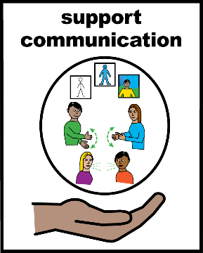 | - We need to make sure communication plans are created and are available for all staff to understand the communication needs of people.  - We need to make sure staff and carers know the person they are supporting and recognise when they are in pain.
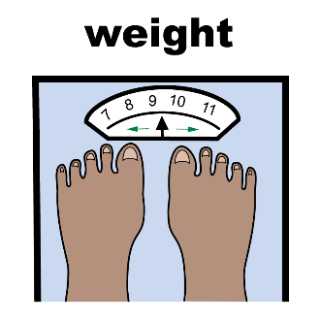 | - People should know where to access suitable weighing equipment locally.
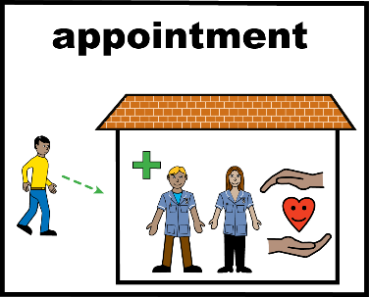 | - Every effort should be made to improve people going to their screening appointments.  - That reasonable adjustments are made, and barriers removed to support people to attend all health appointments.
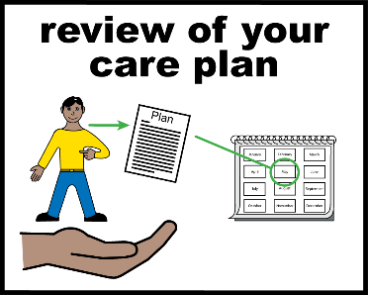 | - Better understanding of STOMP/STAMP across all physical and mental health services.
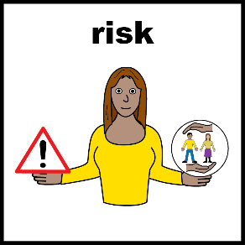 | - We need to make sure that risks linked with a person’s lung problem (aspiration pneumonia) is found early and care and treatment is planned.  - This requires a multi-disciplinary approach that involves the person and all those supporting them.
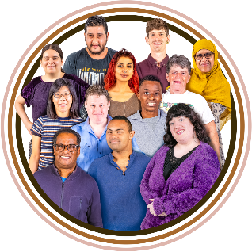 | - That the deaths of those from Leicester City and from diverse ethnic backgrounds are reported to the LeDeR Programme.  - That the deaths of people with autism (with or without a LD) are reported to the LeDeR Programme.

