Adverse Childhood Experiences (ACE) Project at CAMHS

Information for young people and their families or carers.

What the Adverse Childhood Experiences Project at CAMHS does

The Adverse Childhood Experiences (ACEs) project is part of the Young People’s Team within our Child and Adolescent Mental Health Services (CAMHS).

Adverse Childhood Experiences (ACEs) are a range of highly stressful and potentially traumatic events that occur during childhood and/or adolescence. These experiences may be isolated incidents or they may occur repeatedly over time.

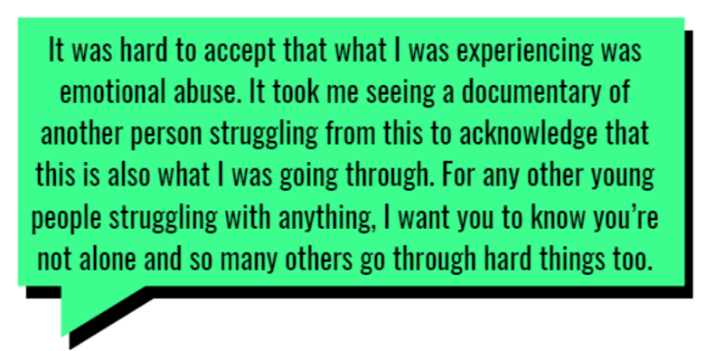

The Adverse Childhood Experiences project began in 2019 to support children and young people who have experienced difficult or stressful events in their lives. These experiences can affect how young people feel, behave and manage everyday situations.
Our team works with young people who are involved with the Youth Justice Service. We take time to understand each young person as a whole, including their experiences and what has happened to them, rather than focusing only on behavior or current difficulties.
What we offer
- Teaching and training for Youth Justice staff on mental health, ACEs, adolescent development, and how neurodevelopmental needs can affect behaviour and wellbeing.

- Consultation and advice for Youth Justice workers to ensure the support they provide is child-focused, trauma-informed, and helps young people access appropriate mental health pathways.

- Formulation sessions, where we explore a young person’s life experiences to better understand their strengths, challenges, and what may help them move forward.

- Direct support for a small number of young people who meet our criteria. This usually takes place in the community and is designed for those who find it difficult to engage with traditional services..

Why this matters

Our work is based on evidence about how trauma and adversity affect the brain, emotions, and behaviour. By understanding these experiences early and offering the right support, we aim to:

reduce the impact of ACEs

prevent further harm

help young people feel understood, supported, and able to make positive changes in their lives

We are one of only a small number of services like this in the country, and we received ongoing NHS funding in 2022 in recognition of the positive impact of our work.

How we know our work makes a difference

The ACEs team is a well-established part of both the City and County Youth Justice Services. Professionals who work with young people tell us that our involvement helps them gain a deeper understanding of children and young people. This means support can be more thoughtful, better co-ordinated, and more closely tailored to each young person’s needs.

Who can access this offer

This support is only available to young people who are currently known or involved with the Youth Justice Service.

We welcome any comments and suggestions you may have. To share your feedback, you can speak with a member of our team, complete our Friends and Family Test or reach out to our Patient Advice and Liaison Service (PALS). For more information, please visit www.leicspart.nhs.uk/contact/patient-advice-and-liaison-service-pals/.

PALS and Complaints Team is here to help with any compliments, questions, comments, or concerns you may have relating to our services. They can also:
- Provide confidential advice and support to patients and service users, their families and carers
- Listen and respond to any compliments, comments or suggestions
- Provide information about services and local support groups
- Help to resolve concerns on your behalf
- Provide information about how you can get involved in helping us to develop our service

If you would like to speak to them, you can contact PALS using the details below:
- 0116 295 0830 (Monday to Friday 9.00am – 4:30pm) You can leave a voicemail at any time, and a member of the team will call you back.
- lpt.pals@nhs.net

If you are accessing this leaflet electronically, you can use our accessibility toolbar. This is especially useful to people who have a hidden disability, such as dyslexia or other reading difficulties, people with a visual impairment, or those who have English as a second language.

If you need help to understand this leaflet or would like it in a different language or an alternative format such as large print, braille, or audio, please speak to a member of our staff.

Why not follow our social media account?

Search for ‘healthforteens_leicester’ on Instagram to stay up to date with our latest content.

Here are some useful resources for young people and their families or carers:

Information discussed during appointments will be kept confidential (this means we will keep your information
within certain limits). Please scan the QR code or visit www.leicspart.nhs.uk/privacy-policy/ to learn more about our Trust’s privacy policy.
 | lptnhs.com/  MHSupport |  | lptnhs.com/  WhileYouWaitCAMHS
 | lptnhs.com/CAMHS  Leicester |  | www.healthforteens.co.uk

Date Implemented: 29.04.26
Last Review: 29.04.26
Review Date: 29.04.29
Leaflet No: ACEPCAMHS
Website: www.leicspart.nhs.uk
Date Implemented:
Last Review:
Review Date:
Leaflet No:
Website: www.leicspart.nhs.uk
Email: feedback@lecispart.nhs.uk

