Family Therapy
Information for families


What is family therapy?
Family and systemic psychotherapy (also known as family therapy) can help those in close relationships to better understand and support each other. It enables family members to express and explore difficult thoughts and emotions safely, understand each other’s experiences and views, appreciate each other’s needs, build on family strengths, and work together to make useful changes in their relationships and their lives.

Who is family therapy for?
Family therapy can help families at all stages of life when they’re feeling overwhelmed, sad and angry; when they feel stuck in repeating patterns of hurtful behaviour or when they’re not sure what to do for the best. It can also help families talk together about difficult experiences they have had or are still having, such as bereavements or the impact of ongoing physical or mental health issues of family members.

Who will the sessions be with?
You will be working with a family therapist (also known as a family and systemic psychotherapist) and possibly, if it is felt to be helpful, with a family therapy team. If you are working with a team, you will meet with at least one family therapist and up to four other mental health clinicians.
Who should attend?
Initially we may talk with you, by phone, to decide who should attend, or leave the choice up to you. Sometimes we ask that everyone in your household attends, as we find that each family member usually contributes thoughts and ideas that are helpful. At other times (if the referred person is under 18 years old) we may ask that only parents attend, or we may meet siblings together. Who attends may change over time and this will be discussed with you.

How often do sessions take place and how long do they last?
At our initial session we talk together about what you may want to be different and if Family Therapy is something that could help with this. If it is agreed that more sessions could be useful, the number and frequency of sessions will be discussed with you, as this varies between families. This will be reviewed with you at regular intervals. Each session usually lasts for an hour.
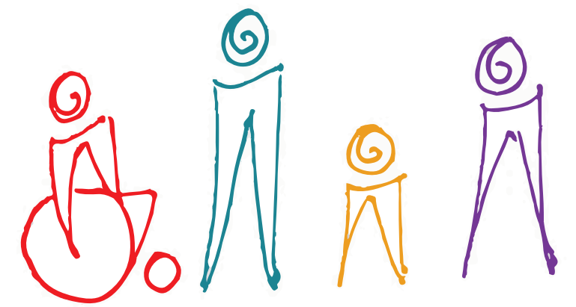

Where and when do the sessions take place?
We usually meet with families in a range of NHS bases, and may sometimes offer video sessions, if appropriate.
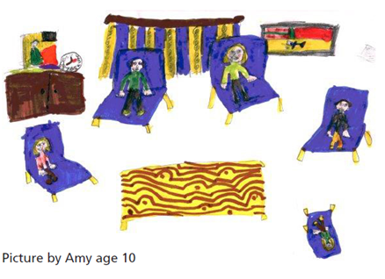
It is usual for us to review our work together regularly, to check out if the therapy is meeting your needs, if the focus is right for you and if we need to do anything differently. If you ever have any issues you wish to raise about the therapy, we hope that you would talk with us about these. If you do not feel able to do this, then we would encourage you to speak with the worker who referred you to family therapy. More information about Family Therapy can be found at: https://www.aft.org.uk/page/whatisfamilytherapy

What will happen at sessions?
The therapist who meets with your family will be most interested in hearing the ideas of everyone, regardless of age, about what the issues are and what they think may help. This enables us to understand how your family wants to change and how we can be most helpful.
If you meet with a family therapy clinic team during therapy sessions, families will have a conversation with one of us while other team members, who you will meet, will be behind a one-way screen or in the room. They are not there to judge your family. Their role is to listen to the conversation, think carefully and generate ideas. They will share their thoughts and ideas with you during the session. Families usually find these ideas helpful to think about when trying to find a way forward.
Families have talked about finding this way of talking quite different from previous experiences and that it can take a little time to become used to it. However, once this happens, they usually tell us that they like to hear the team members’ ideas and find this a very helpful part of the session.

Will sessions be confidential?
We keep electronic records and your consent to sharing these will already have been discussed with you at your initial mental health assessment. During our work together we occasionally write letters to you to share ideas from our sessions and these will be copied to others involved in your care.
If we have any reason to be concerned at any time about the welfare or safety of any member of your family, we may have to let the other people involved in your care know. This may also mean contacting other agencies outside of the health service. We will usually try to talk with you before doing this.

What happens if you are not sure about attending?
Some families are worried about attending the sessions together and are unsure if it will be helpful. If you are feeling like this, it can be useful to talk further with the person who referred you or come to an initial session to talk about what the sessions will be like and how they may benefit your family. It is not unusual for families to be worried or anxious about coming, but we find that these concerns usually ease quite quickly.

If you need help to understand this leaflet or would like it in a different language or format such as large print, Braille or audio, please ask a member of staff.
Here are some useful resources for young people and their families or carers:
Information discussed during appointments will be kept confidential (this means we will keep your information
within certain limits). Please scan the QR code or visit www.leicspart.nhs.uk/privacy-policy/ to learn more about our Trust’s privacy policy.
 | www.healthforteens.co.uk  https://bit.ly/CAMHSLeicester (CAMHS page)
 | www.leicspart.nhs.uk/mental-health/
 | www.nhs.uk

 | Your feedback matters. Scan the QR code or visit the link below to share your thoughts on CAMHS  https://bit.ly/FFTCAMHS

Why not follow our social media account?
Search for ‘healthforteens_leicester’ on Instagram to stay up to date with our latest content

Date implemented: January 2026
Last review: January 2026
Review date: January 2028

Leaflet No. FTCAMHS2

