

**Working together and referral to the Speech and Language Therapy service**

**Supporting children and young people with speech, language and communication needs and eating, drinking and swallowing needs**



Children’s Speech and Language Therapy Service

**Contents**

Main Body

|  |  |  |
| --- | --- | --- |
| Section | Title | Page Number |
| Introduction | --- | - 2 - |
| Top Tips | --- | - 4 - |
| Section 1 | Early Years | - 5 - |
| Section 2 | Primary school aged children | - 16 - |
| Section 3 | Secondary school aged children | - 23 - |

Appendices

|  |  |  |
| --- | --- | --- |
| Appendix | Title | Page Number |
| Appendix 1 | Further information | - 31 - |
| Appendix 2 | Developmental guidelines | - 32 - |
| Appendix 3 | Eating and drinking guidelines | - 35 - |
| Appendix 4 | Glossary of terms | - 37 - |
| Appendix 5 | FYPC Referral form | - 38 - |

**Introduction**

The Speech and Language Therapy service meets the needs of children or young people with significant delay and/or persisting needs in the areas of speech, language, communication or eating, drinking and swallowing.

Learning to communicate is a natural process and for most children and young people the first steps are taken at home with the help of family and this continues when they go to school or other learning environments. There is a lot that can be done to promote children’s speech and language development. In order for them to make that progress it is essential that *everyone* in their environment participates.

The guidelines outline what to expect but it is important to remember that children learn skills at different rates and ages.

For those who need more specialist intervention guidelines for referral are included.

The term **SLCN (Speech, Language and Communication Needs**) is used throughout the document.

**Referral Criteria**

Referrals are accepted when the child will benefit from this specialist service

Referrals are accepted for children 0-16 years and young people (16-19 years in statutory education such as special school provision) with the following:

* Eating, drinking and swallowing difficulties, for example;
  + Evidence of regular coughing, spluttering, gagging or choking during meals
  + Sensory difficulties or feeding aversion with associated faltering growth
* Voice difficulties
* Stammering – a difficulty speaking fluently
* Speech sound difficulties, e.g. children whose speech is unclear/difficult to understand.
* Language difficulties, for example;
  + Difficulties understanding spoken language
  + Difficulties using words and sentences
* Social interaction difficulties associated with other speech, language and communication needs.

**Referrals Not Accepted**

Referrals are not accepted for children and young people when the following criteria apply:-

* The child’s speech, language and communication needs could be met effectively within early year’s settings/ school and/or by other agencies. The Speech & Language Therapy service will signpost other appropriate agencies and resources both within and external to LPT.
* The child’s difficulties lie in acquiring English as an additional language and are not present in their home language.
* The child has difficulties purely with attention/listening, memory, literacy, phonological awareness or has selective mutism but these are not associated with an underlying speech, language or communication difficulty.
* The child has limited food preferences but is otherwise healthy and growing well.
* The child has difficulty using utensils and feeding themselves.
* Young people aged 16-19 who are not in statutory education.
* The child/young person has been discharged within the last 6 months because no therapy was required and there has been no change in the child/young person’s circumstances/ no additional difficulties.

**Immediate Referral**

An individual should request involvement immediately for Speech & Language Therapy if there are concerns with voice, stammering, severe speech sound difficulties, eating, drinking and swallowing or a significant deterioration in communication skills or significant communication difficulties as part of the child’s general developmental delay. In the case of deterioration of skills please consider an additional referral to a general practitioner

**References**

1. DCSF/DoH (2008) Better Communication: an action plan to improve services for children and young people with speech, language and communication needs.
2. DoH (October 2008) Framing the Contribution of Allied Health Professionals: delivering high-quality healthcare
3. DoH (2009) Healthy Lives, Brighter Futures – the Strategy for Children and Young People’s Health

.

**Top Tips**

There are suggestions in each section on how to help the child **NOW**. Try to implement these suggestions: remember “communication is everyone’s business”. What we do as adults can have a huge impact on speech and language development and not all children need specialist intervention

Remember, an immediate referral to the Speech and Language Therapy service should be made if the child or young person has:-

* eating /drinking difficulties
* speech sound difficulties (see developmental guidance)
* a voice problem
* a stammer
* a significant deterioration of skills
* significant developmental concerns

It is recommended that you speak to your local therapist or contact the service when making a decision about a referral.



.



Ensure that consent has been gained and recorded prior to making a referral using the FYPC referral form (Appendix 5)

Section 1

**Early Years**



**This pack has been written for any person working with children aged 0 to 4 years old who has concerns about how easily a child is learning to listen, understand and talk. The pack aims to address the questions below:**



**What are the steps involved in helping a child with communication difficulties? (page 7)**

**Where can I get some ideas on how to help? (page 14 – 15)**

**How do I know that a child is doing what they should be for their age? (page 8 – 12)**

**If a referral to SALT is needed what should I do? (page 7 and appendix 5)**

**Where else can a child get help? (page 15)**

**Concerns about Speech, Language and Communication Needs: What to do next?**

Having observed the child and used appropriate resources e.g. development matters, ASQs etc, a concern is raised about the child’s speech language or communication

Identify the appropriate strategies to put into place

**Monitor** Childs progress

Complete relevant sections of the developmental guidelines checklist for child’s age.

Liaise with local speech and language therapist

Follow the 2 Year pathway (page 8) - contact the local HV team to provide support through the local ‘Let’s Get Talking’ groups

No

No

Yes

Difficulties are identified and a **request for SALT** involvement is made

Child shows **Expected Development** in the language skills. No involvement is needed.

Review in 2 to 3 months using the development guidelines checklist

Yes

Don’t know

Using LPT e-referral or Referral form, request involvement from the SLT team (send with completed checklist – page 10 and referral- appendix 5)

Continue with appropriate strategies, no request for involvement is currently needed

Has the child made progress?

Is the child 2 years old?

**What to expect when…**

**(using the developmental guidelines checklists)**

The checklist starts at 18 months; for younger children, referrals to the Speech and Language Therapy service are accepted where the following difficulties are identified: eating and drinking difficulties, cleft palate, loss of skills, significant communication difficulties (which may be accompanied by medical needs, physical and/or sensory difficulties or significant difficulties in social interaction.) A local speech and language therapist will be available to discuss any queries about referring very young children.

There are many resources available for you to use to check the stage a child is at with their communication:

* Development Matters
* Ages and Stages Questionnaire (ASQ 3 BE, ASQ SE and activity sheets)
* Leicestershire Child Monitoring Tool
* Leicester City Child Individual Language Development Journey (CHILD)
* Leicester City Early Years Support Team – Next Steps

The information from these resources will help when completing the **Developmental Guidelines Checklist**

How to use the checklists:

Complete the checklist for the child’s age to work out whether the child:

* has **expected development**
* needs **monitoring**
* needs a **request for SALT involvement**

If the child needs **monitoring** click on the **Early Interventions** website link for ideas to help the child progress with communication

* sharing ideas with parents and other supporting professionals for all to put into place for a suitable amount of time ( 2 – 3 months)
* After this time, look back at the checklist and review the child’s progress.
* If no progress is made, complete a SALT referral form (appendix 5), and attach the completed checklist.

**DEVELOPMENTAL GUIDELINES CHECKLIST**



**18 months**

|  |  |  |  |  |  |
| --- | --- | --- | --- | --- | --- |
| Expected Development | Tick | Monitor | Tick | Request for SALT Involvement | Tick |
| * Understands simple words e.g.: car, door, shoes and simple instructions e.g. ‘up you come’ |  | * Understands only some words or names   [www.leicspart.nhs.uk/slcn-earlyinterventions](http://www.leicspart.nhs.uk/slcn-earlyinterventions) |  | * Does not appear to understand any of the everyday words adults use with them (in their first language) e.g.: does the child look when you ask ‘where’s shoes?’ ‘where’s mummy?’ |  |
| * Communicates using gestures e.g. pointing, waving with some words or sounds | * Looks with interest at speaker but no attempts to copy words, sounds or gestures   [www.leicspart.nhs.uk/slcn-earlyinterventions](http://www.leicspart.nhs.uk/slcn-earlyinterventions) | * Started to use single words and appeared to ‘lose’ words / no longer using them |
| * Uses babble (strings of sounds) and some words which family understand | * Using babble, jargon or gesture but no words   [www.leicspart.nhs.uk/slcn-earlyinterventions](http://www.leicspart.nhs.uk/slcn-earlyinterventions) | * No babble or sounds |

|  |  |
| --- | --- |
| If Monitoring:  Strategies/Activities to use:........................................................................  ………………………………………………………………………………………  ………………………………………………………………………………………  ……………………………………………………………………………………… | Review Date:………………………………………………………………………..  …………………………………………………………………………………………  Progress made:…………………………………………………………………….  …………………………………………………………………………………………  Action needed:……………………………………………………………………..  ………………………………………………………………………………………… |

**2 Years**

|  |  |  |  |  |  |
| --- | --- | --- | --- | --- | --- |
| Expected Development | Tick | Monitor | Tick | Request for SALT Involvement | Tick |
| * Understands lots of words and simple instructions e.g.: where’s your shoes? Show me your nose. * Uses a range of single words and puts 2 words together e.g.: ‘more juice’ ‘ben jump’ |  | Language   * Shows little understanding of the name of familiar objects, actions and instructions e.g.: Where’s the car? * Using no words or a small number of single words * Not copying words or phrases   [www.leicspart.nhs.uk/slcn-earlyinterventions](http://www.leicspart.nhs.uk/slcn-earlyinterventions) |  | * Use the Pathway for Late talking 2 year olds to identify whether a child meets criteria for SALT referral (concerns with stammer, voice, eating drinking and swallowing, complex needs, deterioration in skills or significant difficulty engaging with parents/carers). Also consider referral to GP * Child has attended Let’s Get Talking group and made little progress (after period of 2-3 months post group) |  |
| * Child is understood by family members around 50% of the time. * Children often miss ends off words at this stage * Sounds to expect at this stage: p,b,m,n,t,d, * Sounds emerging by 3 years: w,s,f,k,g | Speech  Is understood by main carer around 50% of the time but other family members often cannot understand.  [www.leicspart.nhs.uk/slcn-earlyinterventions](http://www.leicspart.nhs.uk/slcn-earlyinterventions) | Alongside good developing language:   * Very few of the early consonant sounds developing * Child only using vowel sounds * Reduced number of speech sounds used |

|  |  |  |
| --- | --- | --- |
| If Monitoring child’s language development:  Child should access ‘Let’s Get Talking’ group for 2 year olds – contact your local health visitor | If monitoring how clear the child’s speech is:  Strategies/Activities to use: ………………………………  ………………………………………………………………….. | Review Date: ………………………………………………………………  Progress made: …………………………………………………………..  Action needed: …………………………………………………………… |

**3 Years**

|  |  |  |  |  |  |
| --- | --- | --- | --- | --- | --- |
| Expected Development | Tick | Monitor | Tick | Request for SALT Involvement | Tick |
| * Understands and uses simple ‘who’, ‘what’, ‘where’ questions * Understands longer instructions such as ‘make teddy jump on the chair’ * Starting to understand simple concepts such as big, little, in. |  | * Understands only simple instructions such as ‘put the cup on the table’ without adult support. E.g. pointing or showing .Use:   [www.leicspart.nhs.uk/slcn-earlyinterventions](http://www.leicspart.nhs.uk/slcn-earlyinterventions) |  | * Difficulty understanding simple instructions. Need adult support e.g. pointing and showing |  |
| * Puts 3 or more words together in a sentence * Uses action words as well as nouns * Beginning to use word endings e.g. ‘going’ ‘cats’ * Can retell a simple past event | * Using sentences containing only 2/3 words e.g. ‘more juice’ ‘mummy wash hands’ and has made progress over the last 3 months   [www.leicspart.nhs.uk/slcn-earlyinterventions](http://www.leicspart.nhs.uk/slcn-earlyinterventions) | * Not using 3 or more words together in sentences (and has not made progress in the last 3 months) * Unusual word order |
| * Child understood by familiar people most of the time. * Most sounds are now heard * It is very common for children to have difficulty with k, g, ch, j, sh, th, r, y at this age. | * Child is not yet using some consonant sounds e.g. ‘s’, ‘f’, ‘g’, * Childs speech is understood by strangers less than 75% of the time   [www.leicspart.nhs.uk/slcn-earlyinterventions](http://www.leicspart.nhs.uk/slcn-earlyinterventions) | * Child not understood by familiar people most of the time. * Speech patterns show:   + Missed initial consonants   + Unclear Vowels   + All final sounds missed   + Not using sounds such as p,b,t,d,n,m   + ‘f’, ‘v’, ‘s’, ‘z’ –none of these present |

|  |  |
| --- | --- |
| If Monitoring:  Strategies/Activities to use:........................................................................  ………………………………………………………………………………………  ………………………………………………………………………………………  ……………………………………………………………………………………… | Review Date:………………………………………………………………………..  Progress made:…………………………………………………………………….  …………………………………………………………………………………………  Action needed:…………………………………………………………………….. |

**4 Years**

|  |  |  |  |  |  |
| --- | --- | --- | --- | --- | --- |
| Expected Development | Tick | Monitor | Tick | Request for SALT Involvement | Tick |
| * Responds appropriately to questions and instructions e.g. take a biscuit and put your carton in the bin * Listens to and understands the gist of simple stories |  | * Starting to understand longer instructions. Sometimes needs adult support   [www.leicspart.nhs.uk/slcn-earlyinterventions](http://www.leicspart.nhs.uk/slcn-earlyinterventions) |  | * Difficulties understanding longer instructions or understanding question words e.g.: who, what, where |  |
| * Produces 5 – 8 word sentences. These may contain some typical errors e.g.: ‘I felled over’ ‘look at the sheeps’ * Talks about own experiences and describes a sequence of event | * Sentences are appropriate and at least 5 – 6 words long but vocabulary may be limited and grammar immature. Small words such as ‘the ‘and ‘to’ may be omitted.   [www.leicspart.nhs.uk/slcn-earlyinterventions](http://www.leicspart.nhs.uk/slcn-earlyinterventions) | * Significant expressive language difficulties e.g.: struggles to recall familiar words, unusual word order, unable to relate a short sequence of events, not using any linking words e.g.: ‘and ‘but’ * Communication breaks down due to sentences being inappropriate, echoed or very repetitive |  |
| * Child is understood by listener unless child is excited or using longer/more complex sentences * Some longer words can be muddled e.g.: elephant – ephalent * Use of blends still developing e.g.: bl, sp, str * Harder sounds still developing e.g.: ch,j,sh,y,th,r, l | * Child can occasionally be difficult for strangers to understand   [www.leicspart.nhs.uk/slcn-earlyinterventions](http://www.leicspart.nhs.uk/slcn-earlyinterventions) | * Child not understood by most people most of the time. * Child is not using a range of consonant sounds in words (f, k, s etc.). See appendix 5).This does not include the harder sounds yet to develop ( v, z, ch, j, r, th and ‘str’ etc.) |  |

|  |  |
| --- | --- |
| If Monitoring:  Strategies/Activities to use:........................................................................  ………………………………………………………………………………………  ……………………………………………………………………………………… | Review Date:………………………………………………………………………..  Progress made:…………………………………………………………………….  …………………………………………………………………………………………  Action needed:…………………………………………………………………….. |

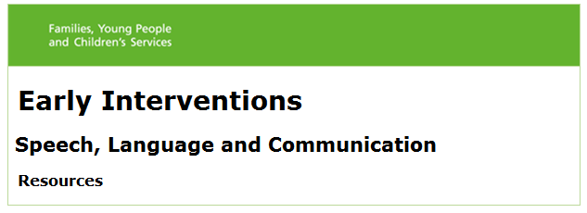

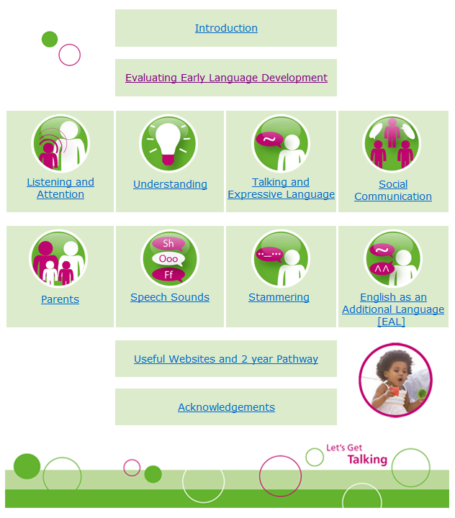

**Who is it for?**

*All professionals working with children under 5.*

“Practitioners are a child’s most valuable resource in an Early Years setting”

This tool is packed full of ideas and activities for practitioners to use to support children’s speech, language and communication development.

**What is it for?**

This interactive tool helps you *find information* and is linked to the EYFS Development Matters.

It includes simple practical tips to use while playing with children. One practitioner commented:

“I used the tip of just naming the objects the child is looking at and playing with. It made a big difference, we realised that although the children knew what to do with the tools they didn’t know what they were called”

**What are the Benefits?**

Practitioners *can feel confident that they are giving targeted support at the appropriate level for the child.*

As soon as the child’s communication and language needs are identified then practitioners can use the strategies and give them the help they need straight away.

**How to use it?**Using this tool, you can see what stage a child is at in the areas of attention and listening, understanding, talking and social communication. From here, with a simple click, you can open up ideas and activities to help in any of these areas. ([www.leicspart.nhs.uk/slcn-earlyinterventions](http://www.leicspart.nhs.uk/slcn-earlyinterventions))

[cid:image006.jpg@01CF8EFE.478A3130](http://www.leicspart.nhs.uk/_OurServicesAZ-SpeechandLanguageTherapy-SaLTresource-EvaluatingEarlyLanguageDevelopment.aspx)

1. Click on ‘Evaluating Early Language Development’ box to identify area of concern

2. Click on that area that needs support e.g. ‘Listening and Attention’

3. Click for information and ideas to help and specific activities to support the child at their developmental level

4. Click for more information when needed:

* 2 year pathway
* Stammering
* Speech sound development
* EAL
* Ideas to give to parents
* Useful websites

[cid:image022.jpg@01CF8EFE.478A3130](http://www.leicspart.nhs.uk/_OurServicesAZ-SpeechandLanguageTherapy-SaLTresource-UsefulWebsites.aspx)[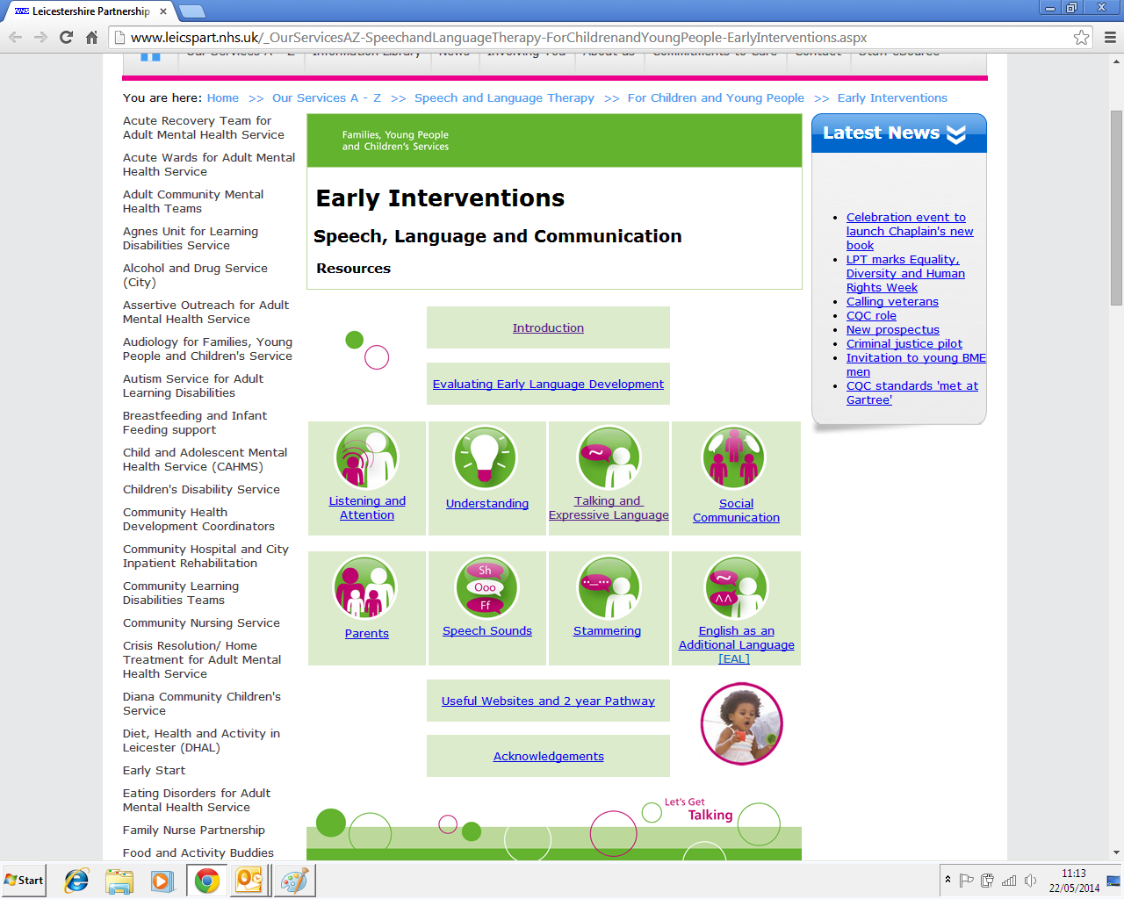](http://www.leicspart.nhs.uk/_OurServicesAZ-SpeechandLanguageTherapy-SaLTresource-EnglishasAdditionalLanguage.aspx)[](http://www.leicspart.nhs.uk/_OurServicesAZ-SpeechandLanguageTherapy-SaLTresource-Stammering.aspx)[](http://www.leicspart.nhs.uk/_OurServicesAZ-SpeechandLanguageTherapy-ForChildrenandYoungPeople-EarlyInterventions-SpeechSounds.aspx)[](http://www.leicspart.nhs.uk/_OurServicesAZ-SpeechandLanguageTherapy-SaLTresource-Parents.aspx)[](http://www.leicspart.nhs.uk/_OurServicesAZ-SpeechandLanguageTherapy-SaLTresource-SocialCommunication.aspx)[](http://www.leicspart.nhs.uk/_OurServicesAZ-SpeechandLanguageTherapy-SaLTresource-Expression.aspx)[](http://www.leicspart.nhs.uk/_OurServicesAZ-SpeechandLanguageTherapy-SaLTresource-Understanding.aspx)[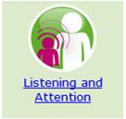](http://www.leicspart.nhs.uk/_OurServicesAZ-SpeechandLanguageTherapy-SaLTresource-ListeningandAttention.aspx)

**Pathway for Late Talking 2 year olds**

If a child is two years of age and is identified as having SLCN (which do NOT require immediate referral to Speech and Language Therapy), they are supported by their local Health Visiting Team through the ‘Let’s Get Talking’ groups.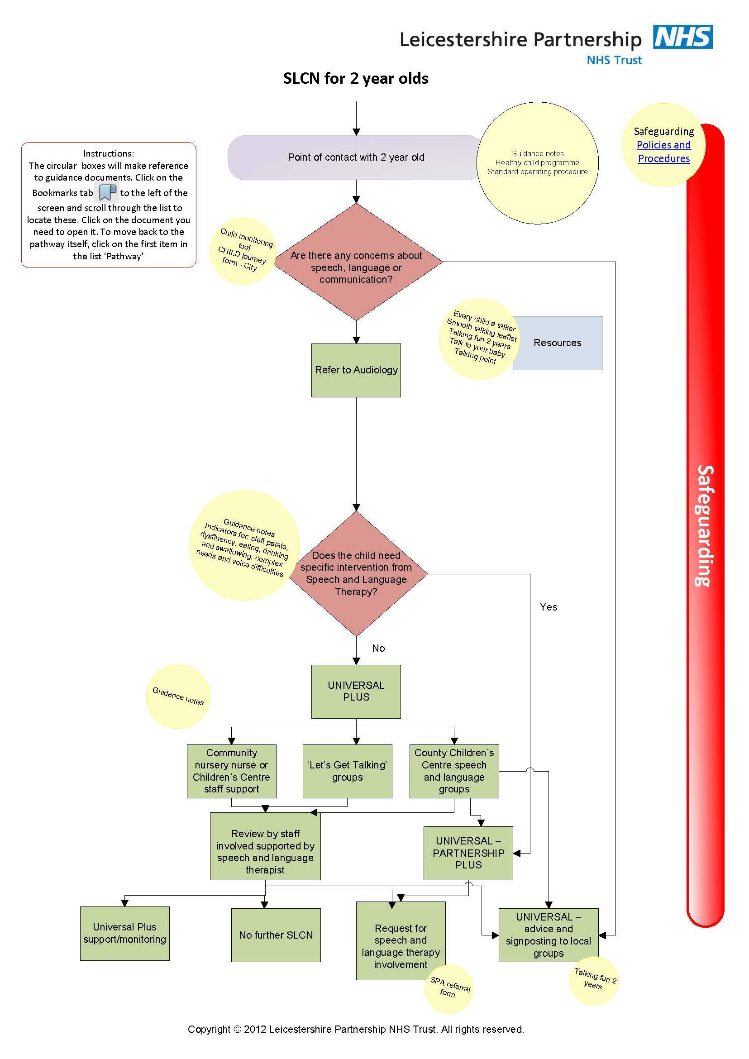

YES

NO

Section 2

**Primary School**

Primary school refers to children from age 5 to 11.

Before you consider a referral to the Speech and Language Therapy service for a primary school aged child with languagedifficulties, read the flow chart on page 18 carefully, and follow the process. Monitor the child carefully over a period of time rather just on a specific day.

Remember there are strategies included on page 21 -22 so you can begin to help your child/pupil now.



Talk to your local therapist if you are unsure or ring the Speech and Language Therapy Service for advice (0116 295 5256).



Remember language difficulties impact on literacy development so this must be part of your programme of support.

Difficulties with using language to communicate will need ***everyone*** around the child to use the strategies as part of a daily routine .This will have the greatest impact. Ensure everyone around the child is aware of the strategies you have selected and understands how to implement them.

If you are sure you require further support, when making a referral give details of the strategies you have tried; the impact on the child; and think about what you would like the outcome of the referral to be – it is often the start of the collaborative process of working together to support the child.

**Pre Referral to Speech & Language Therapy Flow Chart**

Speech, language, communication development or eating, drinking or swallowing is identified as an area of concern and discussed with school Special Educational Needs Co-Ordinator (SENCO) and parent/carer.

Refer straight to Speech and Language Therapy if concerns with voice, stammering, eating/ drinking/swallowing or a significant deterioration in communication skills (in the latter case referral to GP is advised)

School staff complete initial school screen sheet (page 19-20) by gathering information from relevant adults and observing in different contexts.

Contact local Speech and Language Therapist if you have significant concerns.

Specific area(s) of need is identified

Targets are set and strategies chosen to be implemented in school (page 21 - 22)

Strategies implemented

Training accessed by relevant staff

Recommended resources used

* Set review date for 3 months’ time and monitor progress. Complete screen again at this point (page 19 - 20)
* Discuss with Special Educational Needs Coordinator (SENCO).
* Discuss with named Speech and Language Therapist for the school if appropriate.

**If there are ongoing concerns refer to Speech and Language Therapy service through the FYPC Referral form (page 38)**

**Initial School Screen**

Please refer to the developmental guidelines (Appendix 2) when completing this screen. Please also think about the child in relation to their peers.

|  |  |  |
| --- | --- | --- |
| **Name:** | **Age:** | **Date completed:** |
| **Person completing screen & role:** | | **Review Date (after 3 months) :** |

*Date of last hearing test: ________________ (if there are concerns about the child’s hearing a referral should be made to audiology)*

| **AREA OF LANGUAGE** | **Initial screening date:** | | **STRATEGY TO BE USED** | **Review date:** | |
| --- | --- | --- | --- | --- | --- |
|  | **YES** | **NO** |  | **YES** | **NO** |
| **1. Understanding Instructions and Information** |  |  |  |  |  |
| * Does he/she listen and attend at the same level as his/her peers? |  |  |  |  |  |
| * Does he/she follow instructions at the same level as his/her peers? |  |  |  |  |  |
| * Does he/she answer questions at the same level as his/her peers? |  |  |  |  |  |
| * Is he/she able to participate in extended listening times, e.g. stories, assembly, group discussions? |  |  |  |  |  |
| Comments: | | | | | |
| **2. Understanding and Use of Vocabulary** |  |  |  |  |  |
| * Does he/she use a range of vocabulary (nouns, verbs, adjectives)? |  |  |  |  |  |
| * Is he/she able to learn and use new vocabulary appropriately? |  |  |  |  |  |
| * Is he/she able to understand and use concept words (e.g. size, place, position)? |  |  |  |  |  |
|  | | | | | |

|  |  |  |  |  |  |  |  |
| --- | --- | --- | --- | --- | --- | --- | --- |
|  | **Initial date** | | | |  | **Review date** | |
| **3. Expressive Language** | **Yes** | | | **No** |  |  |  |
| * Compared to peers, is he/she able to speak in full sentences, using appropriate grammar (e.g. pronouns, tenses, joining sentences using ‘and’ & ‘because’)? |  | | |  |  |  |  |
| * Does he/she use the correct word order when speaking in sentences? |  | | |  |  |  |  |
| Comments: | | | | | | | |
| **4. Speech Sound System** |  | |  | |  |  | |
| * Are the child’s speech sounds clear enough to be understood by others? * Are the child’s speech sounds developing in line with his/her peers? |  | |  | |  |  |  |
| Comments: | | | | | | | |
| **5. Social Communication Skills** |  | |  | |  |  |  |
| * Does he/she interact with peers and adults in the environment? |  | |  | |  |  |  |
| * Does he/she use appropriate conversation skills, e.g. take turns, stay on topic, use appropriate eye contact? |  | |  | |  |  |  |
| * Does he/she use his/her language for a number of different reasons, e.g. to comment, request, seek clarification, initiate a conversation? |  | |  | |  |  |  |
| Comments: | | | | | | | |
| **6. If there are concerns with the child’s voice, stammer/stutter, or eating and drinking refer directly to SALT** | |  | |  | See strategies for stammering while referral is being processed |  | |

**Strategies to Support Children with Speech, Language and Communication Difficulties**

|  |  |
| --- | --- |
| **AREA** | **STRATEGIES** |
| Listening and attention | 1. Secure the child’s attention before giving an instruction, e.g. use their name. 2. Be aware of the number of distractions in the classroom – reduce where possible. 3. Promote *active listening* - good listening, good looking, good sitting. Praise and use reward charts to help reinforce this. 4. Vary activities, keeping listening times short. Gradually increase the length of expected listening time. 5. Provide opportunities to develop attention and listening skills as part of a small group. |
| Understanding Instructions and Information | 1. Keep instructions short. 2. Use simple, clear language. 3. Use demonstrations. Support your language with visual cues, such as objects, gesture, pictures, signs and/or symbols. 4. Pause to give the child extra time to think about what has been said and plan their response. 5. Provide opportunities to develop understanding as part of a small group i.e. language group intervention |
| Understanding and use of Vocabulary | 11 1. Pre-teach new vocabulary to small groups, before using in whole class activities.  1 2. Use practical, concrete activities to introduce new vocabulary.  3. Use demonstrations. Support your language with visual cues, such as objects, gesture, pictures, signs and/or symbols  4. Repeat vocabulary in different activities across the curriculum.  5. Build on language the child already has. Link new words into child’s existing vocabulary (classification, sorting, word definitions, word webs, mind maps).  6. Teach a range of vocabulary, e.g. nouns, verbs, adjectives and other concept words).  7. Provide opportunities to develop understanding of language as part of a small group.  8. Provide opportunities to develop expressive language as part of a small group i.e.. language group intervention |
| Speech Sounds | 1. Develop general listening and discrimination skills, e.g. environmental sounds, musical instruments. (Letters and Sounds phase 1 aspects 1-4 ) 2. Develop early phonological awareness skills – rhyme, syllables. 3. Model the correct speech sounds, i.e. repeat back what the child has said but using the correct sounds. Do not ask the child to repeat it after you in front of others . 4. If you do not understand the child, encourage him/her to tell you some more about/show you what he/she is talking about. 5. Provide opportunities for the child to talk about things where you know the context so that there is a greater likelihood that you will understand him/her. |
| Social Communication Skills | 1. Teach social communication rules explicitly, e.g. eye contact, personal space, turn taking. 2. Develop whole class rules, reinforced by visual cues e.g. listening when someone else is talking, allowing each other ‘thinking time’. 3. Encourage the child to stay on topic. 4. Provide opportunities to practise social communication skills as part of a small group. 5. Practise skills during role play situations. 6. Develop the child’s awareness and understanding of emotions in him/herself and others. 7. Set up small group games/peer support systems in the playground. |
| Stammering/Stuttering  NB. Always refer a child who appears to be stammering immediately. | 1. Reduce the number of questions that you ask the child – comment rather than question. 2. Allow the child ‘thinking time’, giving him/her time to think about what you have said and formulate a response. 3. Do not tell the child to e.g., “slow down”, “think about what you are saying” – just allow him/her to work through what he/she is saying. 4. Keep your own talking calm and relaxed. 5. Do not complete sentences for them. 6. Give alternative means of communicating if the child does not wish to speak in front of others e.g. at register time |

Section 3

**Secondary School**



Secondary school refers to children age 11 to 16.

Please read the following flow chart carefully (page 25), and follow the process. Monitor the child carefully over a period of time rather just on a specific day.

Difficulties with using language to communicate will need ***everyone*** around the child to use the strategies as part of a daily routine .This will have the greatest impact. Ensure everyone around the student (all curriculum staff and parents) is aware of the strategies you have chosen to focus on and understands how to implement them.



Remember language difficulties impact on literacy development so this must be part of your programme of support.

Talk to your local therapist if you are unsure or ring the Speech and Language Therapy Service for advice.



There are strategies included on page 29 - 30. You can start to implement these now to support the student in school.

**Pre Referral to Speech & Language Therapy Flow Chart**

Speech, language, communication development or eating, drinking or swallowing is identified as an area of concern and discussed with school Special Educational Needs Co-Ordinator (SENCO) and parent/carer.

Refer straight to Speech and Language Therapy using FYPC referral form (page 38) stammering, eating/ drinking/swallowing or a significant deterioration in communication skills.

School staff to carry out and complete observation checklist (Page 28) by observing in class and gathering information from relevant subject teachers

.

* Discuss observation checklist with Special Educational Needs Coordinator (SENCO)
* Fill in additional information for referral form (page 26 - 27)
* Discuss concerns and observation checklist with named Speech and Language Therapist for the school if appropriate
* Refer to strategy sheet (page 29 - 30) for strategies to support the student in school.

If there are ongoing concerns refer to Speech and Language Therapy service through the FYPC referral form (parge 38) and include speech and language additional information for referral form, observation checklist and relevant documents as stated on referral form, i.e. educational psychology report, statement report/EHCP

**Speech and Language Therapy**

**Secondary School Age Additional Information for Referral**

**Student’s Name: DOB:**

**Name & Contact Details of School:**

**Statement of Concern:**

**Speech Difficulties:**

Speech is difficult to understand Yes/No

Student is concerned about being understood Yes/No

**If yes describe speech sound errors and the impact this is having in class/with peers:**

**Language Difficulties:**

Understanding of spoken language is causing significant concern: Yes/No

If yes*,* describe concerns here:

* *Include the impact this is having with the young person’s ability to access the curriculum/interact with peers*
* *Document any strategies in place to support these skills.*
* *Enclose the observation checklist*

Use of expressive language is causing significant concern Yes / No

If yes, describe concerns here:

* *Include the impact this is having with the young person’s ability to access the curriculum and interact with peers.*
* *Document any strategies in place to support these skills*
* *Enclose the observation checklist*

**Difficulties with Social Interactions** Yes/No

If yes, describe concerns here:

* *Include the impact this is having with the young person’s ability to access the curriculum and interact with peers.*
* *Document any strategies in place to support these skills*
* *Enclose the observation checklist*

**Essential Information:**

* Please attach the following as **appropriate**:
* SAT/CAT scores
* Copy of Statement of Special Educational Needs/EHCP (Statemented students)
* Copy of Personalised Learning Plan (Non Statemented students)
* Reading/Spelling Assessments
* Multi-agency meeting minutes
* Reports from Educational Psychology
* Reports from Specialist Teaching Service
* Recent School Report

**If this is a re-referral please state what has changed since the young person was last seen?**

**Secondary School Classroom Observation Checklist**

Student’s Name: Lesson observing:

Name of person carrying out observation: Date:

|  |  |  |  |  |
| --- | --- | --- | --- | --- |
| **Did the student demonstrate the following:** | **Yes** | **No** | **Don’t Know** | **Comments** |
| Follows expected class behaviour, e.g. sitting, looking, listening |  |  |  |  |
| Responds to teacher instructions or directions |  |  |  |  |
| Responds to instructions correctly |  |  |  |  |
| Requests help  *Please state who request is directed to peer, LSA, Teacher* |  |  |  |  |
| Requests repetition  *Please state who request is directed to peer, LSA, Teacher* |  |  |  |  |
| Requests clarification or explanation  *Please state who request is directed to peer, LSA, Teacher* |  |  |  |  |
| Answers questions |  |  |  |  |
| Answers questions correctly |  |  |  |  |
| Spoken language makes sense |  |  |  |  |
| Vocabulary is appropriate |  |  |  |  |
| Speech is intelligible |  |  |  |  |
| Completes task on time |  |  |  |  |
| Interacts with peers appropriately |  |  |  |  |
| Copes with challenging situations |  |  |  |  |
| Appears quiet / isolated |  |  |  |  |

**Strategies to Support Children with Speech, Language and Communication Difficulties in Secondary School**

|  |  |
| --- | --- |
| AREA | STRATEGIES |
| Understanding instructions and information | 1. Make sure the student is **looking** at you and **listening** before speaking to him/her. 2. Keep instructions **short** and clear. **Simplify** whole class instructions and ensure these are in a **logical sequence.** 3. **Pause** between sentences to allow time for processing 4. **Repeat** information, especially key words. 5. Use **practical demonstration** – show what you want. 6. Use gesture, signing, tone of voice, facial expression, pictures, objects, key words to support understanding. 7. Encourage the student to say when they haven’t understood and ask for **clarification or repetition.** 8. Remember that words can sound the same but have **more than one meaning**, e.g. peace/piece or prison/prism. Where possible write these down and use visual support. 9. Be aware of confusion over idiomatic language. The student may interpret a statement literally or become confused. |
| Understanding and Use of Vocabulary | 1. Ensure you highlight new vocabulary and **explain meaning**. 2. Use a vocabulary **word web** or a **mind map** to support retention of new vocabulary and to help to link it to previous knowledge**.** 3. Be aware of the **level of vocabulary** you are using. Naming words, e.g. ‘trachea’ are easier to learn than concepts or processes, e.g. ‘osmosis’ 4. **Repeat** new vocabulary whenever possible 5. Draw the student’s attention to any **visual support in class**, wall display, vocabulary charts. 6. Use **mini whiteboards** to draw or write new key words to help support retention during the lesson 7. Be aware that vocabulary used in class may have a double meaning. Explain both meanings and make it clear which is being used in class. 8. Do not assume that understanding of vocabulary will be transferred from one curriculum area to another. |
| Expressive Language | 1. **Pause** to allow the student to think about and plan their response. 2. Encourage the student to use **visuals** and **key words** to help structure their language when giving a description or explanation. 3. Use a story planner or writing frame to support sequencing and recall of information when speaking in front of a small group. 4. **Model correct language** and vocabulary use to the student, i.e. repeat what they have said using the correct vocabulary. 5. **Provide opportunities** to develop expressive language skills as part of a small group. |

|  |  |
| --- | --- |
| Speech Sound System | 1. Seat the student near to you. 2. Ask for responses :    * where the context is known    * where single word responses only are required    * where a friend may be able to interpret 3. Encourage the student to show you, point to something or draw as an alternative 4. Ask for repetition 5. Provide opportunities for the student to talk about 6. Tell the young person what you understood in order to check you were correct. 7. Do tell them when you don’t understand. |
| Social Communication Skills | 1. Teach social communication rules explicitly, e.g. turn taking, personal space 2. Encourage the student to stay on the conversation topic 3. Provide opportunities to practise social communication skills in form time, or specific social communication intervention packages, ask your named Therapist for suggestions. 4. Set up support systems for break times and for new students 5. Explain non-literal language whenever it is used to avoid confusion |
| Stammering  ALWAYS refer a student who appears to be stammering. | 1. Wherever possible reduce the amount of questions you ask the student especially in front of the class or a group. 2. Allow thinking time to plan a response 3. Do not tell the student to “slow down” allow him or her to work through what they are saying 4. Do not finish the young person’s sentence for them 5. Keep your own talking calm and relaxed. |

**Appendix 1: Further Information**

|  |
| --- |
| **TRAINING AVAILABLE** |
| Training can be accessed through a number of agencies:   * + Speech and Language Therapy Service   + Early Years Support Team (Training for Foundation stage staff in City Schools –telephone 0116 4544750)   + Learning, communication and interaction team (SEND support service) (Training for KS1 and KS2 staff in City and County Schools –telephone 0116 4544650)   + Your named speech and language therapist can advise you of appropriate training to suit your school staff needs. |

|  |
| --- |
| **USEFUL WEBSITES** |
| * [www.leicspart.nhs.uk](http://www.leicspart.nhs.uk) * [www.ICAN.org.UK](http://www.ICAN.org.UK) * [www.**talkingpoint**.org.uk](http://www.talkingpoint.org.uk) * [www.afasic.org.uk](http://www.afasic.org.uk) * <http://www.leicspart.nhs.uk/_OurServicesAZ-SpeechandLanguageTherapy-ForChildrenandYoungPeople-earlyInterventions.aspx> (For resources and advice) * <https://www.thecommunicationtrust.org.uk/>   These websites are provided for information and convenience only, we cannot accept responsibility for the sites or the information found there. Providing these addresses does not imply an endorsement of a site. |

|  |
| --- |
| **INCLUSION DEVELOPMENT PROGRAMME** |
| Further detailed information on identification of children with speech, language and communication needs and strategies to support children in both the Foundation Stage and Key Stage 1 and 2 can be found on the IDP website.  www.**idponline.org.uk** |

**Appendix 2: Developmental Guidelines**

**Development of Speech Sounds**

There is great variation in the rate of children’s development of speech and language so the ages below should be used as a guide only. Knowledge of normal stages of development may aid identification of SLCN.

The table shows at what age 50% and 90% of children usually use the sounds listed.

|  |  |  |
| --- | --- | --- |
|  | 50% of children use these sounds by | 90% of children use these sounds by |
| most vowels | 1 ½ to 2 years | 3 years |
| p, b, m, n, t. d.w | 1 ½ to 2 years | 3 years |
| k, g, f, h,y | 1 ½ to 3 years | 4 years |
| ng, s | 1 ½ to 3 years | 5 years |
| L | 3 to 3 ½ years | 6 years |
| sh, ch, j, z, v | 3 ½ to 4 ½ years | 6 years |
| r, th | 4 ½ to 5 ½ years | 7 years |

**NB The common errors of using ‘f’ for ‘th’ e.g. ‘fumb’ for ‘thumb’ and ‘w’ for ‘r’** e.g. ‘wed’ for ‘red’ are immaturities not to be worried about and may **not** need therapy.

**Sound Clusters**

Two or more consonants together are known as ‘clusters’ or ‘blends’ and take longer to develop e.g. sp, st, pl, cr.

|  |  |  |
| --- | --- | --- |
| Beginning of Words | pl/bl, cl/gl, fl e.g. play, blue | Usually by 4 – 4½ years |
| Beginning of Words | pr/br, tr/dr, fr e.g. present, bridge.  qu (‘kw’) e.g. queen has the cluster ‘kw’. | Usually by 4 – 4½ years |
| Beginning and/or End of Words | sm, sn, sp, st, sk, sw, sl e.g. smile, spider, ask. | Usually by 5 years |
| Ends of Words | ms, -ls, -ps, -ts, -ks e.g. drums, balls, lips | Usually by 4 - 4½ years |
| Beginning or Middle of Words | spr, str, scr, spl, thr, shr e.g. spring, straw, instruction | Usually by 7 years |

**Development of Speech and Language 5 Years and Upwards**

|  |  |  |
| --- | --- | --- |
| AGE | UNDERSTANDING | EXPRESSION |
| 5 years | Understands more complex stories.  Understands ‘how’ and ‘why’ questions.  Can name basic categories and give examples from a theme e.g. food, animals.  Can follow short sets of instructions e.g. “get your PE kit”, “choose a partner then line up at the door”. | Generally uses well-formed sentences but still errors e.g. “the boys fighted in the playground?”  Joining sentences with ‘if, so, could’ e.g. “if I eat my lunch can I go out to play”  Asks and answers ‘what, where, when, what could we do?’ questions  Can explain simple word meanings |
| 6-7 years | Development of connectives e.g. now, so, then, instead, anyway, though.  Understands the key points in a paragraph  Be aware of when they have not understood/remembered and ask for help.  Can carry out complex 2-3 part instructions e.g. “choose a character from the story who feels unhappy and tell your partner why this is”. | Greater sophistication:  “She’s not letting me use X”  (persuades and justifies)  Initiates conversation more maturely; “By the way …” as we’re talking about …”  Tell a story with key components (who, where, when, what happened)  Is able to guess the word when given clues such as attributes and function.  Describe their experiences in detail. |
| 8-9 years | Understanding inference e.g. “It’s cold in here” (so close the door).  Understands connectives such as ‘otherwise, at any rate, at least, except, only’.  Can understand some idioms, passive sentences (something done ‘by’ someone) starting to appreciates simple jokes. | Sensitive to listener:  e.g. “I know you’re busy…”  Adds detail or leaves out information according to listener needs. Refers back to explain the context.  Is able to use more formal language e.g. showing a visitor round a school. |
| 10-11 years | Knows the difference between promise/prediction.  Understands and uses connectives such as: ‘for instance, therefore, however,’ etc.  Long and complex sentences are used (7-10 words in conversation)  Uses some sophisticated words but not always accurately. | |
| 11-13 Years | Recognises sarcasm and knows how to use it  Changes topic in conversations appropriately  Can use subtle and witty humour  Understands some idioms  Knows that he can talk differently to different groups, e.g. friends, parents, authority figures.  Understands and uses slang socially  Is able to use language to persuade others  Able to define words and give explanations  Is able to understand complex long instructions that don’t follow the same order of the words (e.g. using before you do X, you need to check y and Z and then….) | |
| 14-16 Years | Can carry out conversations on one topic and move sensibly to another.  Can identify when they have not understood and spontaneously uses strategies when not understanding.  Can switch easily between formal and informal styles of talking  Can talk in group social interactions, knowing appropriate times to join in conversations. | |

**Appendix 3: Eating, Drinking and Swallowing Guidelines**

Date completed:

|  |  |  |
| --- | --- | --- |
| Name: | DOB: | Language(s) used with the child: |

|  |  |  |  |  |  |  |
| --- | --- | --- | --- | --- | --- | --- |
|  | YES | |  | | | NO |
| **SECTION 1** | | | | | | |
| 1. Does the child cough, choke or splutter when feeding? | |  | |  |  | |
| E.g. | |  | |  |  | |
| 1. Is the child’s breathing noisy or gurgly during meals / feeds? | |  | |  |  | |
| E.g. | |  | |  |  | |
| 1. Does the child gag (retch) or vomit before, during or after meals / feeds? | |  | |  |  | |
| E.g. | |  | |  |  | |

|  |  |  |  |  |  |
| --- | --- | --- | --- | --- | --- |
| **SECTION 2** | | | | | |
| 1. Does the child get upset and/or refuse to eat or drink at mealtimes? | | |  |  |  |
| E.g. | | |  |  |  |
| 1. Other concerns?   E.g. Meals/feeds taking excessively long time | | |  |  |  |
|  | | |  |  |  |
| Action – *Tick the appropriate box* | | | | | |
|  |  | Refer to Speech and Language Therapy if any questions have a ‘yes’ response in Section 1. (FYPC staff to use Request For Involvement process before referring) | | | |
|  |  | Discuss with local Speech and Language Therapist if any questions have a ‘yes’ response in Section 2 | | | |

After discussion with SLT:

|  |
| --- |
| Check progress in ______ months |
| Refer to other agency |
| Provide advice and reassurance, review in _______ months |

**Eating and Drinking:**

**Early Identification and Referral Pathway**

A concern about a child’s eating, drinking or swallowing is identified

Use guidelines to establish whether a referral to the Speech and Language Therapy Service is indicated

No

Don’t know

Yes

Any yes answers to the questions on Section 1

* Discuss process of referral with Parents/Carers
* Seek parental consent to refer
* Following discussion with Speech and Language Therapist complete appropriate referral form

Mild delay in development or general immaturity

* Reassure parents
* Review progress

Concerns identified which are not included in guidelines or concerns identified in Section 2 of Eating and Drinking Screen.

Liaise with Speech and Language Therapy Service to discuss whether referral is appropriate, whether referral to another agency is more appropriate or whether the difficulties can be managed with general advice.

**Appendix 4: Glossary of Terms**

Comprehension or Receptive Language Difficulties

A difficulty understanding what is said, in terms of grammar, vocabulary and word meanings. Understanding of spoken language falls below the level expected for their age.

Expressive Language Difficulties

Difficulty with talking. A process of formulating ideas into words and sentences, in accordance with an established set of grammatical rules, vocabulary and word meanings.

Selective Mutism

Selective Mutism is a persistent anxiety disorder where a child will present as communicating in one social context but not another. For example, the child may speak freely at home but be silent at school. [1]

Speech Difficulties

A difficulty in producing sounds in speech. This may be due to difficulties in physically articulating sounds or in selecting, sequencing and using the right sounds. This may impact on the clarity of speech.

Stammering, stuttering

A difficulty with fluency. It may take various forms, including repetition of whole words, repetition of single sounds or prolonging of sounds. Extra body movements may occur as the child attempts to ‘push’ the words out, such as stamping the feet, shifting body position or tapping with the fingers, or considerable use of ‘fillers’, e.g. “um, um”.

Voice

Voice disorders range from complete absence of the voice to varying degrees of vocal impairment. Abnormalities can involve one or more of the vocal parameters, namely habitual pitch, pitch range, loudness, vocal note quality, resonance, flexibility and stamina.

Choking

Obstruction of the airway by a foreign body e.g. a piece of food.

**Appendix 5: FYPC Referral Form**

|  |
| --- |
| **FAMILIES, YOUNG PEOPLE & CHILDREN’S SERVICE REFERRAL FORM** |

|  |  |  |  |  |  |  |
| --- | --- | --- | --- | --- | --- | --- |
| **Forename of child** | **Surname of child** | |  | **Referrer Name** | | |
|  |  | |  |  | | |
| **Parent’s names** | | |  | **Designation** | | |
|  | | |  |  | | |
| **Address** | | |  | **Address** | | |
|  | | |  |  | | |
|  |
|  |
| **Postcode** | | |  |
|  | | |  |
| **School/Nursery** | | |  |
|  | | |  |
| **How long have the family lived in the UK?** | | |  |
|  | | |  | **Telephone Number** | | |
| **Contact Numbers** | **Gender** | |  |  | | |
|  | Male  Female | |  | **Fax Number** | | |
| **NHS Number** | **Date of Birth** | |  |  | | |
|  |  | |  |  | | |
| **Languages Spoken** | | **Languages Read** | | | **Is interpreter needed** | | |
|  | |  | | | Yes | No | |

**Referral information**

|  |
| --- |
| **Which services\pathway do you consider are needed** |
|  |
| **State if mental health needs requiring assessment by CAMHS** |
|  |
| **Principle reason for referral** |
|  |
| **Nature of concern** |
|  |

|  |  |  |
| --- | --- | --- |
| **Any additional information that you feel is relevant?** | | |
| *(Please attach relevant documentation & reports)* | | |
| **Other professional’s \ services currently involved with the family?** | | |
| *(Please provide details of relevant previous input as well if available)* | | |
| **Any Safeguarding concerns?** | | |
| Yes | No | Not known |
| *(If yes please specify with details of Social Worker if Known)* | | |
| **Any Special Education Needs** | | |
| Yes | No | Not known |
| *(If yes please specify*) | | |
| **Please record if the patient has given consent to access information recorded via the SystmOne Electronic Record System.** | | |
| *(please note referrals cannot be processed without consent obtained)*  Consent given  Dissent given  Consent obtained on patient’s behalf | | |
|  | | |
| **Views of child/parent or carer: *(optional)*** | | |
|  | | |
|  | | |
| **Signature** | | **Date** |
|  | |  |

**Once completed please return form to us by:**

|  |  |  |
| --- | --- | --- |
| **Email:** | [fypc.referrals@nhs.net](mailto:fypc.referrals@nhs.net) |  |
| **Post:** | FYPC Referrals. Families, Young People and Children's Services,  Leicester Partnership NHS Trust, Bridge Park Plaza, Bridge Park Road, Thurmaston, Leicester, LE4 8PQ. | |

*Where possible please complete the form electronically, if completing by hand please use additional sheets if needed. For more information view www.leicspart.nhs.uk/fypcreferrals.*

1. Royal College of Speech and Language Therapists (2006) Communicating Quality 3. RCSLT:London.