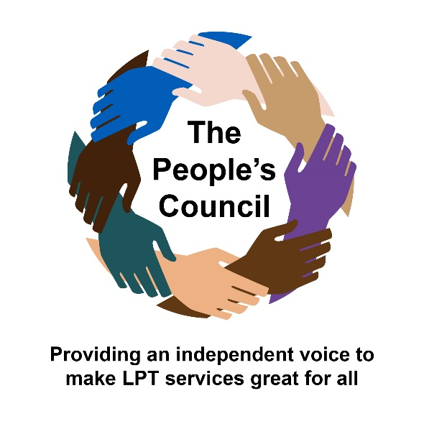

**People’s Council Patient/Carer Leader**

**Application form to become a member of the People’s Council**

If you require this document in an alternative format, such as large print or a coloured background, please contact [Diane.Harrison9@nhs.net](mailto:Diane.Harrison9@nhs.net) who is the People’s Council administrator at Leicestershire Partnership NHS Trust.

Please send this completed application form to: [Diane.Harrison9@nhs.net](mailto:Diane.Harrison9@nhs.net?subject=Application%20to%20join%20The%20People's%20Council%20at%20LPT)

|  |  |
| --- | --- |
|  | Please try to answer all of the questions. However, if you are unsure, then please leave it blank. If required, you can ask someone to help you fill in this form. |
| 1. **Contact details**   **Name**:  **Address:**  **Phone Number:**  **E-mail:**  **Are you:** A service user Carer Both  **Preferred method of contact:**  **The Trust is committed to providing equal opportunities for all. If you have a disability, health problem or English is not your first language, please give details below of any services / support that you would like the Trust to provide in order for you to become involved:** | |
| **2. Demographic**  **Gender – are you:**  Male  Female  Prefer not to say  Other - my gender identity is:………………………..  **Is your gender identity the same as the gender you were assigned at birth?**  Yes  No  Prefer not to say  **Age – What age range best describes you?**  0-18  18-64  65 and over  **Disability – Do you have any long-standing illness, disability or health problem?**  Yes  No  Prefer not to say  **Ethnicity**  White British  White Irish  Other white background  Mixed Black Caribbean  Mix/Black African  Mix Asian  Mix other background  Asian Indian  Asian Pakistani  Asian Bangladeshi  Other Asian background  Black/British Caribbean  Black/British African  Black/Other  Chinese  Any other Ethnic group. My ethnicity is…………………………….  **Religion – What is your religion?**  No religion  Hindu  Sikh  Buddhist  Jewish  Christian  Muslim  Other. My religion is……………………………………  **Sexual Orientation – are you:**  Heterosexual  Bisexual  Gay or Lesbian  Prefer not to say  Other – my sexual orientation is: …………………….... | |

|  |  |  |  |
| --- | --- | --- | --- |
| Learning disabilities |  | Long Term Conditions |  |
| Sensory impairment |  | Substance misuse |  |
| Physical disabilities |  | Adult Mental Health Services |  |
| Children’s Services |  | Child and Adolescent Mental Health Services |  |
| I don’t have a health condition |  |  | |
| BME South Asian |  | Family with single parent(s) |  |
| BME Black Caribbean and African |  | Families with young children |  |
| BME Eastern European |  | Carers |  |
| Asylum Seekers & Refugees |  | LGBTQ+ |  |
| Students |  | Gypsy and Traveller |  |
| Physical Disabilities |  | Domestic Violence |  |

**Please indicate which of the following conditions you would wish to represent through your lived experience on the People’s Council (tick all that apply):**

**3.**

**4.**

|  |  |
| --- | --- |
| C:\Program Files\Microsoft Office\MEDIA\CAGCAT10\j0199727.wmf | **What knowledge and skills do you bring to help and support you in the role of an expert by lived experience?** |

**5.**

|  |  |
| --- | --- |
| C:\Program Files\Microsoft Office\MEDIA\CAGCAT10\j0299125.wmf | **Please complete the following statement – ‘I would be a good Patient/Carer Leader with lived experience because……’ – *please use no more than 200 words.*** |

I certify, to the best of my knowledge, that the information provided on this Expression of Interest form is correct.

Yes, it is.

Signed:

Print Name:

Date:

**Please submit this form to Diane Harrison,**

**The People’s Council Administrator at** [**diane.harrison@leicspart.nhs.net**](mailto:diane.harrison@leicspart.nhs.net)