Workforce Race Equality Standard

Leicestershire Partnership NHS Trust

March 2022

Summary

At LPT in 2021/22, colleagues from a Black, Asian or minority ethnic background were…

Under-represented at non-clinical Bands 8B and above
Under-represented at clinical Band 4, and Band 6 and above
Over-represented in medical roles
Over-represented/proportionally represented in non-clinical Bands 2 to 6
Over-represented in clinical Band 2, proportionally represented in clinical Band 5
This is similar to last year.

Less likely to be appointed from shortlisting than White applicants. White people were 1.79 times more likely than BAME people to be appointed from shortlisting.
This is slightly worse than last year.

Similarly likely as White colleagues to enter a formal disciplinary process (taking into account the small numbers). BAME colleagues were 1.64 times as likely to enter a formal process compared to White colleagues.
This is similar to last year.

Similarly likely as White colleagues to undertake non-mandatory training (White colleagues 1.07 times more likely to undertake this).
This is similar to last year.

Similarly likely as White colleagues to suffer harassment, bullying or abuse from the public (24.3% BAME, 21.8% White)
This is similar to last year.
Similarly likely as White colleagues to suffer harassment, bullying or abuse from other staff (20.9% BAME, 18.8% White)
This is an improvement on last year
More than twice as likely as White colleagues to report being discriminated against at work (13.5% BAME, 6.4% White)
This is a slight improvement on last year

Less likely than White colleagues to feel career progression is fair at LPT (52.8% BAME, 67.1% White)
This is an improvement on last year
Able to see BAME people represented within the voting members of the Board, but under-represented among Board members overall, and among executive Board members.
This is an improvement on last year.

Introduction to the Workforce Race Equality Standard

The Workforce Race Equality Standard (WRES) includes nine metrics comparing experiences and outcomes for White and BAME staff. This data is used to develop action plans for improvement.

All NHS Trusts are required to submit WRES data to NHS England and NHS Improvement, by August 31st 2022. An action plan must be agreed by the Trust Board and published on the Trust’s website by October 31st 2022.

Note on data:

Headcounts below 10, and any associated headcounts which could be used to calculate headcounts below 10, have been redacted.

Note on terminology:

The term “BAME” is used throughout this report to mirror the wording of the WRES. However, this term is becoming less used in favour of more inclusive language which does not combine all minority ethnic groups together. Therefore, as well as comparing colleagues from White and BAME backgrounds, further analysis is provided where possible which analyses the differences in outcomes for White, Asian, Black, Mixed and Other minority ethnicities.

Benchmarking of last year’s data

National 2020 – 2021 WRES data broken down by organisation was made available in April 2022, allowing comparisons to be made.

- LPT performed better than, or the same as, other Trusts in the Midlands as a whole. The exception was in Indicator 1: LPT has a race disparity when comparing the ethnic profile of colleagues at lower bands to the ethnic profile of colleagues at higher bands. BAME colleagues were under-represented from Band 8B upwards (non-clinical) and Band 6 upwards (clinical), with the exception of medical colleagues.
- With regards to Staff Survey responses from BAME colleagues, LPT was in the best 30% of Trusts nationally for Indicators 5, 6 and 8 (bullying/harassment/abuse from the public, bullying/harassment/abuse from colleagues, and discrimination from managers)
- Board representation of the ethnic profile of the entire workforce at LPT was about average, better than 41% of Trusts.

The WRES metrics

Metric 1. Pay Bands

Description of metric 1:

- The percentage of BAME colleagues in each of the Agenda for Change Pay Bands 1 to 9 and VSM (including executive Board members) compared with the percentage of BAME colleagues in the overall workforce, calculated separately for non-clinical and for clinical colleagues.

Narrative for metric 1:

- At March 2022, BAME colleagues made up 25.6% (1409/5511) of LPT’s substantive workforce of known ethnicity, up from 24.4% (1287/5278) in March 2021.

- 180 colleagues had no ethnicity recorded on ESR, or had declined to disclose this information. Ethnicity was known for 96.8% (5511/5691) of the substantive workforce, down slightly from 97.2% last year.

- The ethnicity profile of substantive colleagues at Leicestershire Partnership NHS Trust by individual pay band for the last three years is detailed in Table 1 and Graph A. There has been little change in the distribution of colleagues from BAME backgrounds at each band. A summarised version of this information is given in Table 2 and Graph B, with pay bands grouped to observe trends.

- Non-clinical:
  - Colleagues from BAME backgrounds were overrepresented at Band 2 (39.2%, 104/265) and Band 3 (35.1%, 105/299). This over-representation is primarily due to the proportion of Asian colleagues at this level, as Black colleagues remain under-represented.
  - In common with previous years, colleagues from BAME backgrounds were proportionately represented from Band 4 (26.9%, 52/193) to Band 8a (25.8%, 16/62).
  - BAME representation drops from Band 8B (R), with low levels of representation from Band 8B to Very Senior Manager level in general (R).
  - As shown in Table 1, we have seen a decrease in BAME representation at Bands 7, 8A and 8B. At Bands 2, 3, 5 and 6 we have seen a slight increase.

- Clinical:
  - Bands 2 to 4 (mostly Additional Clinical Services):
    - BAME people were overrepresented at the lowest pay band, Band 2 (38.1%, 175/459), but representation worsens at Bands 3 (20.9%, 115/550) and 4 (15.8%, 53/336). This trend can particularly be seen when looking specifically at Black colleagues. This follows the trend of previous years, although slight improvement can be seen across all three bands.
  - Bands 5 and above (mostly Registered Nurses and Allied Health Professionals):
    - BAME colleagues were proportionately represented at Band 5 (25.0%, 179/717), but representation drops for Bands 6 to 8A. However, the drop is not as significant as it has been in previous years, so some progress is being made. Black colleagues are over-represented at Band 5 (10.0%, 72/717) while Asian colleagues are under-represented (11.7%, 84/717). As seen in Graph B, the drop in representation seen at higher bands is more stark for Black colleagues.
  - Medical:
    - Colleagues from BAME backgrounds are overrepresented in Medical roles (67.4%, 147/218), an increase since last year (63.9%, 129/202). Black colleagues are also over-represented in medical roles (9.6%, 21/218), although not to the extent of Asian colleagues (50.0%, 109/218).

- The WRES does not consider colleagues who work solely on the Bank for LPT (i.e., colleagues who work for LPT on a zero-hours contract and who do not have a substantive role with the Trust):
  - Bank colleagues are more likely to come from a BAME background (42.7% BAME, 409/958) than substantive colleagues (25.6%, 1409/5511).
  - Of Bank colleagues of known ethnicity:
    - 16.9% are Asian (162/958)
    - 21.0% are Black (201/958)
    - 3.3% are Mixed (32/958)
    - 1.5% are Other (14/958)
    - 57.3% are White (549/958)
  - Therefore, the WRES underestimates the percentage of BAME colleagues in LPT’s overall workforce, particularly at lower bands (Band 2 to Band 6) as these are the job roles most commonly held through the Bank.

Table 1: Metric 1: The ethnicity profile of substantive colleagues (of known ethnicity) at Leicestershire Partnership NHS Trust, by pay band, at March 2020, March 2021, and March 2022

Pay Band | Percentage BAME colleagues March 2020 | Percentage BAME colleagues March 2021 | Percentage BAME colleagues March 2022 | Number of BAME colleagues  March  2020 | Number of BAME colleagues  March  2021 | Number of BAME colleagues  March  2022
Substantive Colleagues Overall | 23.5% | 24.4% | 25.6% | 1221 out of 5203 | 1287 out of 5278 | 1409 out of 5511
Non-clin Apprentices | R | R | R | R | R | R
Non-clinical Band 2 | 33.1% | 37.3% | 39.2% | 86 out of 260 | 98 out of 263 | 104 out of 265
Non-clinical Band 3 | 32.7% | 33.2% | 35.1% | 88 out of 269 | 93 out of 280 | 105 out of 299
Non-clinical Band 4 | 28.3% | 29.3% | 26.9% | 54 out of 191 | 55 out of 188 | 52 out of 193
Non-clinical Band 5 | 30.3% | 30.3% | 31.2% | 43 out of 142 | 46 out of 152 | 49 out of 157
Non-clinical Band 6 | 30.1% | 28.4% | 32.8% | 34 out of 113 | 31 out of 109 | 40 out of 122
Non-clinical Band 7 | 27.3% | 28.7% | 23.4% | 27 out of 99 | 29 out of 101 | 25 out of 107
Non-clinical Band 8a | 27.6% | 26.6% | 25.8% | 16 out of 58 | 17 out of 64 | 16 out of 62
Non-clinical Band 8b | R | R | R | R | R | R
Non-clinical Band 8c | R | R | R | R | R | R
Non-clinical Band 8d | R | R | R | R | R | R
Non-clinical Band 9 | R | R | R | R | R | R
Non-clinical VSM | R | R | R | R | R | R
Clinical Apprentices | 20.0% | 33.3% | 33.3% | R | R | R
Clinical Band 2 | 36.8% | 37.0% | 38.1% | 193 out of 525 | 194 out of 524 | 175 out of 459
Clinical Band 3 | 16.5% | 19.1% | 20.9% | 80 out of 485 | 93 out of 487 | 115 out of 550
Clinical Band 4 | 12.4% | 12.1% | 15.8% | 31 out of 249 | 34 out of 280 | 53 out of 336
Clinical Band 5 | 22.0% | 24.2% | 25.0% | 162 out of 735 | 171 out of 707 | 179 out of 717
Clinical Band 6 | 16.1% | 16.5% | 18.2% | 181 out of 1125 | 190 out of 1149 | 215 out of 1181
Clinical Band 7 | 13.9% | 16.0% | 17.9% | 57 out of 411 | 71 out of 443 | 91 out of 508
Clinical Band 8a | 10.2% | 9.4% | 10.2% | 16 out of 157 | 16 out of 170 | 17 out of 166
Clinical Band 8b | R | R | 20.0% | R | R | 12 out of 60
Clinical Band 8c | R | R | R | R | R | R
Clinical Band 8d | R | R | R | R | R | R
Clinical VSM | R | R | R | R | R | R
Medical Trainee Grade | 66.2% | 66.1% | 70.7% | 43 out of 65 | 41 out of 62 | 53 out of 75
Medical Non-consultant | 47.6% | 57.1% | 55.2% | 10 out of 21 | 16 out of 28 | 16 out of 29
Medical Consultant | 66.1% | 61.9% | 66.7% | 72 out of 109 | 66 out of 105 | 72 out of 108
Medical Senior Manager | R | R | R | R | R | R

Graph A: The ethnicity profile of substantive colleagues (of known ethnicity) of each band compared to overall

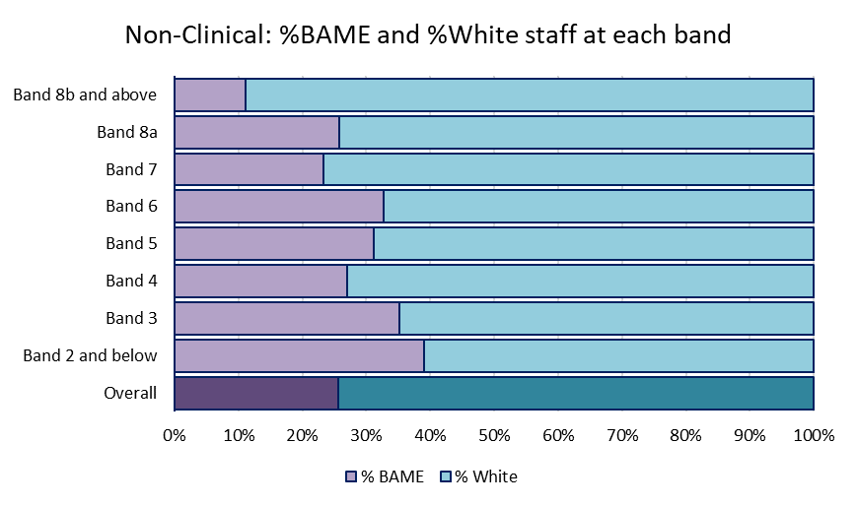

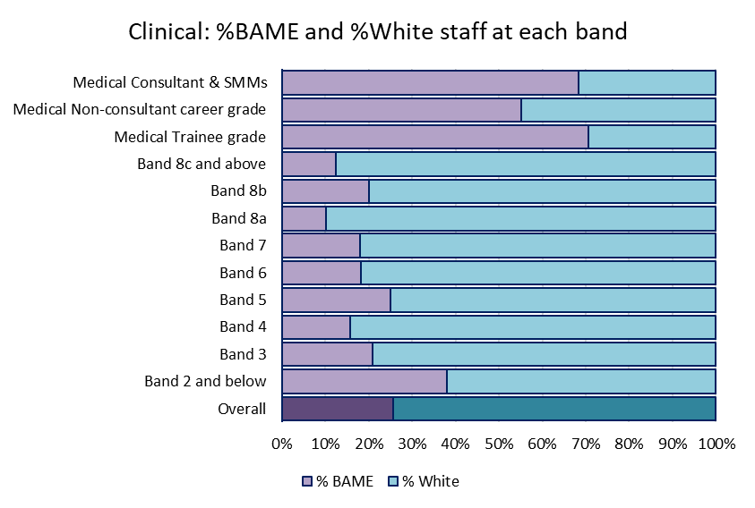

Table 2: Metric 1: The ethnicity profile of substantive colleagues (of known ethnicity) at Leicestershire Partnership NHS Trust, by grouped pay bands, at March 2020, March 2021, and March 2022

Pay Band Group | Percentage BAME colleagues March 2020 | Percentage BAME colleagues March 2021 | Percentage BAME colleagues March 2022 | Number of BAME colleagues  March  2020 | Number of BAME colleagues  March  2021 | Number of BAME colleagues  March  2022
Substantive Colleagues Overall | 23.5% | 24.4% | 25.6% | 1221 out of 5203 | 1287 out of 5278 | 1409 out of 5511
Non-clinical Bands 2 to 8a | 30.7% | 31.9% | 32.5% | 348 out of 1132 | 369 out of 1157 | 391 out of 1205
Non-clinical Bands 8b to VSM | R | R | R | R | R | R
Clinical Band 2 | 36.8% | 37.0% | 38.1% | 193 out of 525 | 194 out of 524 | 175 out of 459
Clinical Bands 3 to 4 | 15.1% | 16.6% | 19.0% | 111 out of 734 | 127 out of 767 | 168 out of 886
Clinical Band 5 | 22.0% | 24.2% | 25.0% | 162 out of 735 | 171 out of 707 | 179 out of 717
Clinical Bands 6 to VSM | 14.9% | 15.7% | 17.4% | 264 out of 1773 | 289 out of 1845 | 339 out of 1947
Medics (all grades) | 64.0% | 64.0% | 67.4% | 128 out of 200 | 130 out of 203 | 147 out of 218
Below Band 2 - clinical and non-clinical | R | R | R | R | R | R

Graph B: The ethnic groups of substantive colleagues (of known ethnicity) of each group of bands compared to overall

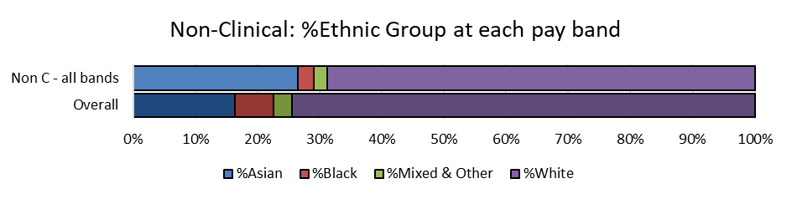
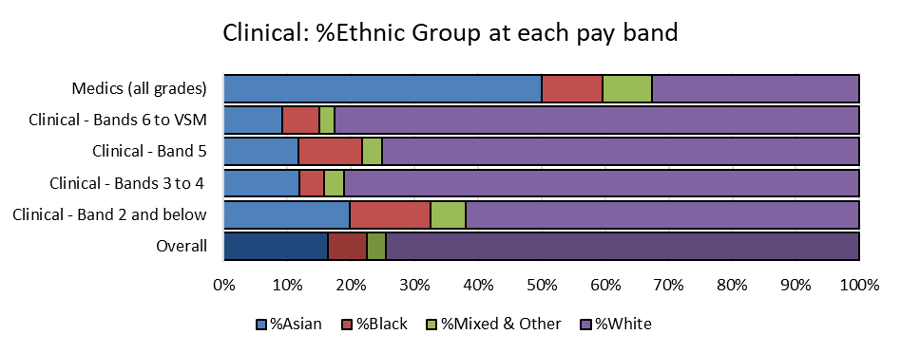

Metric 2. Recruitment

Description of metric 2:

- Relative likelihood of White people compared to BAME people being appointed from shortlisting across all posts. The percentage of White people appointed from shortlisting divided by the percentage of BAME people appointed from shortlisting.

Narrative for metric 2:

- In 2021/22 White people were 1.79 times more likely than BAME people to be appointed from amongst those shortlisted.

- The position has been worsening since 2019/20 when White people were 1.14 times as likely as BAME people to be appointed from shortlisting (statistically equivalent). Please refer to Table 3 and Graph C.

Table 3: Metric 2: The relative likelihood of White people and BAME people being appointed from amongst those shortlisted at Leicestershire Partnership NHS Trust during 2018/19, 2019/20, 2020/21, and 2021/22

Recruitment | 2018/19 | 2019/20 | 2020/21 | 2021/22
Relative likelihood of appointment from shortlisting (White/BAME) | 1.97 | 1.14 | 1.46 | 1.79
% White people appointed from shortlisting | 9.7% | 11.3% | 12.0% | 15.5%
% BAME people appointed from shortlisting | 4.9% | 10.0% | 8.2% | 8.7%
Number of White people appointed from shortlisting | 371 out of 3844 | 341 out of 3005 | 400 out of 3327 | 596 out of 3842
Number of BAME people appointed from shortlisting | 124 out of 2525 | 186 out of 1861 | 171 out of 2082 | 207 out of 2386

Graph C: The percentage of shortlisted applicants of each ethnic group appointed in 2021/22

Metric 3. Formal disciplinary process

Description of metric 3:

- Relative likelihood of BAME colleagues compared to White colleagues entering the formal disciplinary process, as measured by entry into a formal disciplinary investigation. The percentage of BAME colleagues entering the formal disciplinary process divided by the percentage of White colleagues entering the formal disciplinary process.

Narrative for metric 3:

- In previous years, Indicator 3 has been calculated on the basis of a two-year combined total (see Table 4). In more recent years, data has been gathered for each year individually (see Table 5). Therefore, this indicator is liable to vary significantly year-on-year due to the small number of formal disciplinary investigations in question.

- In the two-year window 2020/21 to 2021/22, BAME colleagues were 1.41 times more likely than White colleagues to enter formal disciplinary processes. When considering just the cases which began in 2021/22, the relative likelihood is 1.64. Although this appears to be a worsened position, the number of colleagues going through these proceedings is very low, so the relative likelihood is liable to vary year on year. Due to small figures, a more detailed breakdown by ethnic group is not possible. Please refer to Tables 4 and 5.

- Though not included in the WRES figures, BAME Bank staff were 4.47 times more likely than White Bank staff to enter a formal disciplinary process. This follows the pattern of 2019/20 to 2020/21, when the likelihood was 4.4 times.

Table 4: Historic Metric 3 (two-year windows): The relative likelihood of BAME colleagues and White colleagues entering the formal disciplinary process during the two-year windows 2017/18 to 2018/19, 2018/19 to 2019/20, 2019/20 to 2020/21, and 2020/21 to 2021/22

Formal disciplinary process | 2017/18 to 2018/19 | 2018/19 to 2019/20 | 2019/20 to 2020/21 | 2019/20 to 2020/21
Relative likelihood (BAME/White) | 1.35 | 0.59 | 0.74 | 1.41
% BAME colleagues entering formal disciplinary | R% | R% | R% | R%
% White colleagues entering formal disciplinary | R% | R% | R% | R%
n. BAME colleagues entering formal disciplinary | R out of 1171 | R out of 1221 | R out of 1287 | R out of 1409
n. White colleagues entering formal disciplinary | R out of 4007 | R out of 3982 | R out of 3991 | R out of 4102

Table 5: Metric 3 (one-year windows): The relative likelihood of BAME colleagues and White colleagues entering the formal disciplinary process during the one-year windows 2019/20, 2020/21, and 2021/22

Formal disciplinary process | 2019/20 | 2020/21 | 2021/22
Relative likelihood (BAME/White) | 0.53 | 1.24 | 1.64
% BAME colleagues entering formal disciplinary | R% | R% | R%
% White colleagues entering formal disciplinary | R% | R% | R%
n. BAME colleagues entering formal disciplinary | R out of 1221 | R out of 1287 | R out of 1409
n. White colleagues entering formal disciplinary | R out of 3982 | R out of 3991 | R out of 4102

Metric 4. Non-mandatory training

Description of metric 4:

- Relative likelihood of White colleagues compared to BAME colleagues accessing non-mandatory training and CPD. The percentage of White colleagues accessing non-mandatory training divided by the percentage of BAME colleagues accessing non-mandatory training.

Narrative for metric 4:

- In 2021/22 White colleagues were 1.07 times more likely than BAME colleagues to access non-mandatory training, defined as any training which is not listed on the mandatory or role essential training registers.

- This is similar to the positions observed in previous years. Please refer to Table 6.

- In particular, White colleagues were 1.15 times more likely than Asian colleagues to access non-mandatory training. Please refer to Graph D.

Table 6: Metric 4: The relative likelihood of White colleagues and BAME colleagues accessing non-mandatory training during 2018/19, 2019/20, 2020/21, and 2021/22

Non-mandatory training | 2018/19 | 2019/20 | 2020/21 | 2021/22
Relative likelihood of accessing training (White/BAME) | 1.09 | 1.10 | 1.06 | 1.07
% White colleagues accessing training | 61.7% | 80.4% | 88.3% | 71.6%
% BAME colleagues accessing training | 56.8% | 73.2% | 83.5% | 66.6%
n. White colleagues accessing training | 2473 out of 4007 | 3203 out of 3982 | 3526 out of 3991 | 2936 out of 4102
n. BAME colleagues accessing training | 665 out of 1171 | 894 out of 1221 | 1075 out of 1287 | 939 out of 1409

Graph D: The percentage of colleagues of each ethnic group undertaking non-mandatory training in 2021/22

Metric 5. Harassment, bullying or abuse from patients, relatives or the public

Description of metric 5:

- The percentages of White colleagues and BAME colleagues experiencing harassment, bullying or abuse from patients, relatives or the public in last 12 months, derived from the NHS Staff Survey.

Narrative for metric 5:

- The 2021 NHS Staff Survey showed that White colleagues and BAME colleagues were similarly likely to suffer harassment, bullying or abuse from patients, service users, their relatives or other members of the public (24.3%, 139/571 BAME colleagues and 21.8%, 488/2237 White colleagues). There was a slight decrease in this abuse reported by White colleagues since last year (0.5%), and an even smaller decrease for BAME colleagues (0.1%). As Graph F shows, the discrepancy between White and BAME colleagues is widening but is still not significant.

- LPT’s results for this metric were better than Trusts of a similar type in the benchmark group (31.8% BAME colleagues and 26.2% White colleagues).

- Black colleagues in particular were more likely than any other ethnic group to suffer this type of harassment, bullying or abuse (43.7%, 45/103), and this figure has increased since last year. This reflects a long-term trend and may be due in part to the higher proportion of Black colleagues in clinical patient-facing roles. Please refer to Table 7 and Graphs E and F.

- For the 2021 Staff Survey, results were also gathered for Bank colleagues although these do not contribute to the WRES data. BAME bank colleagues were more likely to experience bullying, harassment or abuse from patients, service users, their relatives or the public (37.5%, 21/56) compared to White bank colleagues (23.0%, 26/113), with a particularly high proportion of Black bank colleagues in particular experiencing this (44.0%, 11/25), mirroring the position observed for substantive colleagues.

Table 7: Metric 5: Percentages of White & BAME colleagues who experienced harassment, bullying or abuse from patients/service users, their relatives or other members of the public, according to the Staff Survey

Harassment, bullying or abuse from patients, relatives or the public | 2018 | 2019 | 2020 | 2021
% White colleagues | 23.1% | 22.9% | 22.3% | 21.8%
% BAME colleagues | 24.0% | 23.4% | 24.4% | 24.3%
Asian |  |  | 18.2% | 16.9%
Black |  |  | 39.6% | 43.7%
Mixed |  |  | 33.3% | 38.0%
Other |  |  | 45.0% | 38.1%
n. White colleagues | 460 out of 1991 | 429 out of 1876 | 487 out of 2183 | 488 out of 2237
n. BAME colleagues | 117 out of 488 | 102 out of 435 | 126 out of 516 | 139 out of 571
Asian |  |  | R | R
Black |  |  | R | R
Mixed |  |  | R | R
Other |  |  | R | R
Graph E: Metric 5: The percentages of colleagues from each ethnic group who experienced harassment, bullying or abuse from patients / service users, their relatives or other members of the public, according to the Staff Survey 2021

Graph F: Metric 5: How the percentage of colleagues who experienced harassment, bullying or abuse from patients / service users, their relatives or other members of the public, has changed since 2018

Metric 6. Harassment, bullying or abuse from other colleagues

Description of metric 6:

- The percentages of White colleagues and BAME colleagues experiencing harassment, bullying or abuse from other colleagues in last 12 months, derived from the NHS Staff Survey.

Narrative for metric 6:

- This metric is based on a combined figure of responses from 2 questions:
  - 14b. In the last 12 months how many times have you personally experienced harassment, bullying or abuse at work from managers?
  - 14c. In the last 12 months how many times have you personally experienced harassment, bullying or abuse at work from other colleagues?
A breakdown by ethnic group is possible for each question individually (Tables 9 and 10) but not the overall metric (Table 8).

- Overall, the 2021 NHS Staff Survey indicated that BAME colleagues were similarly likely as White colleagues to suffer harassment, bullying or abuse from other colleagues (20.9%, 120/574 BAME colleagues and 18.8%, 420/2233 White colleagues). The discrepancy between White and BAME responses has reduced, as have the percentages of respondents in both groups reporting bullying, harassment, or abuse from other colleagues. Please refer to Table 8 and Graph G.

- LPT’s results for this metric in 2021 were slightly better for BAME colleagues than Trusts in the benchmark group, and similar for White colleagues (22.9% BAME colleagues and 18.1% White colleagues).

- Black (11.7%, R) and Mixed (18.0%, R) people report more bullying, harassment and abuse from managers than White (9.4%, R) or Asian (8.1%, R) colleagues do. These trends follow a similar pattern to 2020 responses. Please refer to Table 9 and Graph H.

- Responses to the bank Staff Survey show a similar percentage of White bank colleagues report bullying, harassment or abuse from managers (6.2%, R) compared to BAME colleagues (7.0%, R), although a more detailed breakdown by ethnic group is not possible due to the limited number of responses.

- White colleagues report less bullying, harassment and abuse from other colleagues than other ethnic groups. Members of colleagues from Mixed (21.6%, 11/51) and Black (19.8%, 20/101) backgrounds report the highest levels, with Asian colleagues (14.8%, 58/393) slightly higher than White colleagues (14.3%, 315/2207). There has been an improved position for all BAME groups with the exception of people from Mixed backgrounds. Please see Table 10 and Graph I.

- Responses to the bank Staff Survey show more BAME colleagues report bullying, harassment or abuse from colleagues (29.3%, 17/58), compared to White bank colleagues (14.4%, 16/111), and compared to BAME substantive colleagues (16.4%, 93/566). Again, a more detailed breakdown by ethnic group is not possible due to the limited number of responses.
Table 8: Metric 6: The percentages of White colleagues and BAME colleagues who experienced harassment, bullying or abuse from other colleagues (including managers), Staff Survey

Harassment, bullying or abuse from other colleagues | 2018 | 2019 | 2020 | 2021
% White colleagues | 18.8% | 19.9% | 19.8% | 18.8%
% BAME colleagues | 20.1% | 24.4% | 24.8% | 20.9%
n. White colleagues | 374 out of 1994 | 373 out of 1879 | 432 out of 2187 | 420 out of 2233
n. BAME colleagues | 98 out of 487 | 107 out of 438 | 128 out of 516 | 120 out of 574

Graph G: Metric 6: How the percentage of colleagues who experienced harassment, bullying or abuse from other colleagues (including managers), has changed since 2018

Table 9: Staff Survey Question 14b: The percentage of colleagues who experienced harassment, bullying or abuse from managers

Harassment, bullying or abuse from managers | 2018 | 2019 | 2020 | 2021
% White colleagues | 9.3% | 10.3% | 10.6% | 9.4%
% BAME colleagues | 9.4% | 14.3% | 12.7% | 9.8%
Asian |  |  | 9.9% | 8.1%
Black |  |  | 18.0% | 11.7%
Mixed |  |  | 12.5% | 18.0%
Other |  |  | 38.1% | 14.3%
n. White colleagues | 186 out of 2007 | 194 out of 1891 | 230 out of 2181 | 208 out of 2216
n. BAME colleagues | 46 out of 490 | 63 out of 442 | 65 out of 513 | 56 out of 570
Asian |  |  | R | R
Black |  |  | R | R
Mixed |  |  | R | R
Other |  |  | R | R
Graph H: Metric 6: Percentage of colleagues who experienced harassment/bullying/abuse from managers

Table 10: Staff Survey Question 14c: The percentage of colleagues who experienced harassment, bullying or abuse from colleagues (not managers)

Harassment, bullying or abuse from colleagues (not managers) | 2018 | 2019 | 2020 | 2021
% White colleagues | 13.6% | 14.7% | 13.9% | 14.3%
% BAME colleagues | 16.3% | 20.1% | 20.6% | 16.4%
Asian |  |  | 19.3% | 14.8%
Black |  |  | 25.6% | 19.8%
Mixed |  |  | 17.8% | 21.6%
Other |  |  | 26.3% | 19.0%
n. White colleagues | 271 out of 1993 | 274 out of 1858 | 300 out of 2152 | 315 out of 2207
n. BAME colleagues | 78 out of 479 | 87 out of 433 | 104 out of 506 | 93 out of 566
Asian |  |  | R | R
Black |  |  | R | R
Mixed |  |  | R | R
Other |  |  | R | R

Graph I: Metric 6: Percentage of colleagues who experienced harassment/bullying/abuse from colleagues (not managers)

Metric 7. Equal opportunities for career progression or promotion

Description of metric 7:

- The percentages of White colleagues and BAME colleagues believing that the Trust provides equal opportunities for career progression or promotion, derived from the NHS Staff Survey.

Narrative for metric 7:

- In 2021, the way responses to this question were calculated was adjusted. For the first time, “Not sure” responses were included in the total. Therefore, positive response percentages are now lower than in previous years. To enable accurate comparison, data below has been calculated using the new method for all previous years retrospectively. Therefore, data will be different to that reported in previous years.

- The 2021 NHS Staff Survey showed that BAME colleagues, and especially Black colleagues, were less likely than White colleagues to believe that the Trust provides equal opportunities for career progression or promotion (52.8%, 302/572 BAME colleagues, 41.2%, 43/103 Black colleagues, and 67.1%, 1495/2228 White colleagues).

- The position for BAME colleagues has remained low in previous years, but 2021 represents the highest positive response rates of the included years. Please refer to Table 11 and Graphs J and K.

- LPT’s results for this metric in 2021 were better than Trusts in the benchmark group (46.8% BAME colleagues and 61.0% White colleagues).

Table 11: Metric 7. The percentages of White colleagues and BAME colleagues who felt that the organisation provides equal opportunities for career progression or promotion, Staff Survey

Equal opportunities for career progression or promotion | 2018 | 2019 | 2020 | 2021
% White colleagues | 66.0% | 61.2% | 65.2% | 67.1%
% BAME colleagues | 49.7% | 43.8% | 48.2% | 52.8%
Asian |  |  | 52.9% | 56.0%
Black |  |  | 34.8% | 41.2%
Mixed |  |  | 46.9% | 52.0%
Other |  |  | 28.6% | 47.6%
n. White colleagues | 1311 out of 1986 | 1145 out of 1871 | 1428 out of 2191 | 1495 out of 2228
n. BAME colleagues | 244 out of 491 | 193 out of 441 | 250 out of 519 | 302 out of 572
Asian |  |  | R | R
Black |  |  | R | R
Mixed |  |  | R | R
Other |  |  | R | R

Graph J: Metric 7: The percentages of colleagues from each ethnic group who feel the Trust offers equal opportunities for career progression, according to the Staff Survey 2021

Graph K: Metric 7: How the percentage of colleagues feeling the Trust provides equal opportunities for career progression has changed since 2018

Metric 8. Discrimination at work from a manager, team leader or other colleagues

Description of metric 8:

- The percentages of White colleagues and BAME colleagues experiencing discrimination at work from their manager / team leader or other colleagues in last 12 months, derived from the NHS Staff Survey.

Narrative for metric 8:

- The 2021 NHS Staff Survey indicated that BAME colleagues, and especially Black colleagues, were more likely than White colleagues to have experienced discrimination at work from their manager / team leader or other colleagues (13.5%, 77/569 BAME colleagues, 23.3%, 24/103 Black colleagues, and 6.4%, 142/2228 White colleagues). However, this does represent a slight improvement on last year for BAME colleagues.

- The position for BAME colleagues has remained high across previous years, as has the position for Black colleagues in particular. Please refer to Table 12 and Graphs L and M.

- LPT’s results for this metric in 2021 were slightly better for BAME colleagues than Trusts in the benchmark group (14.4% BAME colleagues and 6.0% White colleagues).

- For bank colleagues in 2021, levels of discrimination at work from a manager / team leader or other colleagues followed a similar pattern with BAME bank colleagues being higher (19.3%, 11/57) than White bank colleagues (6.1%, R), and were even higher amongst Black bank colleagues in particular (25.9%, R).

Table 12: Metric 8: The percentages of White colleagues and BAME colleagues who experienced discrimination at work from their manager / team leader or other colleagues in last 12 months, Staff Survey

Discrimination at work from a manager / team leader or other colleagues | 2018 | 2019 | 2020 | 2021
% White colleagues | 4.3% | 5.8% | 5.9% | 6.4%
% BAME colleagues | 10.8% | 13.1% | 14.5% | 13.5%
Asian |  |  | 11.6% | 10.6%
Black |  |  | 26.1% | 23.3%
Mixed |  |  | 12.2% | 15.7%
Other |  |  | 20.0% | 15.0%
n. White colleagues | 85 out of 1987 | 108 out of 1863 | 129 out of 2175 | 142 out of 2228
n. BAME colleagues | 52 out of 481 | 57 out of 434 | 74 out of 511 | 77 out of 569
Asian |  |  | R | R
Black |  |  | R | R
Mixed |  |  | R | R
Other |  |  | R | R

Graph L: Metric 8: The percentages of colleagues from each ethnic group who experienced discrimination from managers or colleagues, according to the Staff Survey 2021

Graph M: Metric 8: How the percentage of colleagues who experienced discrimination has changed since 2018

Metric 9. Board representation

Description of metric 9:

- Percentage difference between BAME representation in the organisation’s Board membership and the organisation’s overall workforce, disaggregated by the Board’s voting membership and executive membership.

Narrative for metric 9:

- In March 2022, compared to the level of representation in the workforce overall, BAME people were underrepresented:
  - amongst board members overall (-8.9% difference in representation),
  - and amongst executive board members (-8.9% difference in representation);
- however, BAME people were proportionately represented
  - amongst voting board members (+1.7% difference in representation).
- This represents a year-on-year improvement since March 2020. Please refer to Table 13.

Table 13: Metric 9. Differences in the levels of representation of BAME people amongst board members (overall, voting members, and executives), relative to the level of representation of BAME people in the workforce overall, at March 2019, at March 2020, at March 2021, and at March 2022

Board representation | March 2019 | March 2020 | March 2021 | March 2022
Percentage BAME in the substantive workforce overall | 22.6% | 23.5% | 24.4% | 25.6%
Difference between all board members and the substantive workforce overall (%BAME) | -15.5% | -17.6% | -12.6% | -8.9%
Difference between voting board members and the substantive workforce overall (%BAME) | -13.5% | -14.4% | -6.2% | 1.7%
Difference between executive board members and the substantive workforce overall (%BAME) | -22.6% | -23.5% | -14.4% | -8.9%

Leicestershire Partnership Trust
WRES Action Plan 2022 - 2024
Objective 1. Ensure Recruitment and Selection processes are inclusive and free from bias where candidates from Black, Asian and Minority Ethnic backgrounds have an equitable outcome compared to their white colleagues from application to appointment across all employment roles with an aim of eliminating any race equality disparities by 2025.
No. | Action | Lead | By When | Milestone | Progress | Improvement to Metric(s) | RAG
1 | To ensure we involve key stakeholders such as our Black, Asian and minority ethnic Staff Support Network in the upcoming review of the Recruitment and Selection Policy | Deputy Director of HR and OD, Resourcing Manager, and Head of EDI | February 2023 (policy due for review) | - Commencement of review and engagement with stakeholders Autumn 2022  - Production of revised policy and process February 2023 | Diverse panel process in place and being monitored in line with 6 high impact Race Equality and Inclusion Strategy (REHIA) actions. | 2, 7 | B
2 | Review Recruitment and Selection training to ensure it is up to date | Resourcing Manager, and member of EDI team | January 2023 | - Commence review and engage with stakeholders Autumn 2022 (Black, Asian and minority ethnic Staff Support Network, managers, Recruitment team)  - Commence new training Winter 2022 | Incorporate learning from Inclusive Recruitment Masterclasses run by NHS England Regional EDI team | 2, 7
3 | Continue to work towards having 100% ethnically diverse recruitment panels | Resourcing Manager | Ongoing | - Identify hotspot areas where recruitment panels are not diverse, and work with managers  - Identify any quick wins (e.g. managers not filling out panel information) |  | 2, 7
Objective 2. Ensure that BAME staff are benefitting from Talent Management, Succession Planning and Career Progression leading to achievement of LPT model employer target of 25.6% by 2025
No. | Action | Lead | By When | Milestone | Progress | Improvement to Metric(s) | RAG
1 | Establish Talent Management and succession planning Processes enabling Black, Asian and minority ethnic staff to progress into senior management positions in line with model employer targets (25.6% Black, Asian and minority ethnic staff into band 8a and above roles by 2025) | Head of OD and Head of EDI | March 2024 | - Develop On-Merit plan aligning to LPT, Group, regional and national Talent Management strategies  - Launch programme  - Create an Inclusive Talent Management toolkit for managers | Action 3 of the National 6 high impact actions require focus on establishing criteria for talent pools. System wide EDI Taskforce have set Talent Management, Succession Planning and Career Progression as a key priority. Talent Management and Succession Planning Strategy in place and includes focus on model employer target. TM pilot programme has started with Executive Directors and will be cascaded down management tiers. | 1, 2, 4 | A
2 | Continue to provide targeted Interview Skills and mock interview training for Black, Asian and minority ethnic colleagues. | Resourcing Manager | Ongoing | - Dates set and advertised for 2021/22  - Continue throughout 2022/23 | These sessions are being regularly run. Numbers are small but positively received. Continuation of these sessions are planned for 2022/23 with an aim of increasing participation.  Expand interview coaching offer following positive feedback. | 1, 2, 4 | A
3 | Provide and support targeted career development opportunities for Black, Asian and minority ethnic colleagues  Identify additional specific needs of International recruits. | Head of OD/Executive Team, Head of International Nursing Recruitment | Ongoing | - Continue We Nurture training to Black, Asian and minority ethnic colleagues  - Work in collaboration with the Midlands Academy to run local Stepping Up Programme  - Developing Diverse Leadership course for Nurses and AHPs (Bands 5 to 7) – LLR Academy, Autumn/Winter 2022 | We Nurture Programme is underway.  Working with Midlands Leadership Academy to run local Stepping Up Programme. All leadership programmes were put on hold during the pandemic.  Developing Diverse Leadership course applications opened July 2022, closing September 2022  To ensure International recruits also access career development opportunities | 1, 2, 4 | A

Objective 3. Create a culturally inclusive organisation for Black, Asian and Minority Ethnic Colleagues in order that there are demonstrable improvements in WRES staff survey indicators 7 and 8
No. | Action | Lead | By When | Milestone | Progress | Improvement to Metric(s) | RAG
1 | Deliver a series of Listening events for staff who are Black, Asian and minority ethnic, Disabled and LGBT in order for colleagues to speak up and raise any concerns. | Chairs and exec sponsors of staff networks, EDI team | Summer 2023 | - Agree timetable of LIA events  - Review themes as identified in the Staff Network Survey and Discussions at Network meetings  - Ensure outputs from events feature in staff network highlight reports to EDI Workforce Group | A number of Trust wide and directorate level Listening events took place during 2020/21. Plans are to continue these as they have worked well as a mechanism for raising concerns and feedback.  Ask what barriers there are to speaking up, if there are any barriers affecting certain groups? | 7 | A
2 | Continue to deliver impactful Race and Cultural Intelligence Learning Sets which include lived experience of Black, Asian and minority ethnic staff to all line-managers | Head of EDI and EDI Specialist | Sessions to recommence in Autumn 2022 | - Communicate requirement for all line-managers to attend the learning sets  - Report numbers attending to EDI Workforce Group  - Refresh learning package Summer 2022 – complete  - Relaunch sessions Autumn 2022 | Over 200 managers have attended the training to date.  Consider how to embed learning after the initial training – delegates commit to an EDI objective in their next appraisal. Delegate-led action learning sets? SMART delegate pledges to review after 6/12 months? | 1, 2, 3, 6, 7, 8 | A
3 | Completion of third Cohort of Reverse Mentoring Programme | Head of EDI | December 2022 | - 3rd cohort launched  - Programme underway | Latest programme is underway and midway through programme delivery. Newsletter developed and shared with participants. Feedback is positive.  Review and evaluation  Delegates to commit to an EDI objective in their next appraisal based on learning and actions coming from the programme. | 1, 2, 6, 7, 8 | A
4 | Develop EDI outcome based Objectives within all leadership appraisals. | Head of EDI and Head of OD | August 2022 | - Roll out of guidance for implementation | TBC – awaiting ULearn update  Rollout guidance | 5, 6, 7, 8 | A
5 | Ensure that key/important events and festivals are celebrated and used as learning opportunities for staff from all backgrounds | Chair of Black, Asian and minority ethnic Staff Support Network | Ongoing | - Calendar of events and festivals developed  - Delivery of important events (SAHM and BHM)  - Celebrations for Diwali, Vaisakhi etc. | Black, Asian and minority ethnic SSN Chair has been working with the SSN to co-design and Co-deliver. Working with NHFT to deliver a programme across both Trusts. | n/a | A
6 | Cultural Competency Programme to improve CC across LPT leadership | Head of EDI | February 2023 | - Programme commencing July 2022  - Review success of programme March 2023 | CC Enablers  CC 360 degree feedback | 1, 2, 3, 6, 7, 8 | A
7 | Zero Tolerance campaign relaunch, with additional supportive materials to encourage speaking up | EDI Specialist, Communications | September 2022 | - Relaunch of campaign in September 2022  - Evaluate A/W 2022 | Requirement for more training for staff to know how to approach these situations, what to say | 5, 8 | A
Objective 4: review disciplinary processes to ensure equity among all colleagues
No. | Action | Lead | By When | Milestone | Progress | Improvement to Metric(s) | RAG
1 | Review disciplinary processes for substantive and bank staff to ensure principles of equity and just culture are embedded at every stage | HR, EDI | Summer 2023 | - Review processes  - Present findings and make any necessary changes, 2023  - Scope any other policies where just culture needs to be considered |  | 3 | B

The basis for our action plan:
Midlands Workforce, Race, Equality and Inclusion (WREI) Strategy: key actions
https://www.england.nhs.uk/midlands/wrei/

Action Point 1: Health and wellbeing support for everyone
Action Point 2: Get more BME staff to speak up
Action Point 3: Stop racism when staff are disciplined
Action Point 4: Stop racism when people apply for jobs and get promoted
Action Point 5: Be honest and take responsibility

The National Equality, Diversity and Inclusion Team have identified six high impact actions for recruitment and selection in particular:

6 National High Impact Race Equality actions
1. Ensure ESMs own the agenda, as part of culture changes in organisations, with improvements in BAME representation (and other under-represented groups) as part of objectives and appraisal by setting specific KPIs and targets linked to recruitment which are time limited, specific and linked to incentives or sanctions
2. Introduce a system of ‘comply or explain’ to ensure fairness during interviews. This system includes requirements for diverse interview panels, and the presence of an equality representative who has authority to stop the selection process, if it was deemed unfair.
3. Organise talent panels, creating a ‘database’ of individuals by system who are eligible for promotion and development opportunities and ensure these are advertised to all staff, agree positive action approaches to filling roles for under-represented groups and set transparent minimum criteria for candidate selection into talent pools
4. Enhance EDI support available to train organisations and HR policy teams on how to complete robust / effective Equality Impact Assessments of recruitment and promotion policies and to ensure that for Bands 8a roles and above, hiring mangers include requirement for candidates to demonstrate EDI work / legacy during interviews.
5. Overhaul interview processes to incorporate training on good practice with instructions to hiring managers to ensure fair and inclusive practices are used, ensure adoption of values-based shortlisting and interview approach and consider skills-based assessment such as using scenarios.
6. Adopt resources, guides and tools to help leaders and individuals have productive conversations about race.

