Foundations in Patient
Experience

We are pleased to invite applications for the ‘Foundations in Patient Experience’ training course, delivered by the Point of Care Foundation.
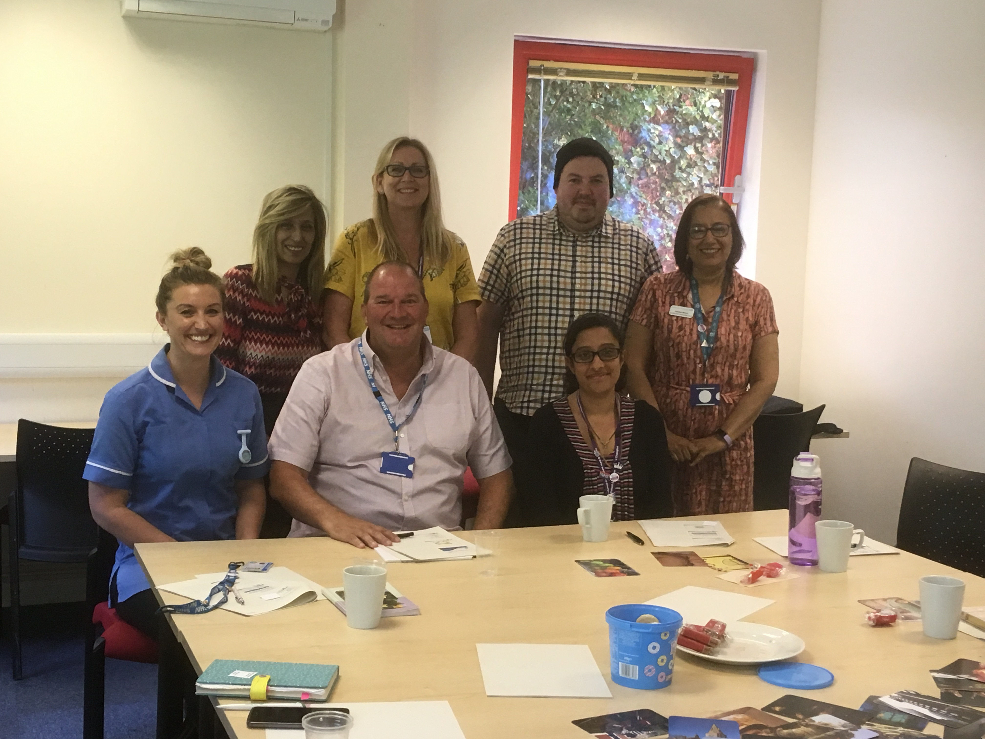

This programme is for those who wish to develop their skills in care experience and people centred approaches to improvements, those committed to co-designing service improvements, and those interested in supporting positive change.

The style of the programme is interactive, and content is divided into 6 distinct modules, with the first 3 modules delivered virtually, and modules 4-6 taking place in person (at the NSPCC centre in Beaumont Leys). The course has 30 places, and these are for a mixture of staff, service users and carers from the Trust’s Involvement Network.

As part of this training, we would like staff to think of a quality improvement area they can work on throughout the programme. Ideas are to be submitted with the expression of interest form so that we can match service users and carers to staff projects. The idea is that you work collaboratively on the improvement.

The objectives of this programme are to:

- Help staff and service users/carers working on experience, involvement, and quality improvement to work strategically as leaders in their field.
- Develop practical skills measuring and improving patient/carer experience
- Strengthen the knowledge of evidence relevant to people’s experiences of using services, related care, and organisational outcomes
- Strengthen the personal impact and effectiveness of participants, increasing confidence in their role, as well as skills in sense making, influencing and collaborative working
- Increase confidence in understanding, analysis and use of different types of patient experience data

When and how the training will be delivered:

Module 1 Introduction to the programme
Tuesday 6th December 11am – 12:30pm - Virtual 90-min session via Zoom

Module 2 Introduction to patient experience data
Thursday 8th December 11am – 12:30pm - Virtual 90-min session via Zoom

Module 3 Introduction to patient engagement, involvement, and experience
Tuesday 13th December 11am – 12:30pm - Virtual 90-min session via Zoom

Module 4 Practical skills in patient-centred quality improvement: An introduction to
Experience Based Co-Design
Monday 16th January 9.30am - 4pm - In-person, one-day session

Module 5 Patient experience data and measurement
Thursday 26th January 9.30am - 4pm - In-person, one-day session

Module 6 Talking about change with patients and the population: Effective facilitation in
patient and public engagement and involvement
Thursday 2nd February 9.30am - 4pm - In-person, one-day session

Who can get involved?

- We are offering this development opportunity to any member of staff working in LPT, of any service and banding, with managers approval and a statement of support from line managers.
- As well as service users and carers registered to LPT’s Service User and Carer Involvement Network.
- The expectation is for all modules to be completed and so commitment to the whole course will be required.

Application Process
- Complete the attached expression of interest form and return to LPT.Patient.Experience@nhs.net
Or post to: FREEPOST LPT Patient Experience

- We are also holding an informal discussion for anyone who wishes to find out more before applying or has any queries. This will take place virtually via MS Teams on Friday 18th November 11am-12pm

- Please contact us if you would like to register your attendance at the above discussion.

- The deadline for sending us your expression of interest form is the end of day Monday 21st November

For further queries please contact LPT.Patient.Experience@nhs.net
Or call 0116 295 0181
Expression of Interest Form (EOI) Foundations to Patient Experience Training Programme

Surname:

Forename(S):

Telephone: | DAY: |  |  | EVENING:
Email Address:

Directorate:
Team/Service:
Manager:
Have you discussed this opportunity with your manager and do they support your involvement? |  |  | Yes/No
Please copy and paste your statement of support from your line manager here:

The Trust is committed to providing equal opportunities for all. If you have a disability, health problem or English is not your first language, please give details below of any services / support that you would like the Trust to provide in order for you to become involved:

Please explain in no more than 150 words what you would like to learn from this opportunity?
Staff only: Please explain in no more than 150 words a possible quality improvement area you would focus on for this programme?

I certify, to the best of my knowledge, that the information provided on this Expression of Interest form is correct.
Signed: ………………………………………………… Date: …………………………………….

Print Name: ………………………………………………………………………..

