Participant Information
‘Easy Read Version’
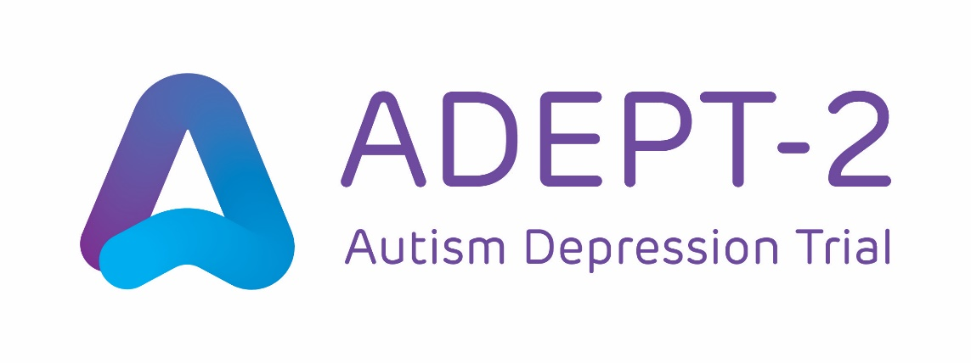
 | Useful words  You – you, if you decide to be in this ADEPT-2 study  We – the ADEPT-2 study team  GSH – ‘Guided Self-Help’ a type of talking therapy  UC – ‘Usual Care’ is the NHS support for depression on offer to you. This could be talking therapy such as cognitive behavioural therapy or counselling; anti-depressant medication; as well as self-care coping strategies and support groups in your local area.  Randomisation – a way to make two similar groups of people with the same chance of getting GSH or UC  Informed consent – learning about a study so that you understand it fully. Then, you can decide if you want to take part

Important things you need to know

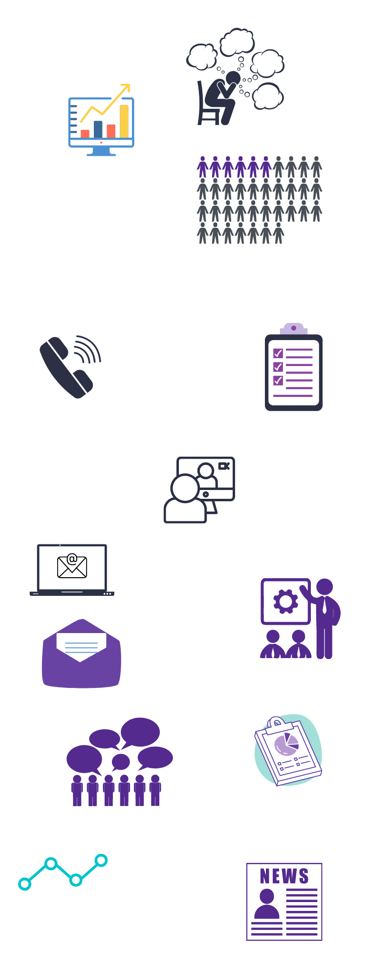          50:50 chance    COVID-19           | - We are inviting adults with a diagnosis of autism who experience low mood/depression to take part in research.  - We want to know if a talking therapy called Guided Self-Help (GSH) helps reduce low mood or depression.  - We know GSH can help with depression in non-autistic adults. It is very commonly prescribed to non-autistic and autistic adults.  - This study will test whether it can also help with low mood/depression in adults with a diagnosis of autism.  - We also want to learn about how useful GSH is for healthcare providers as well as autistic people.  - If you take part in this study:  You will receive either GSH for up to 9 sessions,  Or  Usual Care (UC), which is the NHS support for depression. This may include talking therapy, medication, self-coping strategies, and access to support groups.  - The type of treatment you are offered will be decided by a process called randomisation.  - This is done so that everyone has the same chance of getting GSH or UC. This means that comparing the groups will be fair.  - If you experience any problems or have any concerns during the study, please let the research team know using the contact details on page 6 of this leaflet.  - We can talk to you in person, by video call, on the phone, by email, or a method preferred by you.  - Coronavirus rules might mean that how we talk to you has to change.  - For example, meeting online or talking on the phone instead of meeting in-person.  - You will answer questions about your low mood/depression and service use at the start of the study, and after 16 weeks, 32 weeks, and 52 weeks.  - You will get a £10 gift voucher for answering these questionnaires (up to £40 in total)  - You can stop taking part in the study at any time, and you don’t have to tell us why.  - If you stop being in the study, it will not affect your medical care or legal rights.

If you want to take part, you need to:

- be aged 18 years or over;

- have a diagnosis of autism;

- experience low mood or depression;

- be able to complete forms with questions online or on paper;

- be able to give informed consent to take part.

If you want to take part, this would happen:
          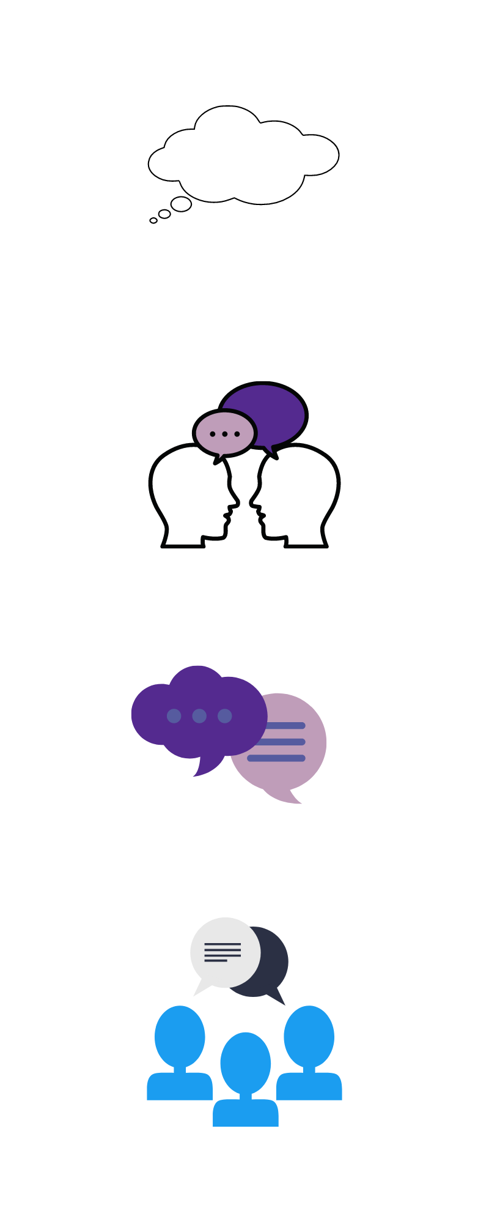             | - You should now ask us for the full Participant Information Leaflet. You can do this by:  emailing us on:  Nargas.begum3@nhs.net  or  Sarah.baillon@nhs.net  Writing to us at:  ADEPT-2 Study Team  Research and Development Office  Swithland House  352 London Road  Leicester  LE2 2PL  Calling or texting us on:  Nargas Begum – 07920102781  Sarah Baillon – 07341789207  Or visiting our website at www.bristol.ac.uk/adept or by scanning the QR code to the left.  - It is up to you if you want to take part in this study, or not. You can ask us any questions before deciding.  - If you want to, you can also talk to family, friends, carers, or your doctor about the study before deciding.  - Next, we would ask you to complete an Expression of Interest form. We will give this form to you. Or we will send you a link so you can complete it online  - Your GP would know if you took part in the study, and if you stopped taking part.  - You would get either GSH or UC  - You may need to complete up to 9 sessions, lasting 30-45 minutes, if you receive GSH  - The treatment can be stopped earlier if it does not suit you.  - If you have any problems during the study, you will be able to contact the study team directly.  - The information you provide to the research team will be treated as confidential unless you tell the research team or therapist that you or someone else is at risk of harm, or that you have or intend to commit a crime.  - If this happens, the research team will have to inform your GP and the relevant authority. We will discuss this with you first.  - We will send you forms with questions to answer after 16 weeks, 32 weeks and 52 weeks.  - You will get a £10 gift voucher for answering these questions.  - At the end of the study, you can discuss your future treatment with your GP.
What are the next steps?
- If you would like to take part, please complete the expression of interest form online or return this to us using the pre-paid envelope provided.

- If you are eligible to take part, the study team will be in touch to answer any questions you may have, record your consent and arrange your first study appointment.

Thank you for taking the time to read this information.
Please keep a copy for your records.


This study is funded by the National Institute of Health and Care Research (NIHR) HTA Programme (Ref 132343). The views expressed are those of the author(s) and not necessarily those of the NIHR or the Department of Health and Social Care.

