

ACUTE MEDICAL TREATMENT OF BEHAVIOURAL CRISIS

Rapid Tranquillisation Policy

The primary objective in the use of these guidelines is to bring to an end a period of highly disturbed behaviour in a patient resistive to intervention as quickly and as safely as possible

Key Words: | Rapid tranquillisation, aggression, behavioural disturbance
Version: | 3
Adopted by: | Trust Policy Committee
Date this version was adopted: | 2 November 2022
Name of Author: | Anthony Oxley
Name of responsible committee: | Medicines Management Group
Please state if there is a reason for not publishing on website | N/A
Date issued for publication: | November 2022
Review date: | April 2025
Expiry date: | 31st July 2026
Target audience: | All medical staff and qualified nursing staff who work in in-patient areas and day hospitals
Type of Policy | Clinical
Which relevant CQC Fundamental Standards? |  | 12

CONTRIBUTION LIST

Key individuals involved in developing the document

Name | Designation
Anthony Oxley | Head of Pharmacy
Robyn McAskill | Pharmacy Clinical Services Manager
Zeibun Patel | Lead Pharmacist - MH&LD Prescribing Group
Rachel Calton | Lead Pharmacist - Education & Training
Jonathan Dexter | Advanced Nurse Practitioner, CHS
Dr R Wong | Consultant in care for the Elderly
Michelle Churchard | Head of Nursing AMH/LD services
Rachael Shaw | Positive and Safe Lead
Dr T Hanley | Associate Specialist in Eating Disorders

Circulated to the following individuals for comments

Name | Designation
Medicines Management Committee
Quality Forum
Positive and Safe Seclusion Group

Contents

Contents 3
Version Control and Summary of Changes 4
Equality Statement 5
Due Regard 5
Definitions that apply to this policy 6
THE POLICY 7
1.0 Summary of the Policy 7
2.0 Introduction 7
3.0 Purpose 7
4.0 Legal 8
5.0 Duties within the Organisation 9
6.0 Training 10
7.0 Initial Measures 10
8.0 Drugs for Rapid tranquillisation 11
9.0 Adults 13
10.0 Older and Frail Adults 16
11.0 After Rapid Tranquillisation 17
12.0 Patients with Eating Disorders 17
13.0 Documentation 18
14.0 Guidelines for Rapid Control Of Acutely Disturbed Younger Patients 20
15.0 Monitoring Compliance and Effectiveness 21
16.0 Links to Standards/Performance Indicators 21
17.0 Distribution and Implementation 22
APPENDICES 23
Appendix 1: Recording Sheet for IM Rapid Tranquillisation 23
Appendix 2: Quick Reference Guide to Rapid Tranquillisation (QRG) 25
Appendix 3: Due Regard 26
Appendix 4: Policy Training Requirements 28
Appendix 5: The NHS Constitution 29
Appendix 6: Privacy Impact Assessment Screening 30

Version Control and Summary of Changes

Version  number | Date |  | Comments (description change and amendments)
1.1 | June | 2012 | Harmonisation of previous documents and update onto new proforma.
1.2 | September | 2012 | Amendments incorporated following comments received by Policy Group in august 2012.
1.3 | November | 2012 | Replacement of olanzapine IM with aripiprazole IM due to unavailability of olanzapine IM.
1.4 | March | 2013 | Replacement of diazepam IV with lorazepam IV.  Amendments incorporated to NHSLA Monitoring Section.
1.5 | March | 2014 | Amendments to monitoring section.
1.6 | September | 2017 | Harmonisation of previous documents and update onto new proforma.  Inclusion of ECG statement.  Update of tools used for recording of monitoring within the Trust.
1.7 | July 2018 |  | Review of policy with reference to NICE TA which recommends the use of promethazine with haloperidol following recommendation from CQC to consider this addition.
1.8 | November | 2019 | Review of RT monitoring sheet and update.  Highlighting drugs and doses so they are more prominent.  Incorporation of CAMHS RT policy into the document.  Addition of a paragraph for patients with Eating Disorders and their particular concerns.
2.0 | July 2021 |  | Addition of the use of IM Promethazine as a sole agent and not in combination with Haloperidol.  Documentation note added if RT policy not strictly adhered to.

All LPT Policies can be provided in large print or Braille formats, if requested, and an interpreting service is available to individuals of different nationalities who require them.

Did you print this document yourself?

Please be advised that the Trust discourages the retention of hard copies of policies and can only guarantee that the policy on the Trust website is the most up-to-date version.

For further information contact:

Head of Pharmacy
Pharmacy Department

Equality Statement

Leicestershire Partnership NHS Trust (LPT) aims to design and implement policy documents that meet the diverse needs of our service, population and workforce, ensuring that none are placed at a disadvantage over others.

It takes into account the provisions of the Equality Act 2010 and promotes equal opportunities for all.

This document has been assessed to ensure that no one receives less favourable treatment on the protected characteristics of their age, disability, sex (gender), gender reassignment, sexual orientation, marriage and civil partnership, race, religion or belief, pregnancy and maternity.

In carrying out its functions, LPT must have due regard to the different needs of different protected equality groups in their area.

This applies to all the activities for which LPT is responsible, including policy development and review.

Due Regard

LPT must have due regard to the aims of eliminating discrimination and promoting equality when policies are being developed. Information about due regard can be found on the equality page on e-source and/or by contacting the LPT Equalities Team.

The due regard assessment template is Appendix 3 of this document

Definitions that apply to this policy

Rapid tranquillisation | The use of injectable medication to control severe mental and behavioural disturbance, including aggression associated with mental illness
Psychoactive substance | A chemical substance that affects the processes of the mind
PRN dose | Medication prescribed for use on an “as required” basis
Stat dose | Medication prescribed as a one-off dose.
Neuroleptic naive | Person who has not previously been treated with an antipsychotic (neuroleptic).
Dystonia | A neurological movement disorder, presenting as sustained muscle contractions, twisting and repetitive movements or abnormal postures.
Extrapyramidal side effects (EPSE) | A group of symptoms that can occur in persons taking antipsychotic medications e.g., tremor, akathisia, slurred speech, dystonia, bradykinesia, muscular rigidity
Due Regard | Having due regard for advancing equality involves:  - Removing or minimising disadvantages suffered by people due to their protected characteristics.  - Taking steps to meet the needs of people from protected groups where these are different from the needs of other people.  - Encouraging people from protected groups to participate in public life or in other activities where their participation is disproportionately low.
NEWS | National Early Warning Scoring Tool
EPMA | Electronic Prescribing and Administration service
SystemOne | System for electronic recording of patient observations.

THE POLICY

1.0 Summary of the Policy

Set of guidelines to assist medical staff in dealing with inpatients requiring intervention to control severe mental and behavioural disturbance.

2.0 Introduction

Rapid tranquillisation (RT) is the administration of carefully monitored amounts of tranquillising drugs over brief intervals of time, to achieve rapid, short-term behavioural control of extreme agitation, aggression and potentially violent behaviour that places individuals or those around them at risk of physical harm or cause damage to property.

The aim of RT is to calm the person, and reduce the risk of violence and harm, rather than to treat the underlying psychiatric condition.

An optimal response would be a reduction in agitation or aggression without sedation, allowing the patient to participate in further assessment and treatment.

3.0 Purpose

Aggressive disturbed behaviour can occur as a consequence of mental disorder, most frequently as the result of a series of complex interactions between a mentally ill person's inner world and their surroundings.

Often, extreme agitation, aggression and potentially violent behaviour can be calmed down by de-escalation techniques deployed by skilled and trained staff. However, there are occasions when these methods fail and patients who cannot control their violent impulses need to be calmed down rapidly in order to ensure safety for all.

RT should be used only for calming a patient who is highly aroused, agitated, overactive, aggressive or making serious threats or gestures towards others or is being destructive to their surroundings, when other therapeutic interventions have failed to contain the behaviour.

Staff who use RT should be trained in the assessment and management of patients specifically in this context; this should include assessing and managing the risks of drugs (benzodiazepines and antipsychotics), using and maintaining the techniques and equipment needed for cardiopulmonary resuscitation, prescribing within therapeutic limits and using flumazenil (benzodiazepine antagonist).

On admission, staff should discuss with patients and, where appropriate, their carers, what may happen if they become disturbed or violent and provide them with the opportunity to express their needs and wishes in the likelihood of such an event.

Interpretation services are available for patients if required.

Nurses should administer medication only according to written prescriptions. Instruction by telephone (verbal orders) to administer a drug that has not been prescribed previously is not acceptable (Guidelines for the administration of medicines, Nursing and Midwifery Council 2004).

In managing disturbed behaviour, it is essential that nursing and medical staff should present a united and easy to understand format to the patient.

If there is disagreement among staff about whether or not to use RT, more senior staff i.e., line managers / senior medical staff must be consulted to clarify the management plan as quickly as possible.

4.0 Legal

Staff involved in RT should be mindful of and take account of the:

- relevant sections of the Mental Health Act 1983 and its Code of Practice

- the principles underlying the common law doctrine of ‘necessity’, and the
requirements of the relevant articles of the European Convention on Human Rights, including Article 2 (right to life)

- Article 3 (the right to be free from torture or inhuman or degrading treatment or
punishment)

- Article 5 (the right to liberty and security of person, save in prescribed cases)

and

- Article 8 (the right to respect for private and family life), and the principle of
‘proportionality’

- the Health and Safety at Work Act 1974, which place duties on both employers and
employees, and applies to the risk of violence from patients and the public

- the Management of Health and Safety at Work Regulations 1999, which place
specific duties on the employer to ensure suitable arrangements for the effective planning, organisation, control, maintenance and review of health and safety (these duties include ensuring that the risk assessments are undertaken and implemented).

- Mental Health Units (Use of Force) Act 2018 which defines “Chemical Restraint” as the use of medication that is intended to prevent, restrict, or subdue movement of any part of the patient’s body. This includes the use of rapid tranquillisation (see National Institute for Health and Care Excellence (NICE) guideline [NG10] Violence and aggression: short-term management in mental health, health and community settings)

It is also important to ensure that any developing situation or positive intervention takes into account the individual needs of patients related to:

- sensory impairment
- black and minority ethnic patients.
- patients with a physical impairment
- patients with a cognitive impairment
- gender assignment e.g. (are some members of staff who are restraining of the same
sex)
- patients with communication difficulties.
- Frail older patients

5.0 Duties within the Organisation

Prescriber

- To ensure patient’s prescription includes details of what medication to use for RT, in
what dose range, and with what frequency

- Minimum time between doses and the maximum dose to be administered in a
specified period must be stated

- Consider medication already prescribed

- To complete the Rapid Tranquillisation Recording Sheet - Appendix 1

Nurse in charge (of unit at time of RT)

To ensure:

- the RT is indicated, having exhausted other strategies to calm the patient
- the prescription is followed
- the patient has the appropriate physical observations completed
- written records are maintained - use SystemOne
- to complete the Review of Rapid Tranquillisation - Appendix 1

Pharmacists

to ensure prescriptions are checked for potential adverse interactions

Clinicians

To:

- ensure the prescription for oral medication is followed
- undertake appropriate physical observations
- maintain written records - Brigid & SystemOne

Ward Sister/Charge Nurse:
- To check after incidents of RT that follow-up is completed by nursing staff.
To complete AMAT tool following incidents of RT to ensure that there is consistent governance.
- Ensure that any incident of RT during the evening/night shift is reported to the morning staff and vice versa.

6.0 Training

There is a need for training identified within this policy. In accordance with the classification of training outlined in the Trust Learning and Development Strategy, this training has been identified as Role Essential Training.

It is delivered via eLearning at least every 3 years. A record of the event will be recorded on uLearn.

Compliance is monitored in accordance with the Trust’s Mandatory Training Policy. The governance group responsible for monitoring the training is the Medicines Management Committee.

7.0 Initial Measures

7.1 Safety

The first step is to ensure safety of the patient, staff and others on the ward. This may involve:

- Making sure that enough staff members are available
- Considering the patient’s preferences
- Considering history of adverse reactions to medication
- Considering what worked in the past
- Removing the patient to a low stimulus environment
- Ensuring availability and easy accessibility of resuscitation equipment. e.g., pulse
oximeter and drugs, including flumazenil
- Physical restraint

7.2 Assessment

Assess the situation within the multidisciplinary team.

Consider the likely diagnoses, physical illnesses, general physical state

e.g.:

- pregnancy
- exhaustion
- dehydration
- recent test results

and current psychiatric and non-psychiatric medication, and alcohol and substance misuse.

A basic physical examination should be done. If this is not possible at the time, the reason should be documented, and the physical examination done as soon as possible afterwards.

Use caution in patients who are already sedated or using alcohol or illicit drugs. Consider the patient’s regular oral and depot medication, as they affect the dose requirements and side effects of the RT medication.

7.3 Pregnant Patients

Special Care must be taken when administering RT to a female patient during any stage of pregnancy. Additional medical advice may be required due to the possible additional complications that may arise. This situation may well require quite complex discussions with relatives / carers.

7.4 Elderly and Frail patients

In elderly patients consider:

- Dementia
- physical frailty
- delirium

Look for causes of confusion.

7.5 Non-pharmacological measures
Always use behavioural approaches and de-escalation techniques, e.g., talking down, distraction, interventions that are outlined within their collaborative care plan or Positive Behaviour Support plan etc. Even when they do not prevent the need for RT, they will help preserve the therapeutic relationship and improve safety.
Before administering any medication, inform the patient that medication needs to be given and that they will have the opportunity to take the medication orally.

8.0 Drugs for Rapid tranquillisation

Try ORAL therapy

If refused, or the behavioural crisis escalates, begin to follow these guidelines when you have established:

- How to quickly contact a consultant / senior colleague
- The availability of mechanical ventilation / cardiac resuscitation equipment

ALWAYS discuss with a consultant / senior colleague if there is ANYTHING you are unhappy or uncertain about.

Remember that there is always on-call pharmacist support.

After RT, monitor:

- side effects
- the service user's pulse
- blood pressure
- respiratory rate
- temperature
- level of hydration
- and level of consciousness

at least every hour until there are no further concerns about their physical health status.

Monitor every 15 minutes if the BNF maximum dose has been exceeded or the service user:

- appears to be asleep or sedated
- has taken illicit drugs or alcohol
- has a pre-existing physical health problem
- has experienced any harm as a result of any restrictive intervention
Planned recording of vital signs may be compromised by the clinical state of the patient.

The recording of these signs should be in the Trust approved monitoring tool: Brigid/System1

If monitoring is not possible, enter:

- Date
- Time
- “Patient uncooperative to monitoring”
- Patient’s conscious level and respiration rate as minimum.

onto the Trust approved monitoring tool; Brigid/System 1

Refer to any advance directives that explain the patient’s preference for medication, if clinically appropriate.

RT is used to reduce markedly aggressive or over-aroused behaviour and agitation, rather than to sedate the individual. However, if the patient’s behaviour is very disturbed, it may become necessary to sedate a patient for safety reasons.

Antipsychotic drugs are used in RT for their calming and sedative effects. Their antipsychotic effect usually takes two weeks.

Benzodiazepines reduce arousal and cause sedation at higher doses. They have no antipsychotic effects.

Oral and IM prescriptions should be prescribed separately on EPMA chart.

IV and IM doses generally have 2 - 5 times higher potency than oral doses.

The ward team need to be clear about the level of nursing observations required and plan staffing accordingly.

9.0 Adults

Lorazepam / Haloperidol and/or Promethazine

Administer Lorazepam 1 - 2 mg IM
OR
the combination of Haloperidol 5 mg IM with or without Promethazine 50 mg IM
OR
Promethazine 50 mg IM
All IM injections should be administered separately not mixed.
Use Lorazepam monotherapy if:

- There is little information available to guide choice of agents
- There is a history of cardiovascular disease
- An ECG shows prolonged QTc interval
- Or if there is no ECG

Please note that the SPC for Haloperidol requires a CURRENT ECG prior to treatment with this drug.

- Dose adjustments should be considered for younger and older patients or those with special requirements (see 10.0)

- If there is a partial response to Haloperidol that has been administered, consider a further dose after 1 hour up to a maximum dose of:

20 mg/24hours.

- If Promethazine has been used in conjunction with haloperidol this may also be repeated after 1 - 2 hours up to a maximum of:

100 mg/24 hours.

- If there is a partial response to Lorazepam that has been administered, consider a further dose after 2 hours up to a maximum of:

4 mg/24 hours.

- If there has been no response to the medication that has been administered, use the alternate regime (i.e., Lorazepam or haloperidol depending on which was used first) unless contraindicated.

Aripiprazole

If alternate regimes are contraindicated, consider IM Aripiprazole:

standard dose | mg | ml
healthy working age adults | 9.75 | 1.3
elderly adults | 5.25 | 0.7

With a 24-hour maximum dosage, via all routes, of

- 30 mg

A maximum of 3 injections can be given within a 24-hour period.

Following administration of IM injection, a further injection can be given 2 hours later if there is no response.

Aripiprazole IM may be used in combination with Lorazepam IM if clinically appropriate.

See Quick Reference Guide (QRG) to RT - Appendix 2

Notes:

Consider giving IM or IV Procyclidine prophylactically with Haloperidol but remember that this may cause or worsen any confusion present.

9.1 If there IS a response to RT medication administered

There is a high likelihood of recurrence of the crisis, unless treatment is instituted for the underlying disorder causing the behavioural emergency.

Therefore, consider the following:

- Commence / re-commence oral antipsychotics.

- Give Zuclopenthixol acetate (Clopixol Acuphase)

50 - 150 mg IM

to minimize likelihood of repeat injections.

- Clopixol Acuphase should NOT be used for RT.

It should only be considered if a patient responds to other short acting parenteral antipsychotics, and it is anticipated that they will require further frequent doses of IM typical antipsychotics.

It is best reserved for people who have had a previous good response to Acuphase.
It should not be given to:

- antipsychotic naïve patients
- elderly patients
- physically struggling patients.

- Clopixol Acuphase should be given only after assessing the response to previously injected drugs:

i.e., 30 - 60 minutes after IM injections:

- Give 50 -150 mg IM and reassess after 24 hours

- Give up to a maximum of 400 mg in 3 days

- Assess patient for dystonia and other extrapyramidal side effects. Continue to monitor vital signs as above. Pulse oximeter should be available and should be used where appropriate.

Acute reversal of benzodiazepine induced unconsciousness requires the use of Flumazenil:

The initial dose is:

- 200 micrograms IV over 15 seconds.

A further dose of

- 100 micrograms

Can be given after 60 seconds where necessary

and repeated up to a total dose of 1 mg.
Flumazenil must be administered by a doctor or suitably qualified person.
If no doctor is available and there is concern for the patient’s safety: please call the crash team on 2222, or where this is not available, call 9999.

9.2 If there is NO response to RT medication administered

If there is a partial response to the medication that has been administered, consider a further dose.

If there has been no response to the medication that has been administered, use the alternate regime, (Lorazepam or haloperidol depending on which was used first), unless contraindicated.

Other medications may occasionally be used if a response from the above cannot be obtained, but only following discussion with a consultant psychiatrist.

10.0 Older and Frail Adults

When the patient refuses oral medication

Lorazepam 0.5 - 2.0 mg IM

OR

The combination of

Haloperidol 2.5 mg IM with or without Promethazine 25.0 mg IM

OR

Promethazine 25.0 mg IM

Please note that the SPC for Haloperidol requires a CURRENT ECG prior to treatment with this drug.

If there is a partial response to HALOPERIDOL that has been administered, consider a further dose after 2 hours up to a maximum dose of:

- 5 mg/24 hours

If PROMETHAZINE has been used alone or in conjunction with haloperidol this may also be repeated after 1-2 hours up to a maximum of

- 50 mg/24 hours

If there is a partial response to LORAZEPAM that has been administered, consider a further dose after 2 hours up to a maximum of:

- 2 mg/24 hours.

If the diagnosis is uncertain or if haloperidol is not indicated
(I.e., there is evidence of Parkinson’s disease and/or Lewy Body Dementia)

give:

Aripiprazole 5.25 mg (0.7 ml) IM

- Give a maximum of 15 mg of Aripiprazole IM in 24 hours.

- Consider giving IV or IM Procyclidine prophylactically with Haloperidol but remember that this may cause or worsen any confusion present.

- If patient presents with Delirium, seek medical advice.

- Clopixol Acuphase is NOT recommended for older people

See Quick Reference Guide (QRG) to rapid tranquillisation - Appendix 2

11.0 After Rapid Tranquillisation

After Rapid Tranquillisation, monitor:

- side effects
- the service user's pulse,
- blood pressure,
- respiratory rate,
- temperature,
- level of hydration
- and level of consciousness

at least every hour until there are no further concerns about their physical health status.

Monitor every 15 minutes if the BNF maximum dose has been exceeded or the service user:

- appears to be asleep or sedated
- has taken illicit drugs or alcohol
- has a pre-existing physical health problem
- has experienced any harm as a result of any restrictive intervention

If the patient is asleep or unconscious, it is important to continue monitoring. In addition, monitor oxygen saturation by pulse oximeter. In case of a patient who is unconscious 1:1 observation by competent staff is required.

Consider a fluid chart if their fluid intake is poor, or if the patient appears dehydrated consider a medical review.

Staff will need to check the patients’ colour and responsiveness at regular intervals, as both these areas could indicate that the patients’ physical health is deteriorating as per section 7

12.0 Patients with Eating Disorders

Anorexia nervosa involves starvation and intense weight loss which not only denies the body of essential nutrients but forces the body to physiologically slow down to conserve energy.

In the early stages of treatment when patients are acutely starved and low in weight, cardiovascular symptoms and objective measures of cardiac impairment are not unusual. Patients can exhibit abnormally slow heart rate (bradycardia) and low blood pressure (the latter often the result of a combination of bradycardia, poor muscle bulk, electrolyte disturbance (impairing contractility) and dehydration.

These factors can individually or in combination contribute to an increased risk of heart failure.

Electrolyte disturbance commonly related to purging behaviours, including self-induced vomiting and laxative misuse can increase the hearts irritability and proneness to arrhythmia.

The literature contains several cases of anorexia nervosa with prolonged QTc interval although it is not clear what risk this presents to patients as a consequence. It is also worth considering issues connected to re-feeding syndrome in particular the possibility of low serum phosphate which can contribute to cardiac failure through reduced muscle contractility.

Incidentally, mitral valve prolapse due to poor muscle bulk (reversible on weight restoration) and pericardial effusion can also be detected more often with echocardiogram than through clinical examination. These last two findings do not necessarily present with clinical symptoms or significant impairment. Clearly consideration needs to be given to medications prescribed in this patient group that may have prolonged QTc interval.

Psychiatric comorbidity is common in patients with anorexia nervosa and thus by extension, so is psychotropic prescribing.
Taking all of this into consideration it seems prudent to consider this group of patients as frail and having a heightened risk of adverse consequences from medications prescribed acutely in the context of RT. A sensible approach might be to start with lower doses and titrate further doses in response to clinical need and close reassessment of the patient especially cardiovascular status.

13.0 Documentation

Documentation would include:
- Completion of an incident form as per the Incident Reporting Policy

- The legal basis of administering RT on the recording sheet. (e.g., Indication, capacity to consent, consented or not)

- Doses of drug/s used. (Whether above BNF or NICE recommended doses)

- Use of de-escalating techniques on the recording sheet

- Physical parameters as above on Brigid/System1

- Reasons why observations could not be performed (if applicable) on Brigid

- Reasons for use of alternative medications in the case records

- If this policy is not strictly adhered to in terms of doses of medication used or any other factor, then the reasoning behind this decision must be clearly documented in the appropriate place in the patient’s electronic profile.

If staff are unable to take observations due to mental state of the patient and risk to staff, this should be clearly noted in the current progress notes.

Other interventions

Provide explanation, advice, reassurance and support to the patient, their carers and any other persons who may have witnessed the incident.

Transfer the patient for nursing in a Low Stimulus Environment or side room.

Whenever possible establish the patient on regular medication with clear instructions regarding regular review.

If in any doubt, a senior member of staff should be consulted. For doctors this means the Consultant, or the senior doctor on call. For nurses this means the duty manager.

14.0 Guidelines for Rapid Control Of Acutely Disturbed Younger Patients
Aged 12-18 years - in inpatient setting
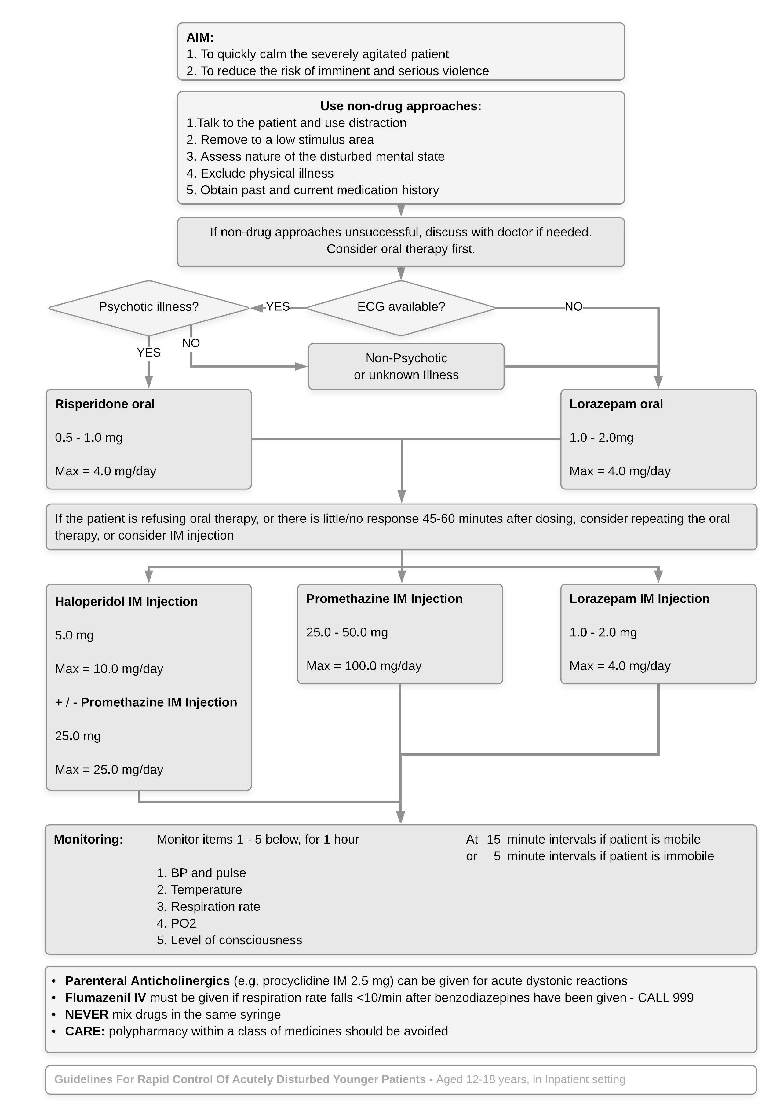

15.0 Monitoring Compliance and Effectiveness

The requirements of this policy with regard to training of staff, will be audited at least biannually.

The requirements of this policy with regard to medicines administered, and monitoring of service users after rapid tranquillisation, will be audited through an ongoing programme of ward level monitoring overseen by the Medicines Management Committee. This requirement will be incorporated into the Trust’s clinical audit plan.

Ref | Minimum Requirements | Evidence for Self-assessment | Process for Monitoring | Responsible Individual /  Group | Frequency of monitoring
 | Training | ESR employee records | Check on ESR if training completed within the time frame required. | Managers | Every 3 years
 | Medicines administered | EPMA records | Audit biannually | Medicines Management Committee / Medicines Audit Group | Ongoing monitoring
 | Monitoring of service users after rapid tranquillisation | Patient records | Audit | Medicines Management Committee / Medicines Audit Group | Ongoing monitoring

16.0 Links to Standards/Performance Indicators

A description of how the procedural document links to Care Quality Commission (CQC) Regulations (e.g., Regulation number and domain) or other standards/performance indicators should be included (e.g., NHS Improvement notices, NICE guidance).

Target/standards | Activity | Key performance indicator
Regulation 12 - Safe Care and Treatment  12(1) Providers should consult nationally recognised guidance about delivering safe care and treatment and implement this as appropriate. | When short acting IM medication* is administered to patients to control severe mental and behavioural disturbance, including aggression associated with mental illness  *Lorazepam, Promethazine, Haloperidol, or Aripiprazole. | Short acting IM medication* is administered to patients in accordance with this policy, which was developed with reference to NICE NG10 and QS154  Evidenced by Version Control, page 4 and References, page 20
Short acting IM medication* is administered to patients in accordance with the Mental Health Act 1983.

Evidenced by Section papers, form 62 or T3 documentation in patients notes.
Regulation 12 - Safe Care and Treatment  12(2)(b) doing all that is reasonably practicable to mitigate any such risks; The provider must have arrangements to take appropriate action if there is a clinical or medical emergency |  | Short acting IM medication* is administered to patients in a ward environment that has suitable resuscitation equipment.  Evidenced by checking which ward patient was on at time of administration and cross referencing this with resuscitation equipment checks.

17.0 Distribution and Implementation

This document will be widely circulated within the Trust including all Directors, Senior Managers and Policy Leads and will be made available on the Trust’s Intranet and Internet sites. Relevant changes will be brought to the attention of staff during circulation.
Comprehensive education and training programmes exist including induction, mandatory training and modules as detailed in the Trust’s education and training brochure. Specialist education will also be targeted at those with responsibility for managing the risk.

18.0 References and Associated Documentation
This policy was drafted with reference to the following:

British National Formulary (BNF)

Summary of Product Characteristics (SPC) of all medicines included. Available at: medicines.org.uk

NICE NG10 - Violence and aggression: short-term management in mental health, health and community settings. Published: 28 May 2015

NICE Quality Standard QS154 - Violent and aggressive behaviours in people with mental health problems. Published 29 June 2017

Leicestershire Partnership Trust, Violence Prevention and Reduction Policy

APPENDICES

Appendix 1: Recording Sheet for IM Rapid Tranquillisation


Recording Sheet for
Patient Label
[Write full name until label can be sought]

IM Rapid Tranquillisation
All parts must be completed

Ward |  | MHA status
Date |  | Time of injection
Capacity to consent? |  | Consent to treatment in place?
Staff administering injection: [Print names]
Medication  administered |  | Dose

A Nurse will ensure that the following duties are carried out |  |  |  | Time done
Allocate staff for observations duties
Contact Ward/Duty Doctor to review patient
Inform Doctor on arrival of if there are any concerns re:
• Medical conditions • Prolonged restraint • Patient has used illicit drugs/alcohol
Document in electronic patient record that: | - Patient has been given RT  - Their response to the medication  - Their capacity related to this  - Any concerns from observations taken after RT
If RT already identified as an intervention in patient’s Care Plan, evaluate the care plan with its use
Update the patient’s Care Plan/Risk Assessment with the use of RT as an intervention if not already identified as one
Diarise post RT incident review for the following day
Complete an Electronic Incident Reporting Form - eIRF
Allocated Staff to document:
All required physical observations  by completing NEWS2 form on SystemOne |  |  | Side-effects & Level of hydration  in patient’s electronic patient record
To be done at least hourly, until there are no further concerns about patient’s physical health status
Or every 15 minutes if the BNF maximum dose has been exceeded, or if the patient:
- appears to be asleep or sedated  - has taken illicit drugs or alcohol |  | - has a pre-existing physical health problem  - has experienced any harm as a result of any restrictive intervention

If a patient refuses to have their vital signs measured: Allocated Staff to document in electronic patient record every 15 minutes as a minimum: • AVPU and • Respiratory rate
A = Alert/Awake | V = responds to Verbal stimuli | P = responds to Pain/Pressure stimuli | U = Unresponsive

Allocated Staff  [Print names] | Hr.1 | Hr.5 | Hr.9
Allocated Staff  [Print names] | Hr.2 | Hr.6 | Hr.10
Allocated Staff  [Print names] | Hr.3 | Hr.7 | Hr.11
Allocated Staff  [Print names] | Hr.4 | Hr.8 | Hr.12

Post rapid tranquillisation
Patient Label
[Write full name until label can be sought]
review for patients

What happened in the incident?
How do you feel about the incident
In your mind, what led to the incident?
What other coping strategies/distraction/calm down methods/activities could we have helped you engage in to prevent this in future?
How do you feel about the way staff involved you during the incident?
Is there anything else they could have done differently?

Care plan reviewed? | Yes ☐ | No ☐ | If not completed, please explain why:
Risk Assessment updated? | Yes ☐ | No ☐ | If not completed, please explain why:
Date |  |  |  | Patient signature
Staff name |  |  |  | Staff signature

Charge Nurse/Sister Review |  | Date:
Name
Signature

Appendix 2: Quick Reference Guide to Rapid Tranquillisation (QRG)

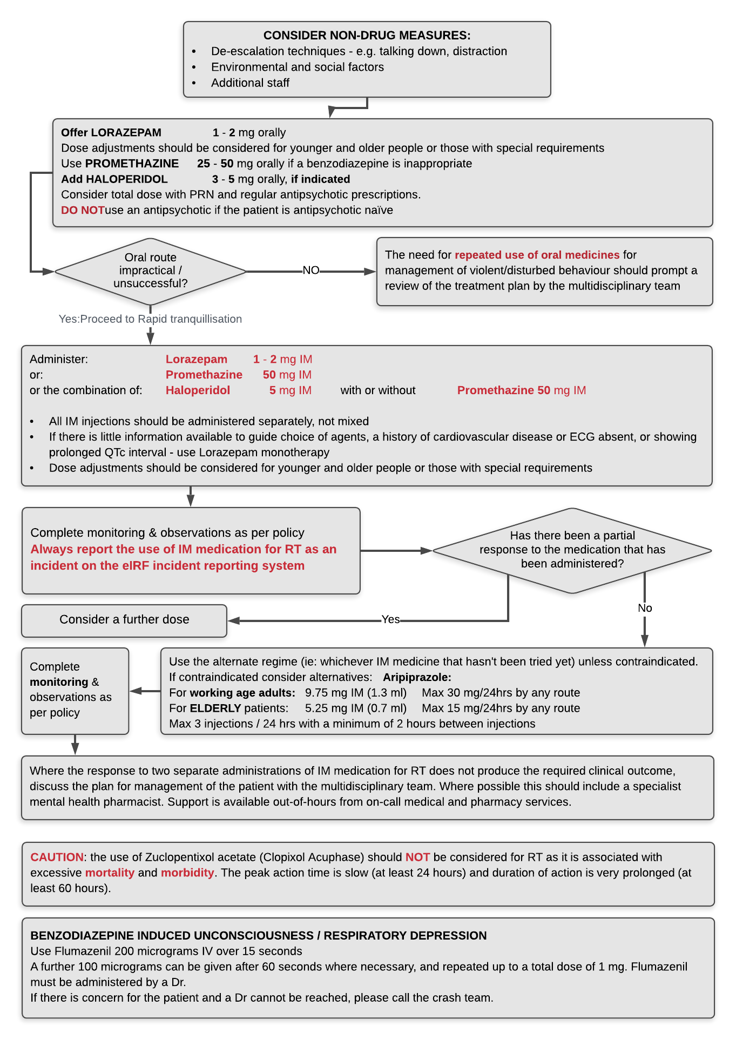

Appendix 3: Due Regard

*A full Due Regard (Equality Analysis) makes sure that any negative impacts have been considered and ways to minimize the impact are specified.

Due Regard Screening Template
Section 1
Name of activity/proposal |  |  | RAPID TRANQUILLISATION Policy
Date Screening commenced |  |  | March 2014
Directorate / Service carrying out the  assessment |  |  | Pharmacy Dept.
Name and role of person undertaking this Due Regard (Equality Analysis) |  |  | Z Patel
Give an overview of the aims, objectives and purpose of the proposal:
AIMS: | This policy describes the appropriate use of RT injectable medication to control severe mental and behavioural disturbance, including aggression associated with mental illness.
OBJECTIVES: | The primary objective in the use of these guidelines is to bring to an end a period of highly disturbed behaviour in a patient resistive to intervention as quickly and as safely as possible.
PURPOSE: | The purpose of RT is to calm the person, and reduce the risk of violence and harm, rather than to treat the underlying psychiatric condition. An optimal response would be a reduction in agitation or aggression without sedation, allowing the patient to participate in further assessment and treatment.
Section 2
Protected Characteristic |  | Could the proposal  have a positive impact  Yes or No (give details) |  | Could the proposal  have a negative impact  Yes or No (give details)
Age |  | Yes - Prevents injury to individual and other service users, including carers/members of staff present, by controlling a period of highly disturbed behaviour.  Measures in place throughout this policy ensure that treatment is person centred, with due regard for protected characteristics, (see section 4, legal; section 7, Assessment; section 10, older and frail adults and section 14, younger patients). |  | Yes - A loss of control by individual or negative views of RT. This might in part be mitigated by use of behavioural approaches and de-escalation techniques, e.g., talking down, distraction, time out etc. Even when they do not prevent the need for RT, such actions will help preserve the therapeutic relationship and improve safety.  Before administering any medication, the patient is informed that medication needs to be given and there is the opportunity to take the medication orally.
Disability
Gender reassignment
Marriage & Civil Partnership
Pregnancy & Maternity
Race
Religion and Belief
Sex
Sexual Orientation
Other equality groups?

Section 3
Does this activity propose major changes in terms of scale or significance for LPT? For example, is there a clear indication that, although the proposal is minor it is likely to have a major affect for people from an equality group/s? Please tick appropriate box below.
Yes |  | No ✓
High risk: Complete a full EIA starting click here to proceed to Part B |  | Low risk: Go to Section 4. | ☒

Section 4
It this proposal is low risk please give evidence or justification for how you
reached this decision:
The requirement for consideration of use of RT medication pertains to a widespread group of individuals (any protected characteristic) and is a means of preventing further injury. It is undertaken in line with policy in order to ensure that actions are proportionate, within agreed parameters, ensuring dignity and respect is maintained and well documented.

Sign off that this proposal is low risk and does not require a full Equality Analysis:

Head of Service Signed: 

Date: 11/08/2021

Lead Pharmacist Signed: 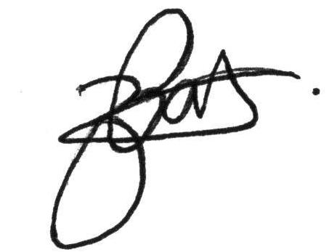

Date: 11/08/2021

Appendix 4: Policy Training Requirements

The purpose of this template is to provide assurance that any training implications have been considered

Training topic:
Type of training: | ☒ Mandatory (must be on mandatory training register)  ☒ Role specific  ☐ Personal development
Division(s) to which the training is applicable: | ☒ Adult Learning Disability Services  ☒ Adult Mental Health Services  ☒ Community Health Services  ☐ Enabling Services  ☐ Families Young People Children  ☐ Hosted Services
Staff groups who require the training: | Please specify…
Update requirement:
Who is responsible for delivery of this training?
Have resources been identified?
Has a training plan been agreed?
Where will completion of this training be recorded? | ☒ Trust learning management system  ☐ Other (please specify)
How is this training going to be monitored?

Appendix 5: The NHS Constitution
NHS Core Principles – Checklist
Please tick below those principles that apply to this policy
The NHS will provide a universal service for all based on clinical need, not ability to pay. The NHS will provide a comprehensive range of services

Shape its services around the needs and preferences of individual patients, their families and their carers | ☒
Respond to different needs of different sectors of the population | ☒
Work continuously to improve quality services and to minimise errors | ☒
Support and value its staff | ☒
Work together with others to ensure a seamless service for patients | ☐
Help keep people healthy and work to reduce health inequalities | ☐
Respect the confidentiality of individual patients and provide open access to information about services, treatment and performance | ☒

Appendix 6: Privacy Impact Assessment Screening

Privacy impact assessment (PIAs) are a tool which can help organisations identify the most effective way to comply with their data protection obligations and meet individual’s expectations of privacy. The first step in the PIA process is identifying the need for an assessment.

The following screening questions will help decide whether a PIA is necessary.
Answering ‘yes’ to any of these questions is an indication that a PIA would be a useful exercise and requires senior management support, at this stage the Head of Data Privacy must be involved.
Name of Document: | Rapid Tranquillisation Policy
Completed by: | Zeibun Patel
Job title: | Lead Pharmacist |  | Date | 03/04/2018
 |  |  |  |  | Yes / No
1. Will the process described in the document involve the collection of new information about individuals? This is information in excess of what is required to carry out the process described within the document. |  |  |  |  | No
2. Will the process described in the document compel individuals to provide information about themselves? This is information in excess of what is required to carry out the process described within the document. |  |  |  |  | No
3. Will information about individuals be disclosed to organisations or people who have not previously had routine access to the information as part of the process described in this document? |  |  |  |  | No
4. Are you using information about individuals for a purpose it is not currently used for, or in a way it is not currently used? |  |  |  |  | No
5. Does the process outlined in this document involve the use of new technology which might be perceived as being privacy intrusive? For example, the use of biometrics. |  |  |  |  | No
6. Will the process outlined in this document result in decisions being made or action taken against individuals in ways which can have a significant impact on them? |  |  |  |  | No
7. As part of the process outlined in this document, is the information about individuals of a kind particularly likely to raise privacy concerns or expectations? For examples, health records, criminal records or other information that people would consider to be particularly private. |  |  |  |  | No
8. Will the process require you to contact individuals in ways which they may find intrusive? |  |  |  |  | No
If the answer to any of these questions is ‘Yes’ please contact the Head of Data Privacy Tel: 0116 2950997 Mobile: 07825 947786
Lpt-dataprivacy@leicspart.secure.nhs.uk
In this case, ratification of a procedural document will not take place until approved by
the Head of Data Privacy.
IG Manager approval name:
Date of approval
Acknowledgement: Princess Alexandra Hospital NHS Trust

