Leicestershire Partnership NHS Trust: Gender Pay Gap Report 2021/22
October 2022

Background to the gender pay gap analyses

The Gender Pay Gap Regulations introduced an annual requirement for public authorities and private organisations with 250 or more employees to publish information relating to the difference between the pay of female and male employees.

Employees include bank staff and substantive staff, but not agency workers.

A “relevant employee” is a person who is employed on the snapshot date (31st March 2022). This is our total workforce. The bonus pay gap is calculated for all relevant employees (section 4).

A “full-pay relevant employee” is a relevant employee who is not, during the relevant pay period (March 2022), being paid at a reduced rate as a result of being on leave. The hourly pay gap is calculated for full-pay relevant employees only (section 2).

The Gender Pay Gap comprises:

- the difference between the hourly rates of pay of male and female full-pay relevant employees (mean and median);

- and the proportions of male and female full-pay relevant employees in the lower, lower-middle, upper-middle and upper quartile pay bands.

- the difference between the bonuses paid to male and female relevant employees (mean and median);

- and the proportions of male and female relevant employees who were paid bonus pay;

The gender pay gap is not the same as the issue of equal pay. Men and women in the same employment performing equal work must receive equal pay. The gender pay gap looks at the difference between what men and women each earn on average, and reflects the fact that there is inequality between the sexes in job roles and pay bands which leaves women earning, on average, less than men.

What has been included in the calculations?

The Electronic Staff Record (ESR) reporting system for the Gender Pay Gap includes various pay elements in its calculation by default. Additional pay elements can be added for locally agreed pay arrangements.

“Hourly pay” includes, by default, payments related to ordinary pay: basic pay, allowances (e.g. recruitment and retention premia), pay for leave, WTD payments, shift premium pay (e.g. enhancements, on call payments), and bonus payments made in the reference period. Hourly pay is calculated after deductions for salary sacrifice schemes, where applicable. Overtime, pay in lieu of notice, pay in lieu of annual leave and arrears are excluded. Hourly pay is calculated before tax, NI and pension deductions. Where an employee has more than one assignment, their pay and hours will be totalled from all assignments and divided together. Only those who are at work or on leave with full pay are included in the calculation for hourly pay; those on reduced pay or nil pay as a result of being on leave are excluded.

The following locally agreed payments have also been included in the ordinary hourly pay calculations: LeDeR payments and Ad Hoc Directors’ allowances (ongoing allowances for extra duties must be included); Covid-19 incentive payments for Bank staff (as ongoing recruitment and retention premia must be included), and percentage payments for working on call.

“Bonus pay” is defined as: payment related to profit-sharing, productivity, performance, incentive, commission, or long service awards with a monetary value (cash, vouchers, or securities). At LPT bonus pay includes Clinical Excellence Awards only.

Note on statistics:

- “Mean” is the average value, calculated by adding up all values and dividing by the number of values. Where there are one or two very small or very large values, this will skew the value of the mean.
- “Median” is the middle value of a data set when all values are ordered smallest to largest. It is less affected by very small or very large values skewing the average.

Both mean and median can be useful to explain differences between men’s and women’s pay.

Section 1 – Workforce Overview | Page 6
Section 2 – Hourly Pay Gap | Page 8
Section 3 – Part-time Working | Page 11
Section 4 – Bonus Pay Gap | Page 13
Section 5 – Benchmarking | Page 16
Section 6 – Next Steps | Page 17

Section 1: Workforce Overview

1.1 Leicestershire Partnership NHS Trust’s workforce at March 2022

Leicestershire Partnership NHS Trust (LPT) provides mental health, learning disability, and community health services to the population of Leicester, Leicestershire, and Rutland (population estimate at March 2021: 1,121,800, based on Census 2021 data).

LPT’s workforce at the end of March 2022:

- 7374 relevant employees:

  - 81.9% female, 18.1% male
- of which 6153 were full-pay relevant employees:
  - 81.9% female, 18.1% male

Women are over-represented in all aspects of the workforce, however the proportionality of this is skewed within each role. Men are disproportionately over-represented in Medical roles in comparison to the overall workforce, while women are disproportionately over-represented in Nursing and Allied Health Professional roles in comparison to the overall workforce.

1.2 Gender Pay Gap Myths

Myth: there can’t be a gender pay gap because that is illegal.

Reality: it is illegal to pay men and women different amounts for doing the same work, but the gender pay gap looks at how much men and women each earn on average, across all roles. There are more women than men in some professions, and more men than women in others. This contributes to the gender pay gap.

Myth: There’s only a gender pay gap because women are more likely to take parental leave and work part-time than men.

Reality: The GPG is based on hourly pay, so it makes no difference how many hours people work each week. Also, maternity leave doesn’t impact incremental progression. However, it is likely that working part-time and taking time out to care for children will impact women’s chances of career progression, which would certainly have an impact on the gender pay gap.

Myth: Women are more likely to participate in salary sacrifice schemes, which reduces their pay.

Reality: At LPT in March 2022, 74.7% of full-pay relevant employees participating in salary sacrifice schemes were women, and their deductions made up 71.6% of all salary sacrifice payments. 25.3% of full-pay relevant employees participating in salary sacrifice schemes were men, and their deductions made up 28.4% of all salary sacrifice deductions. As men make up only 18.1% of the workforce, figures show they are more likely than women to participate in such schemes, when compared to the workforce overall.

Section 2: Hourly Pay Gap

2.1 Gender Pay Gap in mean and median hourly pay

At March 2022, there was a Gender Pay Gap in favour of men in terms of ordinary hourly pay:

- mean hourly pay gap: +12.9%
- median hourly pay gap: +4.2%

The gender pay gap in terms of mean hourly pay was larger than the pay gap in terms of median hourly pay. Mean pay for men was skewed upwards due to over-representation in medical roles (46.5% of Medics were male compared to 18.1% of all full-pay relevant employees in the Trust). Medics were the highest paid staff group. When Medics were excluded from the calculations, the mean and median gender pay gaps came down to +4.3% and +0.5% respectively (in favour of men).

2.2 Proportions of men and women within each pay quartile

At March 2022:

- women comprised 81.9% of the 6153 full-pay relevant employees;
- women were underrepresented in the upper pay quartile, making up only 75.4%;
- women were proportionately represented in the upper-middle, lower-middle, and lower pay quartiles.

2.3 Breakdown by Staff Group

Gender Pay Gaps in different sections of the workforce at March 2022:

- mean hourly pay gap:

- non-clinical staff +16.0%
- clinical staff (not medics) +0.6%
- medics +10.4%
- median hourly pay gap:

- non-clinical staff +15.3%
- clinical staff (not medics) -2.0%
- medics +8.3%

Positive values indicate male pay is higher, negative values indicate female pay is higher.

Mean and median gender pay gaps were highest amongst administrative and clerical staff in favour of men. Meanwhile, the differences in mean and median hourly pay for men and women were much smaller in the clinical workforce, particularly outside of medicine.

Section 3: Part-Time Working

3.1 Overview

The NHS’s Agenda for Change pay bands apply to all staff except very senior managers (VSM) and medics. Jobs are banded based on responsibility and expertise required.

Part-time working does not directly cause the gender pay gap because this is based on hourly rates of pay. However, part-time working is relevant to the pay gap because it may cause perceived or genuine barriers to career progression, if part-time working is not available across different pay bands and professions.

The availability of flexible working, including part-time hours, is likely to influence people’s decision to apply for promotions and progress their careers.

3.2 Proportions of Part-Time Working by Gender and Pay Band

40.6% of full-pay relevant employees worked part-time, with 43.9% of women working part-time compared to 25.6% of men.

- 3656 full time employees:
  - 77.3% female, 22.7% male
- 2497 part time employees:
  - 88.5% female, 11.5% male

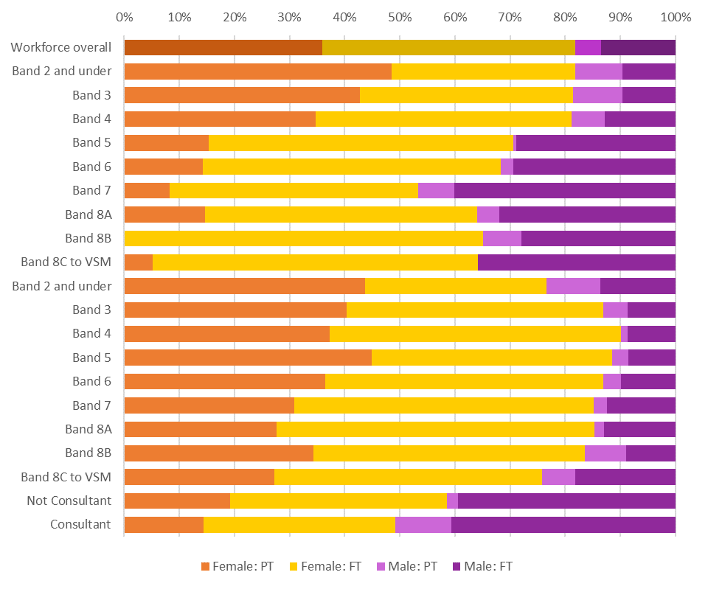
Medical
Clinical
Non-Clinical
Part-time working is more common at lower bands, although this trend is less stark in clinical roles. Women are more likely to work part-time than men across all bands.

In non-clinical roles up to Band 4, part-time working is common for both women and men. This decreases as the bands increase, with fewer people (especially men) working part-time. In the clinical workforce, part-time working is more common at all bands, but women are still more likely to work part-time than men. For medics, very few men work part-time, and again this is more common for women regardless of grade.

3.3 Why is women’s hourly pay less than men’s?

- Women are more likely to work in lower bands than men.
- Men are more likely to work as Consultants, the highest paid professional group.
- Women are more likely to work part-time than men. While part-time working does not in itself affect hourly pay, it may be barrier to women progressing to higher bands if this flexibility is not available.

Section 4: Bonus Pay Gap

4.1 Gender Pay Gap in mean and median annual bonus pay

As in previous years, bonus payments in 2021/22 were exclusively Clinical Excellence Awards (CEAs). These payments are paid to eligible Consultants who must usually apply for the award themselves in recognition of providing safe and high-quality care to patients, and commitment to continuous improvement of NHS services. National Clinical Excellence Awards are not decided by LPT.

Due to Covid, the 2021 Local CEA application process did not go ahead, and national guidance was to pay an equal distribution of the CEA fund to all eligible Consultants as a one-off lump sum. Each eligible doctor received £3109.75 (not pro rata for less than full time; 52 women and 51 men). Thus, bonus payments made during the 2021/22 financial year reflect this non-competitive process, as well as awards made in previous years when there was an application process.

mean annual bonus pay gap: +53.8%

median annual bonus pay gap: 0.0%*

*PLEASE NOTE: There is no gender pay gap between men and women in terms of median pay this year, as the median bonus pay value for both men and women is £3109.75: the one-off lump sum amount paid to all eligible Consultants. If the non-consolidated lump sums are excluded from the figures, and the bonus gender pay gap is based solely on those Consultants receiving CEAs awarded following an application process in previous years, the mean annual bonus pay gap is +51.0%, and the median is +57.5%, made up of 11 women and 24 men.
There was a similar non-competitive process in 2020/21 but this is not included in the figures or graphs above.

Part-time consultants are eligible for Clinical Excellence Awards and will be paid on a pro-rata basis. This applies only to the CEAs which were applied for and awarded in previous years, not the one-off lump sum paid to all eligible Consultants, which was not paid on a pro-rata basis. Of those receiving bonuses following applications to the Clinical Excellence Awards scheme (excluding the payments made as a one-off to all eligible Consultants), [R] women out of 11 and [R] men out of 24 worked part-time for at least part of the year 2021/22, and therefore received pro-rata bonus payments. Because a greater proportion of women receiving bonuses worked part-time than men, this further widens the gap between men and women’s average bonus payments. Revamped National Clinical Impact Awards from 2022 will no longer be issued pro-rata, which should help towards closing the bonus pay gap.

4.2 Why is women’s bonus pay less than men’s?

When considering those who received bonus payments after an application process (pre-2020):
- Men are more likely to receive a higher level (therefore, payment) of Clinical Excellence Award than women.
- Women are more likely to work part-time than men, and therefore more likely to receive a pro-rata bonus payment.

4.3 Proportions of men and women in receipt of bonus pay

In 2021/22, amongst relevant employees, a higher percentage of men than women received bonus pay:

men: 3.82%
women: 0.86%

The percentage of men and women receiving bonus payments in 2021/22 includes those receiving the non-competitive one off lump sum, and therefore the figures are higher than in previous years.

Men are more likely to receive to bonus payments than women because they are exclusively available to Consultants, which is a staff group where men are over-represented compared to the rest of our workforce.

Section 6: Benchmarking

6.1 Benchmarking Leicestershire Partnership NHS Trust’s Gender Pay Gap for the 2020/21 financial year against other NHS provider trusts (2021/22 comparison not yet available)

Trust | Difference in hourly pay |  | Difference in bonus pay
 | Mean | Median | Mean | Median
LPT | 13.6% | 3.9% | 38.6% | 57.5%
Lincolnshire Partnership | 19.0% | 19.1% | 19.0% | 19.1%
Northamptonshire Healthcare | 16.6% | 6.8% | 67.6% | 12.5%
Nottinghamshire Healthcare | 4.6% | -6.4% (pay gap in favour of women) | 13.4% | 33.3%

Section 6: Next Steps

6.1 Summary and actions

In summary, LPT’s gender pay gap has decreased slightly since last year, when looking at hourly pay. However, there still exists a significant pay gap in favour of men, particularly in non-clinical roles.

The bonus pay gap is once again in favour of men, although due to the very small number of people receiving bonuses, it is not as significant as the hourly pay gap.

There are measures we can take to close to gender pay gap, and these are detailed in the action plan below.

6.2 Action Plan (October 2022)

Objective 1: Promote flexible working for 100% of all LPT job roles

No. | Action | Lead | By When | Milestone | Links to Trust strategies | Ambition | Progress | RAG
1 | Be open to all clinical and non-clinical permanent roles being flexible: job share, flexible hours, working from home, part time working, term time working, annualised hours, short term hours reductions, parental leave, flexible retirement, and support for staff with caring responsibilities | Directorates, recruiting managers | Ongoing | - Flexible Working Policy due for review: June 2023. Opportunity to promote the benefits of different types of flexible working and encourage managers to consider applications positively where service demands allow this.  Promote flexible working, including shared parental leave, for both men and women. | People Promise, Step Up To Great | Improved career progression for people working flexibly/part-time increased representation of women at higher bands normalising flexible/part-time working for men and women at all levels improved staff experience and engagement closing the gender pay gap  As above | Work ongoing with People Promise Manager and Recruitment team to ensure managers proactively consider flexible working options at advertising. | 2
2 | Cover flexible working in standard induction conversations for new starters and in annual appraisals. | Organisational Development Team, Equality Diversity & Inclusion Team | Mar-23 | - Incorporate flexible working discussion into recruitment process as appropriate.  Update induction documentation and appraisal form to include discussions with the line manager about flexible working. | People Promise, Step Up To Great |  |  | 1
3 | Requesting flexibility – whether in hours or location, should (as far as possible) be offered regardless of role, team, or grade. | Resourcing Manager, recruiting managers | Ongoing | - Ensure this is incorporated into job adverts wherever possible - needs to be included at an early stage of the process so people are encouraged to apply. | People Promise, Step Up To Great |  |  | 1
4 | Board members give flexible working their focus and support as champions. | Trust Board | Mar-23 | - Briefing in monthly Team Brief  Spotlight examples of people in senior positions who work flexibly |  |  |  | 1
5 | Promote examples of good practice with flexible working | Equality Diversity & Inclusion Team | Mar-23 | - Promote flexible working by sharing examples of where it works well - celebrate our successes. | People Promise |  | People Promise Manager collecting success stories. | 2
6 | Carers’ Passport refreshed rollout | Equality Diversity & Inclusion Team, Deputy Head of Patient Experience and Involvement, supported by Communications | TBC | - Communications out to colleagues about the Carers' Passport  Ensure managers are aware of this and staff are aware of the offer to carers within LPT service areas | Carers’ Working Group | Support for carers (who are disproportionately women) normalise a healthy work/life balance increased representation of women at higher bands improved staff experience and engagement closing the gender pay gap |  | 1

Objective 2: Assess fairness of Clinical Excellence Awards

No. | Action | Lead | By When | Milestone | Links to Trust strategies | Ambition | Progress | RAG
1 | Continue promoting and monitoring access to National Clinical Impact Awards (NCIAs) (previously called National Clinical Excellence Awards) | Medical HR, Comms | Applications deadline, tentatively June 2023 (subject to change) | - Raise awareness of the application process among eligible Consultants.  Monitor the demographics of who applies, and who doesn't apply, for these awards to identify any missed opportunities. |  | All Consultants made aware of how to apply transparent fair process for awarding payments closing the bonus pay gap |  | 1
2 | Provide support for all Consultants to apply for NCIAs. | Medical HR | As above | - LPT must provide written support for any application to be successful, by the application deadline. |  |  |  | 1
Objective 3: Promoting career progression opportunities for all, particularly where the gender pay gap is most significant in non-clinical roles

No. | Action | Lead | By When | Milestone | Links to Trust strategies | Ambition | Progress | RAG
1 | Involve key stakeholders such as our Women's Network in the upcoming review of the Recruitment and Selection Policy | Deputy Director of HR and OD, Resourcing Manager, and Head of EDI | February 2023 (policy due for review) | - Commencement of review and engagement with stakeholders Autumn 2022  Production of revised policy and process February 2023 | WRES and WDES Action Plans | Reduce any areas of potential bias fair recruitment processes men and women proportionately represented across bands |  | 1
2 | Review Recruitment and Selection training to ensure it is up to date | Resourcing Manager, Equality Diversity and Inclusion Team | Summer 2023 | - Consider how to recruit more men into professions and bands typically dominated by women: fair recruitment processes, positive recruitment statements in adverts, links with universities, apprenticeships  - Link with the WRES and WDES (Workforce Race and Disability Equality Standards) Action Plans on this point.  Incorporate learning from Inclusive Recruitment Masterclasses run by NHS England Regional EDI team | WRES and WDES Action Plans |  |  | 1
3 | Understand intersectionality and how this affects career progression of certain groups, e.g. women from Black, Asian and minority ethnic backgrounds; those with disabilities/long-term conditions. Identify additional specific needs of International recruits. | Head of OD/Executive Team, Head of International Recruitment | Ongoing | - Continue We Nurture training  Continue to promote learning and development opportunities where these occur nationally, regionally, and locally (for example the Developing Diverse Leadership Programme).  Engaging with the staff groups such as carers network, women's network, and neurodiversity network, to ensure that we are working with people from all groups | WRES and WDES Action Plans, Culture & Leadership Programme, Step Up To Great, Together Against Racism | Understand the barriers to career progression and how these may differ between different groups address any specific needs women proportionately represented across bands  As above | We Nurture Programme is due to be restarted in May 2023.  LLR DDL Programme launched. | 3
4 | Review the leadership development offering to enable progression | Organisational Development Team, Equality Diversity & Inclusion Team, supported by Communications | Summer 2023 | - Review whether the leadership development on offer can be better targeted at under-represented groups (e.g. women in non-clinical roles, who have historically been under-represented from Band 5 upwards)  - Review recognition schemes for admin & clerical staff to encourage development | Culture & Leadership Programme, Step Up To Great |  | Line Manager Pathway available via ULearn.  Admin & Clerical Improvement Group has a 12 month action plan and terms of reference in place.  Customer Services training in development.  Senior Leadership Development programme being piloted in FYPCLD, to be rolled out wider in Summer 2023 if successful. | 3
5 | Completion of third Cohort of Reverse Mentoring Programme | Head of EDI | Dec-22 | - 3rd cohort launched  Programme underway  Review and evaluation | WRES and WDES Action Plans, Culture & Leadership Programme, Step Up To Great, Together Against Racism | Normalise conversations about gender, ethnicity, disability, sexual orientation, etc. and the barriers faced by certain groups fairer recruitment and talent development processes representation across bands narrow the gender pay gap | Latest programme is underway and midway through programme delivery. Newsletter developed and shared with participants. Feedback is positive.  Delegates to commit to an EDI objective in their next appraisal based on learning and actions coming from the programme. | 3
6 | Develop EDI outcome based objectives within all leadership appraisals. | Head of EDI and Head of OD | Sep-22 | - Roll out of guidance for implementation with examples | WRES and WDES Action Plans, Culture & Leadership Programme |  | TBC – awaiting ULearn update | 3
7 | Develop and share guidance on Shared Parental Leave and Pay | HR, supported by Comms | Dec-22 | - Produce guidance on how to apply for Shared Parental Leave and share with all staff. Explain who is eligible, how to apply if your partner doesn't also work for LPT, etc. |  | Make shared parental leave normalised and easy to apply for enhance career progression for women, and improve work/life balance and staff experience for everyone |  | 1

RAG
Not started | 1
Concerns/not on track | 2
On track | 3
Complete | 4

