

Digital support for autistic people in Leicester, Leicestershire and Rutland – Communications Toolkit
  - March 2023


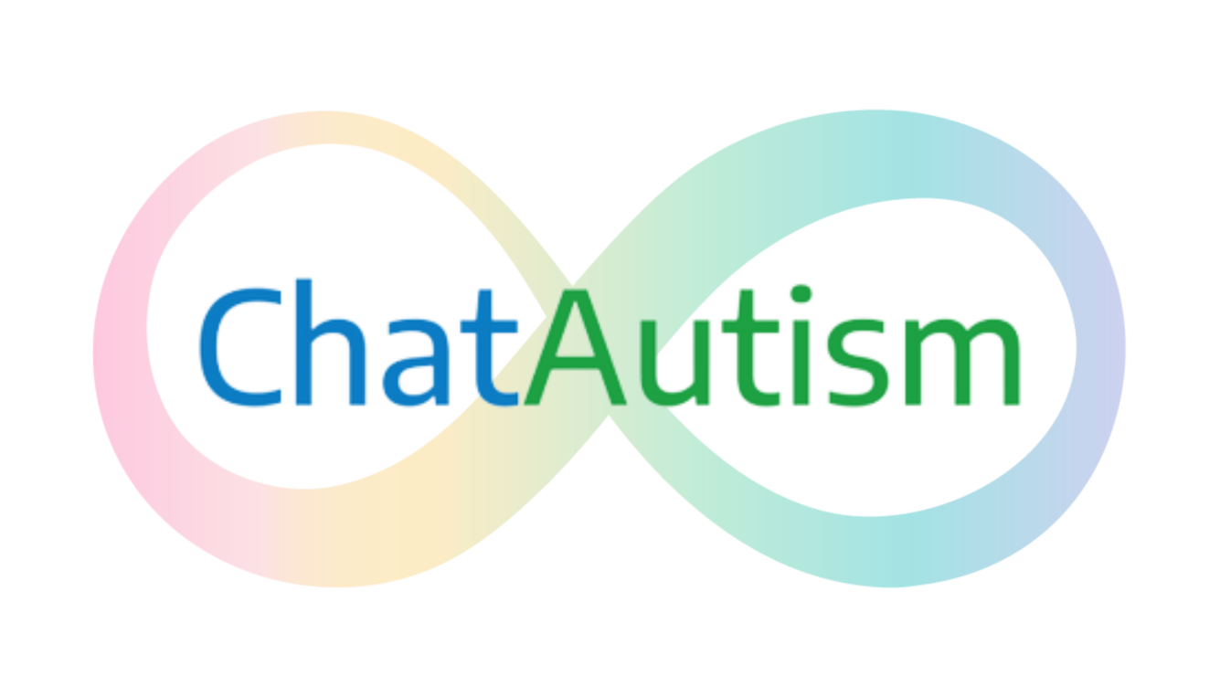
Contents
Background 3
ChatAutism 3
Autism Space 3
Key messages 4
General key messages 4
ChatAutism specific key messages 4
Autism Space specific key messages 5
Copy for internal communications 6
Long copy 6
Shorter copy 7
Copy for autistic people and their families 8
Suggested social media posts 11
Artwork 12
Social media graphics 12
Facebook 12
Twitter 13
Instagram 15
16
Meet the team behind ChatAutism post 16
PowerPoint images for digital noticeboards 17
Posters 18
Combined 18
ChatAutism 19

Background
Leicestershire Partnership NHS Trust has two new innovative digital support options for autistic people who live in Leicester, Leicestershire and Rutland (LLR).
They are:
ChatAutism a free, secure text messaging service run by LPT’s Specialist Autism Team (SAT) for confidential advice and support directly from a qualified health professional. The service is open to autistic people of all ages and their families and carers. Support and advice can also be provided on the autism diagnosis process.
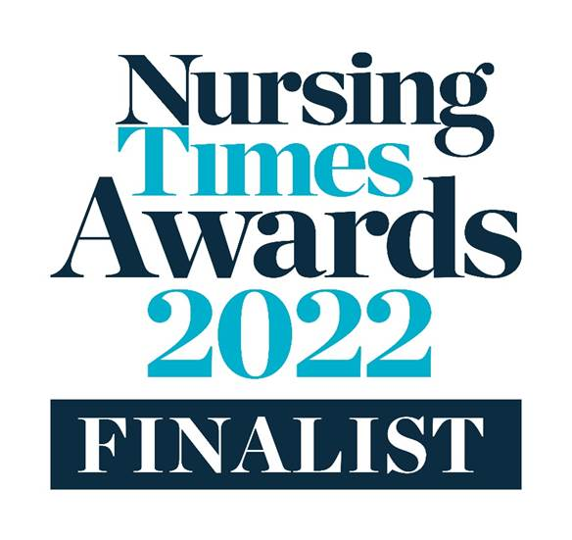
The service, which was a finalist in the Nursing Times Awards 2022, can help with things such as:
- emotional wellbeing
- how to have a healthy lifestyle
- how to have healthy relationships
- advice on drugs, alcohol and smoking
- support with understanding autism
- signposting to helpful resources
- assessment and diagnosis advice.
The service is safe and easy to use. A response will be sent within 24 hours, during Monday to Friday – including over the school holidays (bank holidays not included).
It is the first and only service in the United Kingdom offering text-based healthcare for autistic people. It can be accessed by texting 07312 277097.
Autism Space a free webspace with advice and information about autism related topics and a directory of local support services. Visitors can expect topics such as:
  - Understanding the autism diagnosis and assessment process
  - Advice on support for autistic people in education and employment
  - Mental health and emotional wellbeing support
  - Sleep advice
  - Functioning skills
  - Information about benefits and finances
  - Support services
  - And much more.
The information has been put together by specialists from Leicestershire Partnership NHS Trust, local authorities including Leicester City Council and the Learning Disability and Autism Collaborative, bringing together professionals from across LLR. Local autistic people have also been an integral part of its design and content creation, specifying the need for clear, reliable, accessible local information and advice.
Visit: www.leicspart.nhs.uk/autism-space/

Key messages

General key messages
- Support for autistic people who live in Leicester, Leicestershire and Rutland is available. Use Autism Space or ChatAutism if you or someone you know needs some help or advice.
- Autism is a lifelong developmental disability which affects how people communicate and interact with the world. Autism is a spectrum condition and affects people in different ways. Like all people, autistic people have their own strengths and weaknesses. These may include challenges around social communication and social interactions, repetitive and restrictive behaviour, over, or under, sensitivity to light, sound taste or touch, highly focused interests or hobbies, extreme anxiety and meltdown and shutdowns.
- Just over 1% of the population are autistic; this means around 11,000 people who live in Leicester, Leicestershire and Rutland are autistic.

ChatAutism specific key messages

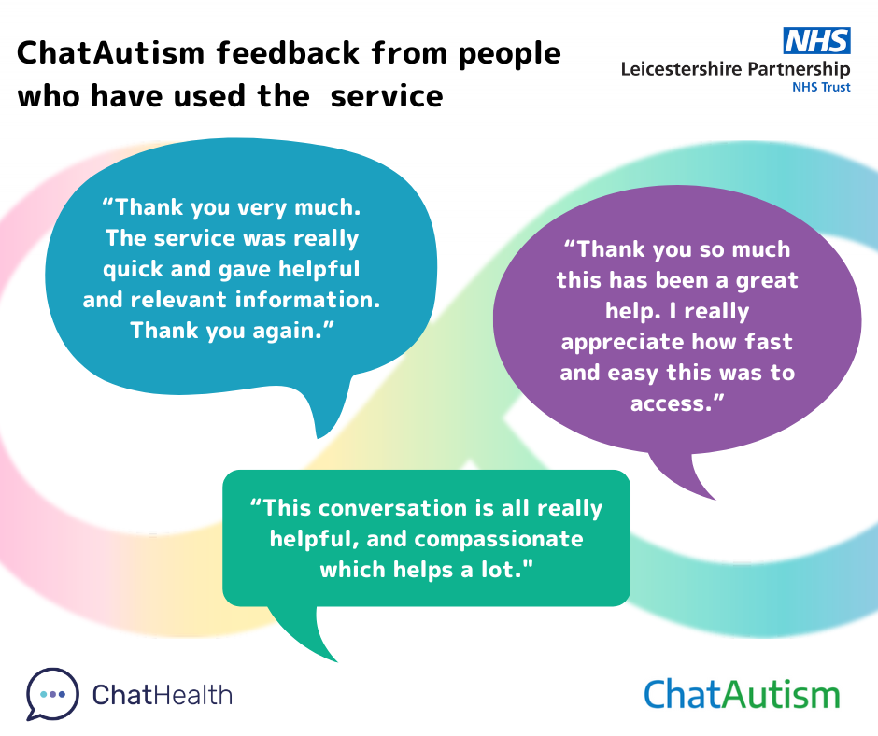

- ChatAutism is a new, safe text message-based service for diagnosed autistic people, those awaiting diagnosis and their families and carers, who need advice and support relating to the condition
- People who contact the service will receive free and confidential advice and support from a qualified professional from LPT’s Specialist Autism Team (SAT) at the other end of the phone
- People will get a response within 24 hours on weekdays. The service runs from 9am-5pm, Monday to Friday.
- Those who are eligible and need more specialised support, such as attending workshops on understanding their autism diagnosis, can be referred to the SAT by using the service.
- Studies have shown that text messaging is often a less stressful way for autistic people to communicate; it allows people to put thoughts down, gives them time to digest messages, think things through and compose a response without the pressure to reply immediately. It can also be easier for autistic people to understand what the other person means without all the additional social cues that come with conversing in person.
- When developing the service, LPT involved autistic people of all ages, as well as their parents and carers, to identify what health and wellbeing support was needed and what adjustments should be incorporated into the offer, such as avoiding ambiguous language in our messages.
- We have listened to feedback from local people about the service to extend and enhance the offer.
- Since launching less than a year ago, the service was a finalist in the Nursing Times Awards 2022 in the Technology and Data in Nursing category.

Autism Space specific key messages
- Autism Space is a new, safe and free online portal for diagnosed and non-diagnosed autistic people and their families and carers, who need clear, reliable and accessible advice and support relating to the condition.
- A range of topics are covered, as well as a comprehensive list of local support networks and organisations for autistic people living in Leicester, Leicestershire and Rutland.
- Information on the portal has been developed by health and social care professionals who specialise in supporting autistic people. Local autistic people and their families have also been involved in its design and content creation.
- Information videos on the portal are available in languages, including: Hindi, Punjabi, Gujarati and Bengali. The website also uses the ReachDeck toolbar (by selecting the speak button) allowing the website to be read aloud, translated into different languages, be read using a screen mask, text to be enlarged and pages simplified or displayed in different fonts and colours.

Copy for internal communications

Long copy
New digital support for autistic people in Leicester, Leicestershire and Rutland
Professionals in Leicester, Leicestershire and Rutland are being encouraged to help promote two new and innovative, free digital resources for autistic people and their families and carers who live in the area.
Leicestershire Partnership NHS Trust (LPT) has been working with partners to set up Autism Space – a webspace with advice and information on a vast array of autism related topics and a directory of local support services. Visitors can expect information on:
  - Understanding the autism diagnosis and assessment process
  - Advice on support for autistic people in education and employment
  - Mental health and emotional wellbeing support
  - Sleep advice
  - Functioning skills, including developing healthy relationships and developing skills and strategies
  - Information about benefits and finances
  - Support services
  - And much more.
Information is set out into clear sections, making it easy it navigate and there are videos available in languages including English, Hindi. Punjabi. Gujarati and Bengali.
The new online platform has been created by specialists from Leicestershire Partnership NHS Trust, local authorities including Leicester City Council and the Learning Disability and Autism Collaborative, bringing together professionals from across Leicester, Leicestershire and Rutland. Local autistic people have also been involved in its design and content creation. To view Autism Space, visit: www.leicspart.nhs.uk/autism-space/
As well as accessing Autism Space, local autistic people can also access support from ChatAutism – a safe and secure new text messaging advice and support service delivered by Leicestershire Partnership NHS Trust’s Specialist Autism Team (SAT).
What’s more, the service has widened its eligibility criteria as part of a year-long trial and it is now open to anyone living in Leicester, Leicestershire or Rutland with autism. This includes children and adults of all ages, as well as their families and/ or carers. The service will also take questions from people who are awaiting an autism assessment or want to find out more about the diagnostic process.
The changes are being tested after being requested by local people, who wanted access to the highly-valued help and support.
The service can help with things such as:
- emotional wellbeing
- how to have a healthy lifestyle
- how to have healthy relationships
- advice on drugs, alcohol and smoking
- support with understanding autism
- signposting to helpful resources
- assessment and diagnosis advice.
The service, which was a finalist in the Nursing Times Awards 2022, is safe and easy to use. It is the first and only service in the United Kingdom offering text-based healthcare for autistic people. If you know anyone who may benefit from ChatAutism, please encourage them to get in touch with the service by texting 07312 277097.
A response will be sent within 24 hours, during Monday to Friday – including over the school holidays (bank holidays not included).
Laura Smith, learning disability and autism service group manager from Leicestershire Partnership NHS Trust, said: “We hope these two new resources will help to make a big difference to the quality of life for autistic people living in Leicester, Leicestershire and Rutland. It can be a frightening experience for someone to get an autism diagnosis – and it can also be difficult to understand what help and support is available, even if a loved one or individual has been diagnosed for some time.
“By bringing helpful and local information together in one place in an easy-to-use format, we hope Autism Space will be the first place people check for information and advice about the neurological condition. We also hope by expanding the ChatAutism text messaging service, we will be able to help more people who need support.
“We have worked tirelessly to make these products with the needs of autistic people in mind at all times and have involved local autistic people and listened to their feedback. We hope our partners will help us to share them far and wide.”
Word count: 638

Shorter copy
New digital support for autistic people in Leicester, Leicestershire and Rutland
Professionals are being encouraged to help promote two new and innovative, free digital resources for autistic people and their families and carers who live in the area.
Autism Space is a webspace with advice and information on a vast array of autism related topics and a directory of local support services. Visitors can expect information on:
  - Understanding the autism diagnosis and assessment process
  - Advice on support for autistic people in education and employment
  - Mental health and emotional wellbeing support
  - Sleep advice
  - Functioning skills, including developing healthy relationships and developing skills and strategies
  - Information about benefits and finances
  - Support services
  - And much more.
To view Autism Space, visit: www.leicspart.nhs.uk/autism-space/
Local autistic people can also access support from ChatAutism – a safe and secure text messaging advice and support service delivered by Leicestershire Partnership NHS Trust’s Specialist Autism Team (SAT).
It is open to any autistic person living in Leicester, Leicestershire or Rutland, including children and adults of all ages, as well as their families and/ or carers. The service will also take questions from people who are awaiting to be assessed or diagnosed as autistic - or who want to find out more about the diagnostic process.
The service can help with questions on:
- emotional wellbeing
- healthy lifestyle
- healthy relationships
- drugs, alcohol and smoking
- understanding autism
- signposting to helpful resources
- assessment and diagnosis.
If you know anyone who may benefit from ChatAutism, please encourage them to get in touch with the service by texting 07312 277097.
A response will be sent within 24 hours, during Monday to Friday – including the school holidays (bank holidays not included).
Word count: 279

Copy for autistic people and their families

New digital support for autistic people in Leicester, Leicestershire and Rutland
More local autistic people are able to access free advice and support regarding their diagnosis as Leicestershire Partnership NHS Trust (LPT) launches a new online information hub and is expanding its new text messaging support service.
Autism Space is a webspace with advice and information on a vast array of autism related topics and a directory of local support services. Visitors can expect information on:
  - Understanding the autism diagnosis and assessment process
  - Advice on support for autistic people in education and employment
  - Mental health and emotional wellbeing support
  - Sleep advice
  - Functioning skills, including developing healthy relationships and developing skills and strategies
  - Information about benefits and finances
  - Support services
  - And much more.
To view Autism Space, visit: www.leicspart.nhs.uk/autism-space/
Local autistic people can also access support from ChatAutism – a safe and secure text messaging advice and support service delivered by Leicestershire Partnership NHS Trust’s Specialist Autism Team (SAT).
It is open to any autistic person living in Leicester, Leicestershire or Rutland, including children and adults of all ages, as well as their families and/ or carers. The service will also take questions from people who are awaiting to be assessed or diagnosed as autistic - or who want to find out more about the diagnostic process.
To access the service text 07312 277097. A response will be sent within 24 hours, during Monday to Friday – including the school holidays (bank holidays not included).
Word count: 239

Chat Autism text service open to all ages
More local autistic people are able to access Leicestershire Partnership NHS Trust’s (LPT) new text messaging to access personalised advice and support as part of a year-long pilot.
ChatAutism is a free and confidential service run by the Trust’s Specialist Autism Team (SAT) and is now open to anyone living in Leicester, Leicestershire or Rutland with autism. This includes children and adults of all ages, as well as their families and/ or carers. ChatAutism will now also take questions from people who think they are autistic or are awaiting a diagnosis.
Previously, the service was only available to people aged 14 and over with an autism diagnosis, however the changes are being trialled after local people requested more access to the highly-valued help and support.
Get in touch with ChatAutism by texting 07312 277097.
A qualified health professional from the Specialist Autism Team will get back to you within 24 hours on weekdays.
The service, which was a finalist in the Nursing Times Awards 2022, can help with things such as:
- emotional wellbeing
- how to have a healthy lifestyle
- how to have healthy relationships
- advice on drugs, alcohol and smoking
- support with understanding autism
- signposting to helpful resources
- assessment and diagnosis advice.
ChatAutism is safe and easy to use. It is the first and only service in the United Kingdom offering text-based healthcare for autistic people.
LPT developed the service with the help of autistic people from all ages, as well as their parents and carers, to identify what health and wellbeing support ChatAutism should provide and adaptions to make the service accessible.
The service runs throughout the year during Monday to Friday – including over the school holidays (bank holidays not included).
Word count: 289

Suggested social media posts

- Are you or a loved one autistic? Did you know there are two new, free and local NHS support services available to you?

📱 ChatAutism is an easy and safe way to get advice and support directly from a qualified health professional by simply texting 07312 277097.

ℹ️ Autism Space is a web hub covering a range of topics relating to autism, including understanding your diagnosis, education and employment advice, functioning skills, benefits and financial, support services and much more.

Find out more ➡️ https://www.leicspart.nhs.uk/autism-space/

- Want to know more about the local support available to autsitc people? Check out the new ChatAutism and Autism Space services. Find out more ➡️ https://www.leicspart.nhs.uk/autism-space/

- Are you, or a loved one, autistic? Now all children and adults who need advice or support regarding their diagnosis can use the local NHS ChatAutism text messaging service. Just text 07312 277097 and a qualified health professional will get back to you.

- If you have a question about your autism get in touch with ChatAutism by texting 07312 277097.
Get free and confidential advice and support from a qualified health professional directly to your phone.

- ChatAutism is a new text message-based support service for autistic people of all ages. Have a question or need some support? Text ChatAutism on 07312 277097.

- If you or a loved one are autistic, or think you are autistic, you can get free and confidential advice and support from ChatAutism. Text your question to 07312 277097 and a qualified health professional will get back to you.

Artwork

Social media graphics

Facebook

Combined
Download link: https://www.leicspart.nhs.uk/wp-content/uploads/2023/03/LLR-autism-digital-support-Facebook-1.png
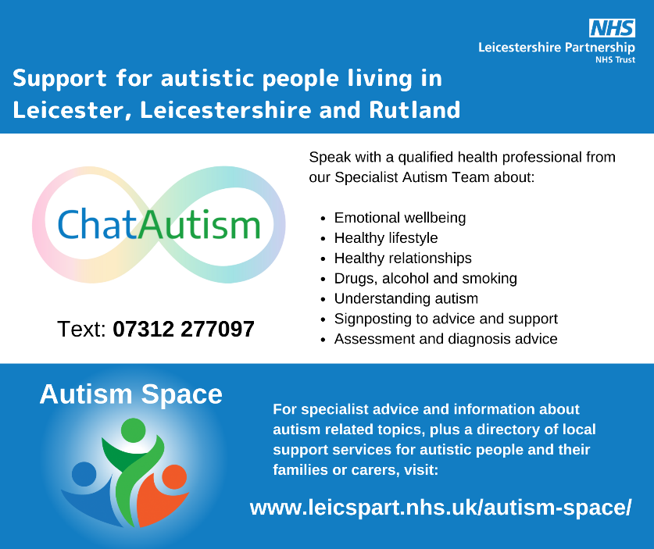
Alternative text:
Title: Support for autistic people living in Leicester, Leicestershire and RutlandChatAutism logo on white background, with Text: 07312 277097 underneath. Accompanying text reads: Speak with a qualified health professional from our Specialist autism team about: emotional wellbeing, healthy lifestyle, healthy relationships, drugs, alcohol and smoking, understanding autism, signposting to advice and support, assessment and diagnosis advice. Below is a blue box with the text: Autism Space and a blue, green and orange abstract logo. Accompanying text reads: For specialist advice and information about autism related topics, plus a directory of local support services for autistic people and their families or carers, visit: www.leicspart.nhs.uk/autism-space

ChatAutism
Download link: https://www.leicspart.nhs.uk/wp-content/uploads/2023/03/ChatAutism-social-media-all-age-Facebook-Post.png
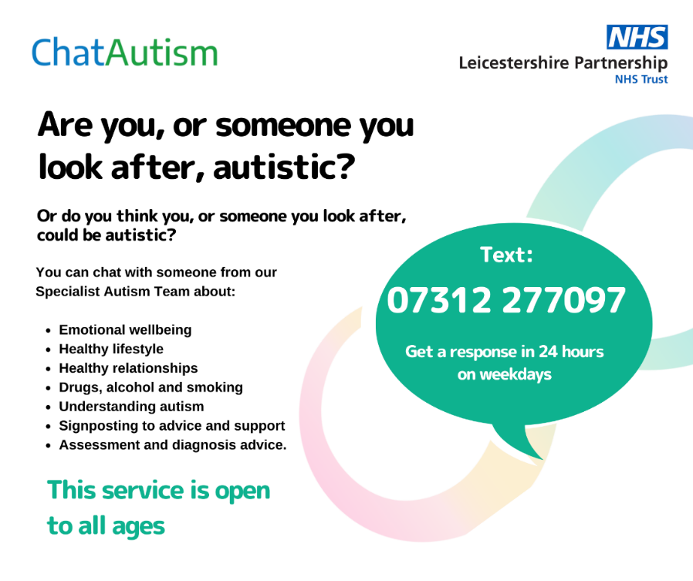
Alternative text:
Graphic on a white background reads: Are you, or someone you look after, autistic? Or do you think you, or someone you look after, may be autistic and would like some information about the assessment and diagnosis process? By texting ChatAutism, you can speak with a qualified health professional from our Specialist Autism Team about: Emotional wellbeing Healthy lifestyle Healthy relationships Drugs, alcohol and smoking Understanding autism Signposting to advice and support Assessment and diagnosis advice.
This service is open to all ages. Text: 07312 277097 Get a response in 24 hours on weekdays.

Autism Space
Download link: https://www.leicspart.nhs.uk/wp-content/uploads/2023/03/Autism-Space-Facebook-Post-Landscape-1.png
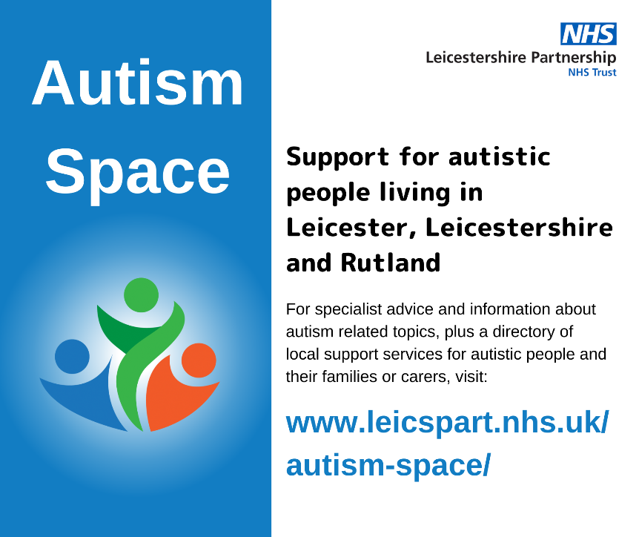
Alternative text:
Graphic shows a blue background with the words Autism Space and a blue, green and orange abstract logo.
The accompanying text reads: For specialist advice and information about autism related topics, plus a directory of local support services for autistic people and their families or carers, visit: www.leicspart.nhs.uk/autism-space

Twitter

Combined
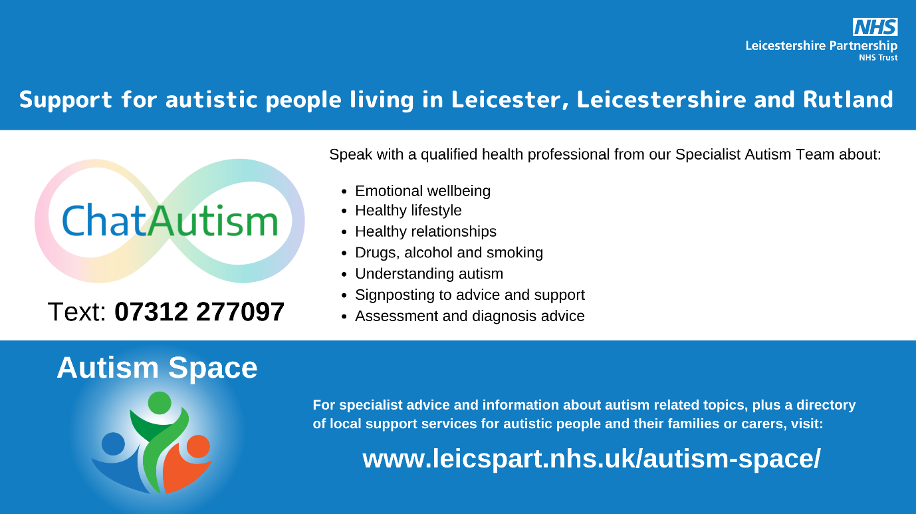
Download link: https://www.leicspart.nhs.uk/wp-content/uploads/2023/03/LLR-autism-digital-support-Twitter-Post-1.png

ChatAutism
Download link: https://www.leicspart.nhs.uk/wp-content/uploads/2023/03/ChatAutism-social-media-all-age-Twitter-Post.png
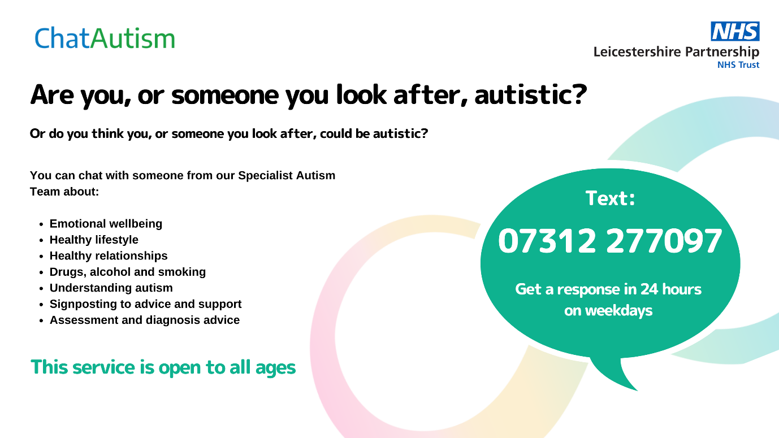

Autism Space
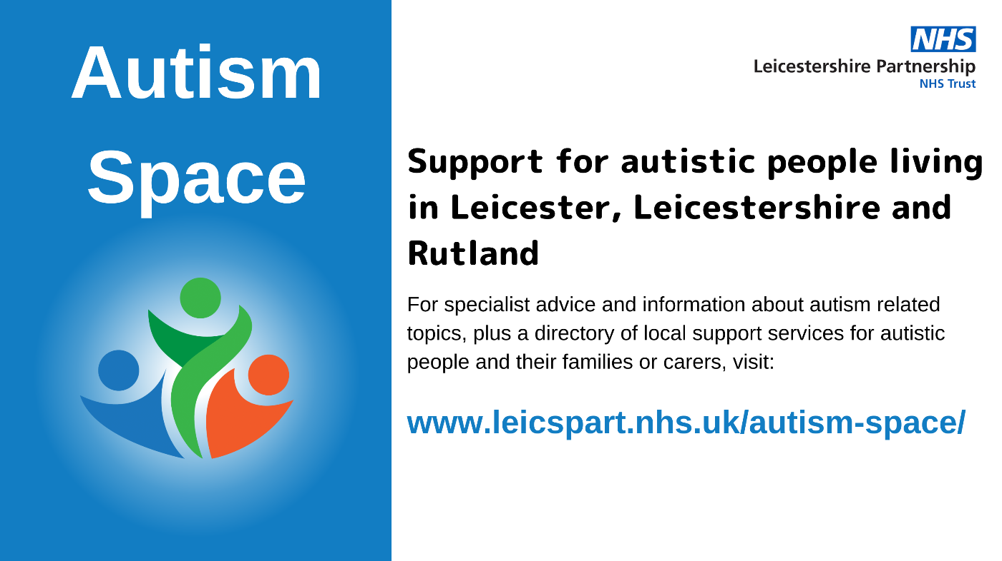
Download link: https://www.leicspart.nhs.uk/wp-content/uploads/2023/03/LLR-autism-digital-support-Presentation-169-2.png

Instagram

Combined
Download link: https://www.leicspart.nhs.uk/wp-content/uploads/2023/03/LLR-autism-digital-support-Instagram-Post-Square-1.png
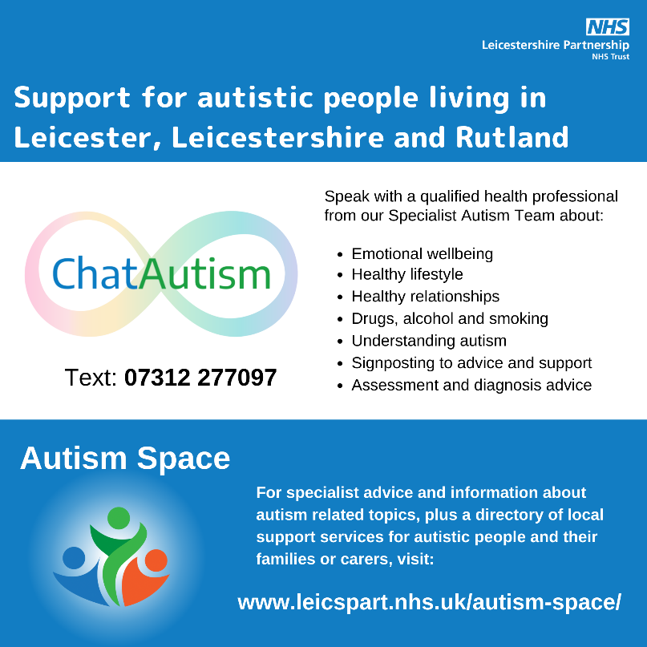

ChatAutism
Download link: https://www.leicspart.nhs.uk/wp-content/uploads/2023/03/ChatAutism-Instagram-social-media-all-age.png
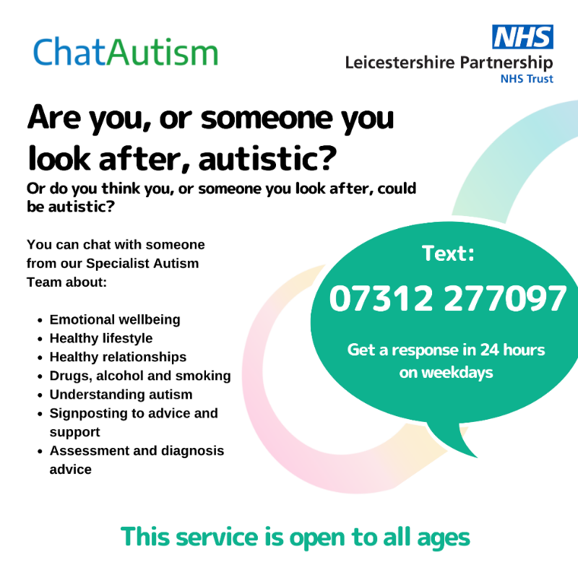

Autism Space
Download link: https://www.leicspart.nhs.uk/wp-content/uploads/2023/03/Autism-Space-Instagram-Post-Square-1.png
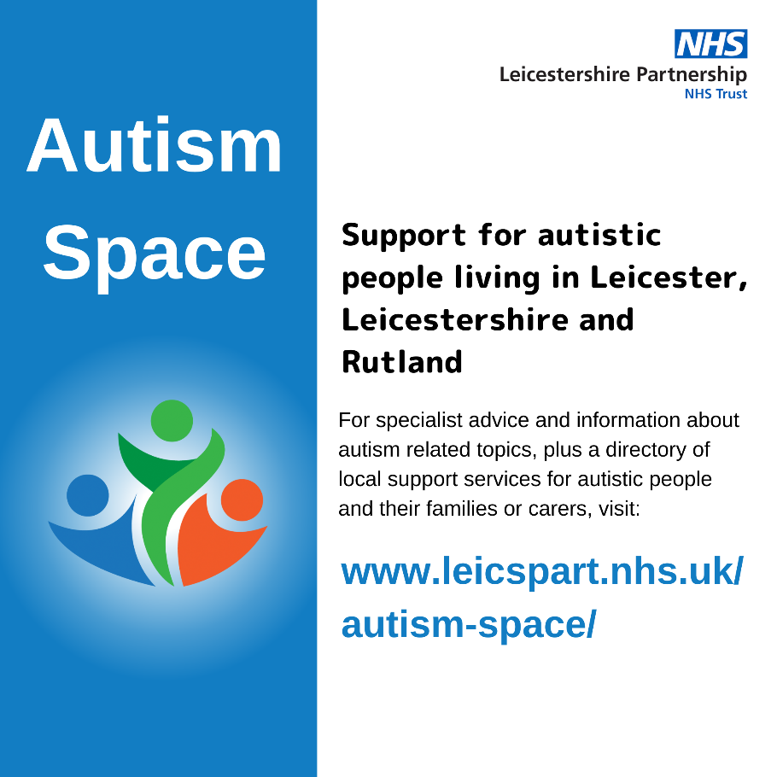

Meet the team behind ChatAutism post
Download link: https://www.leicspart.nhs.uk/wp-content/uploads/2023/03/Meet-our-ChatAutism-team-Faye.png

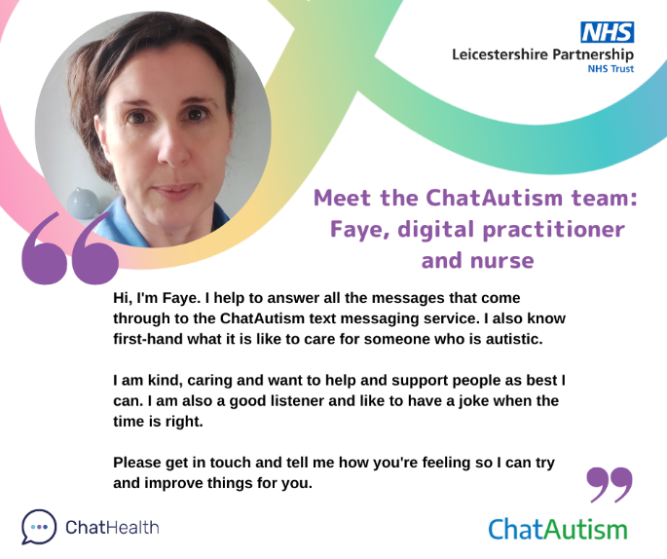

PowerPoint images for digital noticeboards

Combined
Download link: https://www.leicspart.nhs.uk/wp-content/uploads/2023/03/LLR-autism-digital-support-Presentation-169-1.png
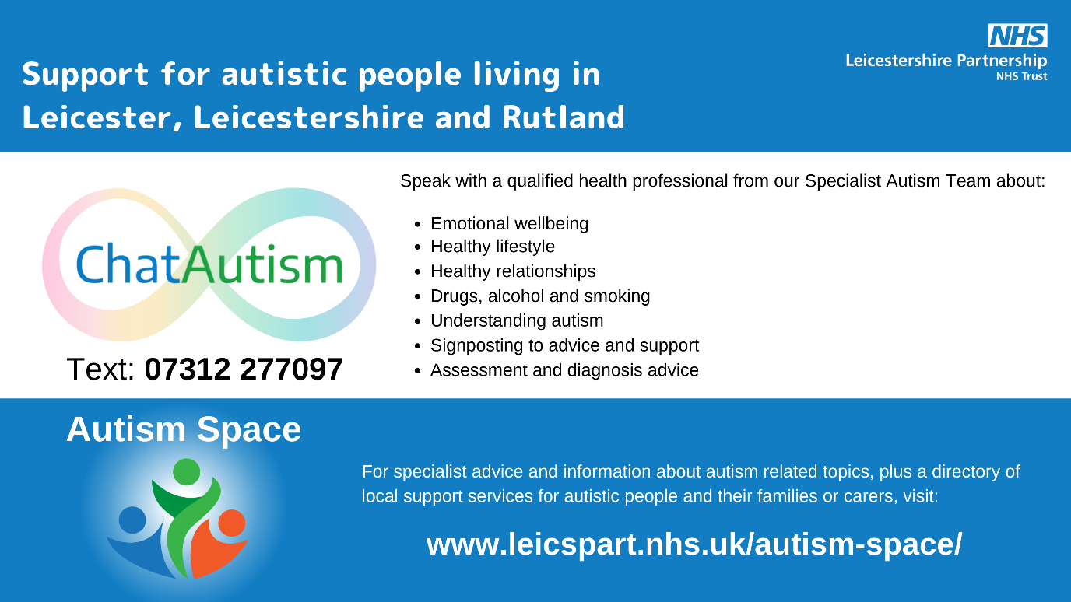

Posters
Please print and display

Combined
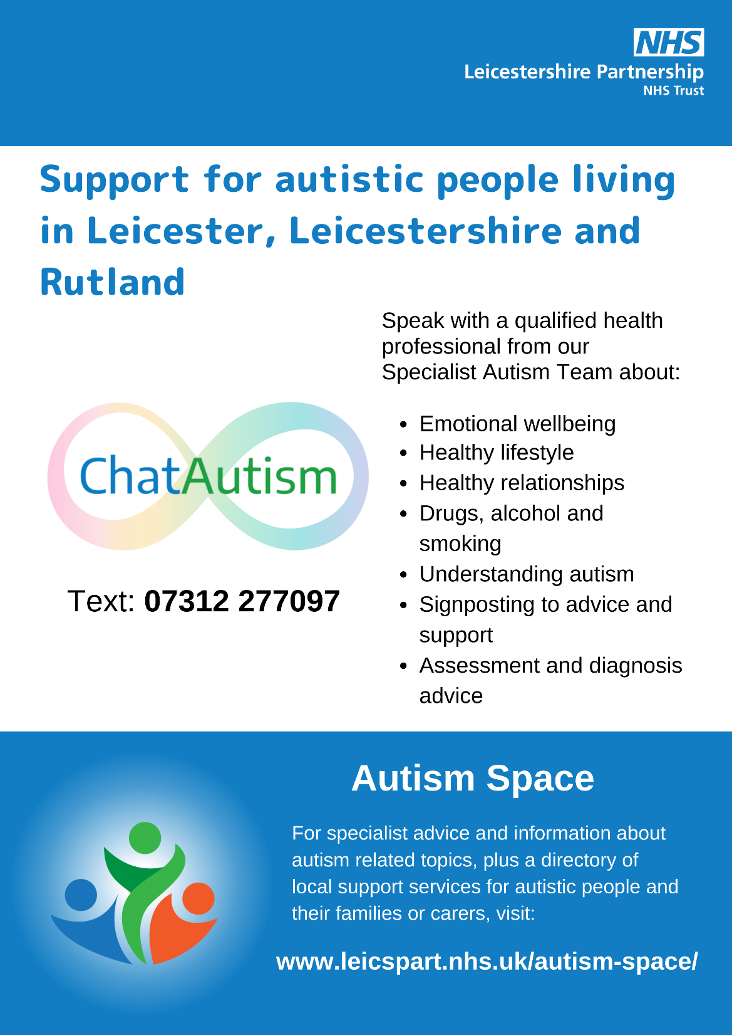
Download link: https://www.leicspart.nhs.uk/wp-content/uploads/2023/03/LLR-autism-digital-support-A4-Document.pdf

ChatAutism
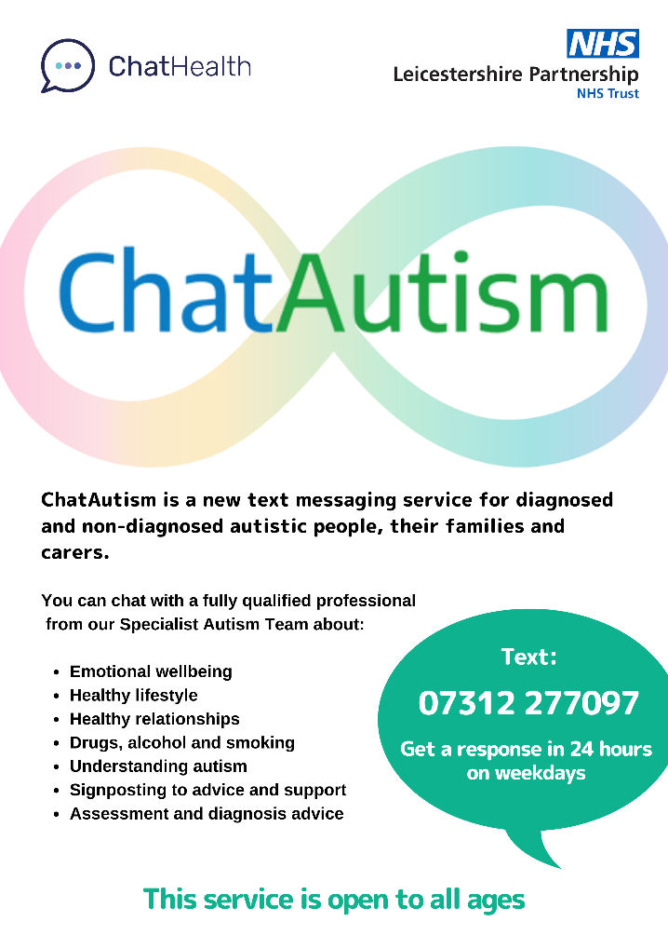

Download link: https://www.leicspart.nhs.uk/wp-content/uploads/2022/10/ChatAutism-A4-poster-all-age.pdf
Limited printed copies of the above ChatAutism poster are available. Please email faye.harwood@nhs.net if you wish to be sent a copy to display, if you are unable to print a version yourself.

