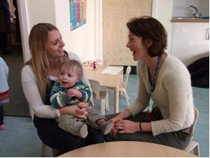

LPT, NHFT and the
University of Northampton
welcome you to an:
Information Evening for
Specialist Community Public Health Nursing

Room LH017, Learning Hub Building, Waterside Campus,
University of Northampton

Thursday 30th March 2023 6.30pm - 8.30pm
PROGRAMME
6.30pm Welcome followed by presentations:
- Working within HV or SN in NHFT or LPT
- Overview of SCPHN programme UoN
- Realities of studying on this programme
- Overview of recruitment process

8.30pm Close

Opportunities available to discuss support in practice, academic support and the application process

For further information please contact either:
NHFT = tanya.watts@nhft.nhs.uk
LPT = lindsey.franks@nhs.net
UON = helen.kimble@northampton.ac.uk

