**Leicestershire Partnership NHS Trust**

**People’s Council**

**Voluntary, Community and Social Enterprise (VCSE)**

**Application and Information Pack**

**April 2023**

**Lived Experience Partners**

**Application and Information Pack**

**April 2023**



**Contents Page**

Introduction to Leicestershire Partnership Trust People’s Council 3

Lived Experience Leadership Framework 4

Role of VCSE Members in the Council 4

How to Apply 7

Application Form 8

**Introduction to Leicestershire Partnership Trust**

We work alongside schools, local hospitals, GP practices, social services and other local authority departments such as housing and education, as well as working with voluntary organisations and local community groups, in order to achieve our goals and to ensure that anyone we care for is treated to the highest possible standard. We provide care and support through three divisions which focus on:

* Adult Mental Health Services
* Families, Young People and Children’s Services and Learning Disability Services
* Community Health Services

You can find out more at [www.lpt.nhs.uk](http://www.lpt.nhs.uk)

Leicestershire Partnership NHS Trust (LPT) believes that patients and carers can be influential partners in driving, delivering, and supporting change and providing us with helpful feedback. Actively engaging and involving our patients, carers, families, and friends will enable us to deliver high quality healthcare services. LPT is leading the way locally to work towards a model of co-production, in which everyone is an equal partner with a shared responsibility to transform services.

**People’s Council**

We created our People’s Council in 2021 to provide us with an independent voice to help the Trust to ensure that our services are great for all. Its membership consists of Patient and Carer Leaders, Lived Experience Partners, senior representatives of local Voluntary, Community and Social Enterprise organisations and representatives of the Trust.

We have reviewed the work of the Council and for it to have more impact, we will focus on:

1. Supporting LPT to learn by being a critical friend.
2. Supporting LPT to involve, engage and co-produce.
3. Supporting LPT to shape strategy and policy.
4. Supporting LPT to deliver on its equality, diversity, and inclusion commitments and to tackle health inequalities.

This will be achieved by the Council:

* Overseeing the delivery of the Trust’s Patient Experience and Involvement Delivery Plan and Lived Experience Leadership Framework.
* Receiving and considering the results of any patient and carer and/or staff surveys.
* Considering themes from patient experience received through various formats such as the Friends and Family Test, Complaints and Concerns.
* Engaging directly with our patients and carers to understand their experiences.
* Providing advice and expertise in the review of the Trust’s Equality Impact Assessments and delivery of equalities plan.
* Review the delivery of Quality Improvement Projects.
* Considering presentations and updates from the Trust and others.
* Establishing Task and Finish Groups to help the Council deliver on its four objectives, that will review, examine, and make recommendations.
* Contributing to key meetings and committees, including meeting with the Trust’s Board.
* Reviewing the Trust’s progress against the developing Patient and Carer Race Equality Framework (PCREF) and its progress in becoming an anti-racist organisation.
* Advising the Trust on new ways to measure the experiences of patients and carers.
* Participating in an annual review of Patient Experience through the Patient Experience Improvement Framework
* Providing assurance on the Trust’s delivery of its Corporate Plan, called Step Up to Great and by helping keep the Trust’s priorities under review.
* Reviewing Care Quality Commission inspection reports and holding the organisation to account for delivery of plans in response to those reports.

The Council meets every quarter. There will be additional meetings in between for you to take part in, including Task and Finish Groups that will be formed to help us meet our four objectives. There will also be opportunities to visit LPT services and to meet other patients and carers to gain their views and opinions on LPT services. We envisage the overall time commitment being around a few hours a month.

**Lived Experience Leadership Framework**

Our Lived Experience Leadership Framework has been developed in partnership with people with lived experience. The Framework which is taken from the Patient Leadership Triangle developed by InHealth Associates sets out how the Trust places lived experience and patient and carer voice at al levels of the Trust.

Lived Experience Partners will be working alongside services and teams. Partners will participate in quality improvement programmes, governance committees, as well as other activities like training, recruitment, and input into academic papers.

We call them ‘partners’ largely because they bring professional and personal wisdom alongside their experiences of using our services.

They are not representatives or there to provide feedback (we have other mechanisms for that) but are ‘advisors’ and ‘critical friends’ who check assumptions, ask questions, provide insights into reframing issues or identifying problems, change dynamics and model collaborative leadership.

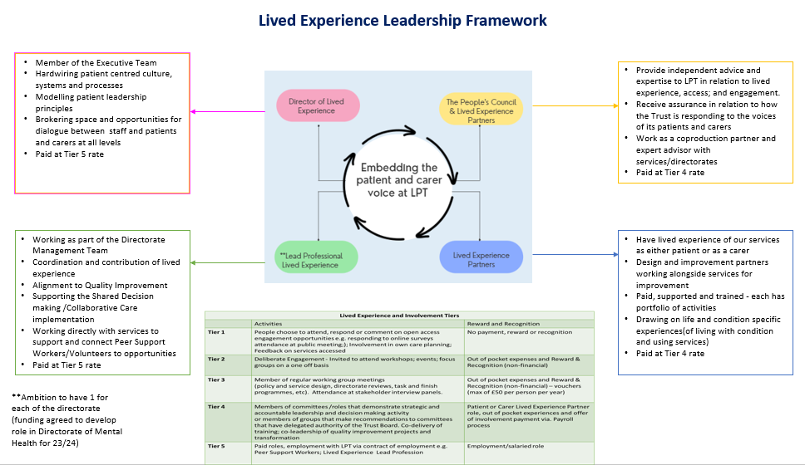

**The role of VCSE Senior Representative**

VCSE representatives will be willing to develop their understanding and be committed to improving the NHS and its services and be able to think widely about health and wellbeing. They must be able and willing to reflect and represent the different views and diversity of their VCSE organisation and the community it serves. They must also understand the challenges faced by that community. VCSE representatives need to be confident and able to contribute to discussions in a critical but positive way; senior managers and clinicians will also attend the meetings

As a senior leader in local VCSE organisation you will work alongside Trust staff as equal partners to strategically influence and shape the development, design, and improvement of LPT services. They will be asked to engage and involve the communities that they work to have a voice in the work of the Council. They will also advise the Trust on the best ways of engaging with our diverse communities.

**What does a VCSE Senior Representative do? They:**

* Provide public scrutiny and assurance to the Board of the Trust.
* Help ensure improvement projects are being done through co-design and co-production.
* Enable the Trust to listen and to provide opportunities for patients, carers, and families in the development of local services and policies.
* Actively influence the strategic direction of the Trust.
* Act as an ambassador to encourage patient and carer involvement.
* Provide their perspective to enable the Trust to place the voice of the patient and carer at the centre of everything it does.
* Support the development and delivery of high-quality public, patient, and carer engagement.
* Understands what the Trust does, working together with staff to identify problems and apply creative and innovative thinking in developing solutions.

Please note that this is not an exhaustive list as there will be many other activities for VCSE Senior Representatives to get involved with.

**Who can get involved?**

We are looking for VCSE Senior Representatives that are in leadership roles within their organisations, who can make commitments on behalf of their organisations. The organisations they represent must work with people in Leicester, Leicestershire, and Rutland.

They need to be able to ensure that their organisation can work with us to engage and involve the communities and individuals that they work with and that they can advise us on the best ways of doing so. They should also be able to share any intelligence they can to help us understand the needs of those communities. They must also be willing to share information with the communities and individuals that their organisations work with.

VCSE Senior Representatives should be willing to develop their understanding and be committed to improving the NHS and its services.

**Why become a VCSE Senior Representative?**

* You can help make a difference to your local community and the services they receive.
* You can help us build a culture and environment where patient and carer need come first.
* You can help us be open, transparent, and accountable.
* You can gain new skills through our training programme.

**Additional information**

The term for membership is for 3 years (subject to a twice-yearly review with the Chair of the Council and the Head of Patient Experience and Involvement to see how things are going, and what support you need to fulfil your role). After the initial three-year term, there will opportunity to extend for a further 3 years.

* You will be required to commit to a minimum of 4 hours every quarter to attend a Council meeting and read any associated papers.
* Any additional hours you will be required to commit will be dependent on the additional work created by the Council; work you may want to be involved with and/or the stage the project is at. Being involved with one project requires on average between 1 and 4 hours per month.
* The Trust must be able to contact you by telephone, post or email.
* You may be required to attend meetings held within normal working hours.

**How to apply:**

If you would like to be a VCSE Representative of the People’s Council, please complete the application form below.

Please send your completed form to: Freepost, LPT Patient Experience

Or you can email it to: [lpt.patient.experience@nhs.net](mailto:lpt.patient.experience@nhs.net)

Applications will close at midnight on 31st May 2023.

If you would like to discuss the position then please contact Alison Kirk, Head of Patient Experience, and Involvement via email in the first instance at [Alison.Kirk3@nhs.net](mailto:Alison.Kirk3@nhs.net)

We will review all application forms and invite those that best fulfil our criteria along for an interview.

**People’s Council VCSE Senior Representatives**

**Application Form**

|  |  |  |  |
| --- | --- | --- | --- |
| SURNAME: |  | | |
| FORENAME(S): |  | | |
| ADDRESS: |  | | |
|  | | POSTCODE: |
| TELEPHONE: | DAY: | EVENING: | |
| EMAIL ADDRESS: |  | | |
| NAME OF ORGANISATION: |  | | |
| YOUR JOB TITLE: |  | | |
| How do you prefer to be contacted: | | | |
| The Trust is committed to providing equal opportunities for all. If you have a disability, health problem or English is not your first language, please give details below of any services / support that you would like the Trust to provide for you to become involved: | | | |

|  |  |  |  |  |  |  |  |  |  |  |  |  |  |  |  |  |  |  |  |  |  |  |  |  |  |  |  |  |  |  |  |  |  |
| --- | --- | --- | --- | --- | --- | --- | --- | --- | --- | --- | --- | --- | --- | --- | --- | --- | --- | --- | --- | --- | --- | --- | --- | --- | --- | --- | --- | --- | --- | --- | --- | --- | --- |
| |  | | --- | | Please identify if your organisation works with people, who are either carers or patients in Leicester, Leicestershire and Rutland who are: (Tick all that apply): |  |  |  |  |  | | --- | --- | --- | --- | | BME South Asian |  | Single Parents |  | | BME Black Caribbean and African |  | Families with young children |  | | BME Eastern European |  | Homeless |  | | Asylum Seekers & Refugees |  | Carers |  | | Students |  | LGBTQ+ |  | | Physical Disabilities |  | **Gypsy, Roma,** and **Traveller** |  | | Older People |  | Domestic Violence |  | | Low income |  | Neurodivergent and Autism |  | |

**Please tell us:**

|  |
| --- |
| Why would you like to join the People’s Council as a VCSE Senior Representative? |
|  |
| How could you help give a voice to the individuals and communities that your organisation works with? |
|  |
|  |
|  |
|  |
| Please confirm:  You are in a Senior Leadership role within your organisation and can make commitments on its behalf and that you have the capacity of a few hours per month of time to put into the work of the Council? |
|  |

I certify, to the best of my knowledge, that the information provided on this Expression of Interest form is correct.

Signed: …………………………………… Date: …………………………………….

Print Name: ……………………………………………………………………

Please submit this form to Alison Kirk, Head of Patient Experience, and Involvement at [Alison.Kirk3@nhs.net](mailto:Alison.Kirk3@nhs.net) by midnight on 31st May 2023.