Flu Heroes Social Media and Website Toolkit for Primary Schools

Text | Graphic | Graphic download link
The School Immunisation Service is coming to school to offer children a free, safe and effective flu vaccine.  The vaccine is usually given as a nasal spray, which provides the most effective protection. The nasal spray contains traces of pork gelatine. A gelatine-free flu injection into the arm is also available if the nasal spray isn’t suitable.  Please register your consent decision online: www.leicsandrutlandimms.co.uk - our school code is [add code]  Or you call the service on: 0300 300 0007 | 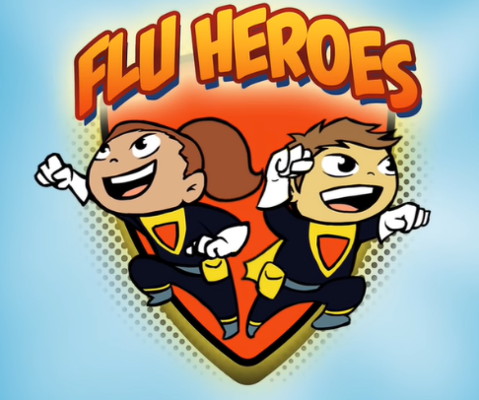 | https://www.leicspart.nhs.uk/wp-content/uploads/2023/09/Flu-heroes-logo.png
Flu is highly contagious and spreads through coughs, sneezes and touching contaminated surfaces. It causes fever, aching muscles, a stuffy nose and cough. In some cases, flu can cause serious problems like painful ear infections or breathing issues.

Good hand hygiene throughout autumn and winter helps to stop flu spreading. Children can also get a free, safe and effective vaccine in school.

Please fill out a consent form for your child online: www.leicsandrutlandimms.co.uk or call the School Immunisation Service on 0300 300 0007.

The School Immunisation Service is coming to school on [add date] to offer children a free, safe and effective flu vaccine.

Please register your consent decision online: www.leicsandrutlandimms.co.uk - our school code is [add code]

Or you call the service on: 0300 300 0007

Whatever you’re planning this Halloween, don’t forget your kids can say ‘boo to flu’ and scare off the nasty virus by getting their free, safe and effective flu vaccine.  Don’t forget to fill out a consent form online: www.leicsandrutlandimms.co.uk or call 0300 300 0007 | 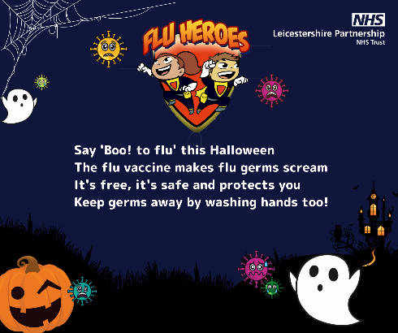 | https://www.leicspart.nhs.uk/wp-content/uploads/2023/09/boo-to-flu-2.png
Your child can join the Flu Heroes by getting their free, safe and effective flu vaccine in school this term.  Don’t forget to fill out your consent form online: www.leicsandrutlandimms.co.uk or call 0300 300 0007. | https://youtu.be/1jHWwm8NQUw?si=5Xo0BNzJqBpg1HpV | (links is to flu hero video)

Website Copy
This term, Leicestershire Partnership NHS Trust’s School Immunisation Service is offering a free, safe and effective flu immunisation to all our pupils.

Flu is highly contagious and spreads through coughs, sneezes and touching contaminated surfaces. It causes fever, aching muscles, a stuffy nose and cough. In some cases, flu can cause serious problems like painful ear infections or breathing issues. Good hand hygiene throughout autumn and winter helps to stop flu spreading. The flu vaccination will help to protect your child from this nasty virus – and help to prevent it spreading to vulnerable friends and family members.

The vaccine is usually given as a nasal spray, which provides the most effective protection. The nasal spray contains traces of pork gelatine. A gelatine-free flu injection into the arm is also available if the nasal spray isn’t suitable. The vaccine is offered each year to protect against the latest flu strains.

Watch the child-friendly Flu Heroes animated film for more information about the vaccine: https://youtu.be/1jHWwm8NQUw?si=5Xo0BNzJqBpg1HpV . There is also an online leaflet you can read through: http://tiny.cc/fluvaccination
The service will be visiting [school name] on [add date]. Please fill out a consent form for your child online, to let the service know your consent decision (vaccine approval or refusal): www.leicsandrutlandimms.co.uk . Our school code is [add code].

If you have any questions, contact the School Immunisation Team on 0300 3000 007.

