Flu Heroes Social Media and Website Toolkit for Secondary Schools

Text | Graphic | Graphic download link
The School Immunisation Service is coming to school to offer young people a free, safe and effective flu vaccine.  The vaccine is usually given as a nasal spray, which provides the most effective protection. The nasal spray contains traces of pork gelatine. A gelatine-free flu injection into the arm is also available if the nasal spray isn’t suitable.  Please register your consent decision online: www.leicsandrutlandimms.co.uk - our school code is [add code]  Or call the service on: 0300 300 0007 | 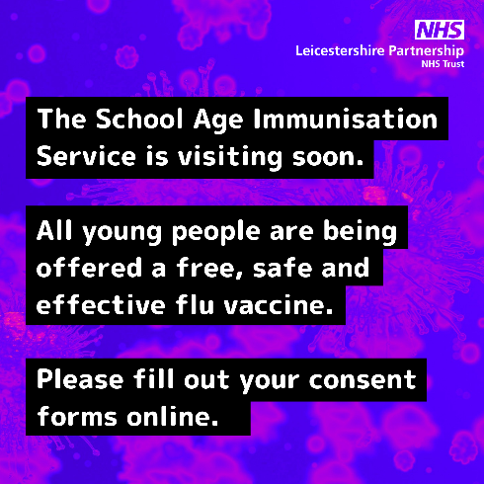 | https://www.leicspart.nhs.uk/wp-content/uploads/2023/09/Flu-secondary-message-social-media-Sep23.png
Flu is highly contagious and spreads through coughs, sneezes and touching contaminated surfaces. It causes fever, aching muscles, a stuffy nose and cough. In some cases, flu can cause serious problems like painful ear infections or breathing issues.

Good hand hygiene throughout autumn and winter helps to stop flu spreading. Young people can also get a free, safe and effective vaccine in school.

Please fill out a consent form for your child online: www.leicsandrutlandimms.co.uk or call the School Immunisation Service on 0300 300 0007.

The School Immunisation Service is coming to school on [add date] to offer young people a free, safe and effective flu vaccine.

Please register your consent decision online: www.leicsandrutlandimms.co.uk - our school code is [add code]

Or you call the service on: 0300 300 0007

All young people in school are being offered a free, safe and effective flu vaccine.  Want to know more about flu and the vaccine? Visit the Health For Teens website.  Parents and carers, please make sure you register your consent decision before the session. | Please link to one of the articles below:  https://www.healthforteens.co.uk/health/flu/flu-just-the-facts/  https://www.healthforteens.co.uk/health/flu/flu-your-questions-answered/

Website Copy
This term, Leicestershire Partnership NHS Trust’s School Immunisation Service is offering a free, safe and effective flu immunisation to all our students.

Flu is highly contagious and spreads through coughs, sneezes and touching contaminated surfaces. It causes fever, aching muscles, a stuffy nose and cough. In some cases, flu can cause serious problems like painful ear infections or breathing issues. Good hand hygiene throughout autumn and winter helps to stop flu spreading. The flu vaccination will also help to protect your child from this nasty virus – and help to prevent it spreading to vulnerable friends and family members.

The vaccine is usually given as a nasal spray, which provides the most effective protection. The nasal spray contains traces of pork gelatine. A gelatine-free flu injection into the arm is also available if the nasal spray isn’t suitable. The vaccine is offered each year to protect against the latest flu strains.

For more information about the flu vaccine please read through this online leaflet: Protect yourself against flu; Information for those in secondary school (publishing.service.gov.uk) . You can also watch this online video from the School Age Immunisation Service.
Please also remember the service has changed its consent process to allow young people in year 8 or above to have the opportunity to self-consent, if a parent or carer has not provided their consent decision. For more information about this change, please either watch this self-consent video from the School Aged Immunisation Service or read through the frequently asked questions.
The service will be visiting [school name] on [add date]. Please fill out a consent form for your child online, to let the service know your consent decision (vaccine approval or refusal): www.leicsandrutlandimms.co.uk . Our school code is [add code].

If you have any questions, contact the School Immunisation Team on 0300 3000 007.

