LLR Learning Disability and Autism Collaborative

Dynamic Support Pathway (DSP)

Guidance Notes for Professionals

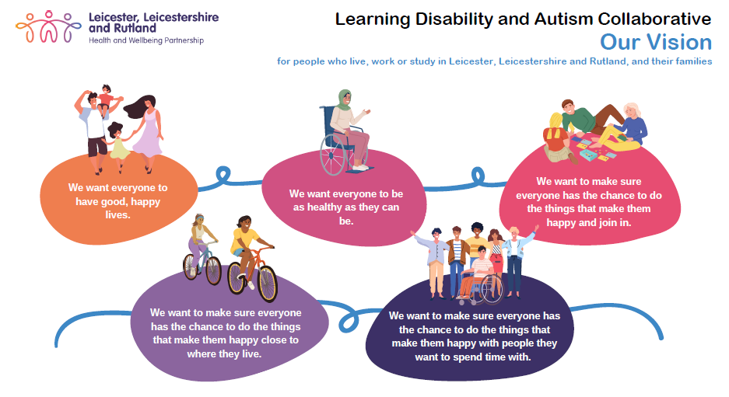
.

Contents

Page No.
Introduction 3
Inclusion Criteria 3
The Dynamic Support Register 4
Consent 4
Confidentiality 4
Risk Rating and Linked Processes 5
Self-referral 6
Referral Process 6
Linked Processes - MAM 7
Linked Processes – C(E)TR 9

Introduction

The Dynamic Support Pathway (DSP) is a pathway developed to provide support for individuals with a Learning Disability, Autism or both who are deteriorating in their health and well-being whilst living in the community. The goal is to identify concerns early and to be able to take steps to provide additional support to prevent further deterioration and any escalation, which may lead to a crisis. This diagnosis must be confirmed, and evidence of this confirmation included within the referral form.

The goal is to identify concerns early and to be able to take steps to provide additional support in order to prevent further deterioration and any escalation, which may lead to a crisis e.g. breakdown of family unit, care order, admission to hospital, offending behaviour, contact with the criminal justice system or serious untoward incident.

The DSP is also for patients stepping down into the community from an in-patient unit. The multi-agency meeting can be used for post discharge follow up to monitor the delivery and suitability of the discharge plan.

The pathway is for both adults and children and young people (CYP). They are managed separately but the referral pathway and form are the same. When you make the referral, it will be clear how to identify on the form whether the referral is for an adult or CYP.

The pathway is owned equally by Health, Social Care & Education and is designed to enhance collaborative joint working between services and to promote the development of a bespoke action plan that will meet the person/child or young person’s needs in the community.

This is not a replacement pathway for your other referrals to other services e.g. Early Help, Specialist Autism team (SAT), Safeguarding, LD Access etc.

Dynamic support systems and processes rely on effective partnership working between health, local authorities, education and social care partners.

Please refer to DSP if one agency is not able to meet all needs and wants multi-agency input.

Inclusion Criteria:

- Adults with a Learning Disability, Autism or both. This diagnosis must be confirmed, and evidence of this confirmation should be included within the referral form. Unfortunately at this time the pathway will not be able to accept referrals for individuals without this diagnosis.

- The person being referred should also be living within Leicester, Leicestershire or Rutland (LLR) and have either a GP surgery that falls within the responsibility of the Leicester, Leicestershire and Rutland ICB or a home address that falls within the responsibility of an LLR Local Authority.

- Individuals fully or partially health funded (117) in an out of area placement can still be referred to the LLR DSP if it is thought that the level of risk/deterioration requires the individuals to have a red rating and an urgent CTR is required.

- CYP fully or partially health funded (117) in an out of area placement can still be referred to the LLR DSP if it is thought that the level of risk/deterioration requires the CYPs to have a red rating and an urgent CETR is being requested.

- Any CYP Looked After Child placed out of area by an LLR Local Authority.

The Dynamic Support Register
The Dynamic Support Register is a simple spreadsheet which holds confidential information about the referral and the outcomes of the referral.
It is a tool to help the administration of the pathway and linked processes
Once an individual is placed on the register, they will be given a unique and anonymous identifier which can be used on future documentation. This database of information will be stored in a confidential clinical folder hosted by Leicestershire Partnership Trust.
The DSR is central to the pathway as the linked processes/actions recommended are informed by the position of the individual on the register.

Consent
A person’s consent must be given to allow their data to be saved onto the DSR. The referral form, consent form, guidance notes and an easy read versions are all available on the DSP web page which is hosted by Leicestershire Partnership Trust. This web page is accessible to all.
https://www.leicspart.nhs.uk/services/dynamic-support-pathway/
Other documentation that can be found at this website include the new referral form link, Multi-agency Meeting notes template, guidance notes for non-professionals and separate quick reference risk rating criteria guidance notes.

Confidentiality
All documentation and data pertaining to the Dynamic Support Pathway is stored in confidential clinical folders with limited access to these folders.
The generic e-mail addresses and folders are also secure and have limited access.

All documentation and data is stored according to regulations within the Data Protection Act (2018) and General Data Protection Regulations (GDPR) and
all individuals accessing this data will follow the ‘data protection principles’ outlined within this guidance.

All documents forwarded to the DSP generic e-mail addresses should always be password protected and the passwords forwarded in a separate e-mail.

Risk Rating and Linked Processes:

- When you make a referral, you will be asked to recommend/suggest the risk rating of the individual’s current situation. In simple terms this is also a question around the urgency of the situation. The individual may often between the cohorts as their situation changes.

- Ideally the individual will access the DSP as amber and be discharged from the DSP as green (deteriorating well-being has been addressed and any impending crisis avoided). A new ‘green’ cohort has been added as a ‘step down’ from the DSP.

- Once the decision has been taken that multi-agency meetings (MAMs) are no longer required the individual will be moved to the green cohort for one month. During this time a new referral to the DSP will not be required if the well-being of the individual should deteriorate again. They can simply be moved to the amber or red cohort and the associated linked processes re-commenced.

- If the agreed actions at the multi-agency meeting do not meet need or cannot be delivered and crisis is not avoided the individual will be escalated to the ‘red’ cohort and a Care and Treatment Review will be arranged.

- If admitted the individual will remain on the DSR (new minimum standard) in the blue cohort and immediately post discharge will be moved back to the amber section.
Summary of Risk Rating and Linked Processes

Risk Rating | Current Situation | Linked Processes
Amber | Well-being is deteriorating - at risk of crisis if action not taken quickly | Timely referral, multi-agency meeting (MAM), development of action plan, delivery, follow up, escalation if required, post discharge follow up MAM
Red | Individual in a crisis situation | Urgent referral, Care (Education) and Treatment Review, development of action plan, immediate delivery, robust follow up, independent scrutiny and oversight is required
Blue | In-patient (most likely moved from ‘Red’ cohort) | In-patient processes, Care (Education) and Treatment Review, MDT, 8-week wellbeing checks, discharge planning. Individual moves to ‘amber’ immediately post discharge
Green | Adults whose well-being has settled and are no longer requiring multi-agency meetings | Individuals will remain in this cohort for one month and then be removed from the DSP.  No MAMs will be arranged by the DSP team.

A more detailed explanation of the risk rating, referral criteria and linked processes is available in a separate document on this website (separate versions for adults and for children).
Self – Referral
This is a new addition to the DSP and is for individuals and their families who would like to be referred to the DSP but are currently not working with a health or social care professional who is able to make this referral. It is a very simplified version of the form so as not to cause additional anxiety.
Once submitted the individual will receive an automated acknowledgement response from the system to assure them that it has been received.
The automated response will include emergency contact information to be used if the request for support is urgent (referral may be out of hours).
The DSP Officer will check and confirm that the individual is registered with an LLR GP and/or receiving support from an LLR Local Authority or an LLR Looked After Child/young person placed out of area. They will also check and confirm that the individual has a learning disability or autism diagnosis
They will then review the referral against DSP risk rating criteria and agree the next steps which will be in line with the appropriate linked processes identified within the risk stratification criteria
Where an individual does not meet the DSP requirements a Directory of Support Services has been developed. This provides guidance and support to a range of services, including Chat Autism and the Autism Space website.

Referral Process

A new referral form has been developed for professionals, capturing the minimum standards outlined in the new policy. It is available via the original link on the Leicestershire Partnership Trust website
Both the referral form for professionals and the self-referral form are available via the following link
https://llrldadmissionavoidancetool.leicestershire.nhs.uk/
All other documentation pertaining to the DSP is also available on this website. These include:
LDA Support Directory
Adult DSP Referral Criteria
CYP DSP Referral Criteria
DSP Consent Form – easy read
DSP Consent Form
DSP Consent Form Guidance
DSP First MAM Notes Template
DSP Follow up MAM Notes Template
DSP Post-discharge MAM Notes Template
DSP Guidance Notes for Professionals
DSP Guidance Notes for Individuals Families and Carers

Contents of the referral form include the following: Patient ID information, Demographic information, Commissioner information, Patient/carer information
Current care team, Current location/home/provider, Communication needs, Brief History, Overview of the Current Situation/Current Concerns
Risk Details, Safeguarding Information, Additional support already in place?

Linked Processes

The Multi Agency Meeting (MAM)

This meeting will bring together the key people from across the system who are or need to be involved in the care of the person being referred. Action plan to be agreed, responsibilities will be allocated, and timelines put in place.

The number of multi-agency meetings needed is agreed within the group. The process must continue until the group is confident that the deterioration in well-being has been halted and any associated risks have decreased. At this stage the process can be stood down and the individual can be stepped down to the green risk group and then after one month discharged from the DSP.

Once the referral has been received a DSP officer will contact the referrer to agree next steps, agree the urgency of the referral and linked processes required. Following this discussion, it may be required to consider escalating the risk rating from amber to red or even to de-escalate to amber from red. This will be a joint decision.

A date for the first MAM and who will chair this meeting will be agreed. A member of the DSP team will attend the first MAM meeting and complete the first notes template. All appropriate templates and documentation will be shared with the referrer.
The DSP officer will set up the MAM and invite all suggested attendees and ensure password protected referral information is sent to them.

There are three different MAM templates. One for the first MAM which is very comprehensive and captures all relevant information, a second for follow up MAMs which is an update template and a third which is specifically designed to capture information when an individual has been discharged from an in-patient environment.

The template captures the names and contact details of all attendees, the action plan, key tasks, who will complete these and the timelines required.

Key Lines of Inquiry

The MAM template has been updated to ensure new minimum standards are being addressed and all sections of this template should be discussed at the multi-agency meeting. Some may not be relevant for some individuals so may be marked as not applicable. The aim of having a template is to provide guidance around what may be relevant could be explored and discussed during the meeting i.e. NHSEI Key Lines of Enquiry.

Each section of the template has some suggested questions which may help to guide the conversation.

Additional sections focus on

- Support being provided by family/carers, the impact of the loss of this support and the support that is being provided to these carers to be explored in detail.

- Looked After Children - The Originating Local Authority remains the corporate parent for any child in care, irrespective of where they are placed. As such, children placed out of area will remain on the in-house list for the Local Authority. Social workers see their children/young people in care on a regular basis as part of statutory processes and a referral will be made to the DSP via the DSP portal by these teams when these oversight processes identify any deterioration in the well-being of the young person.

- Risk of Exploitation - Risk will now be explored at the MAM meeting and referrals made to the LLR Vulnerability Hub to assess risk if concerns are identified.

At the end of this first MAM, it will be agreed what will happen next e.g., another MAM and how soon, step down to green risk rating or perhaps escalation to a red rating and a request for an independently chaired Care (Education) and Treatment Review?

Follow up MAM notes will be taken by the MAM group and forwarded to the DSP team. A member of the DSP hub may continue to attend the follow up MAM to provide additional support.

If the agreed actions do not meet need or cannot be delivered and crisis is not being avoided the individual will be escalated to the ‘red’ cohort and a Care (Education) and Treatment Review (CETR) will be arranged.

Care (Education) and Treatment Review (CETR)

This is similar to a MAM but is more formal, more senior professionals will be required to attend and it will have in place an independent panel that will interrogate the current care package and agree urgent actions.

The independent panel will consist of an experienced ‘chair’, independent clinical expert and independent non - clinical individual with lived experience of LD, autism or both.

This is a nationally mandated process and will have high level scrutiny and oversight to ensure the best possible outcomes will be sought for the individual in the least restrictive environment.

Agreed actions will be robustly followed up by the DSP team to ensure these take place and if cannot be for some reason a Plan B is agreed.

An admission to hospital should not take place prior to the C(E)TR. A decision to admit should not be taken until all alternative options have been explored and it is agreed that a hospital environment is the least restrictive option and that the treatment required can only be delivered in an in-patient environment.

A clear rational for admission should be agreed and an optimal length of stay proposed.

