Leicester, Leicestershire, and Rutland
Dynamic Support Pathway

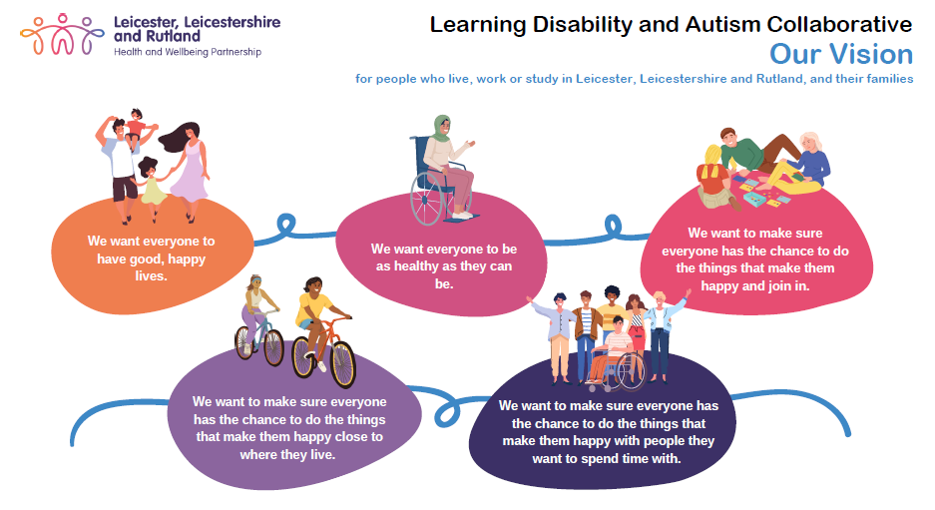

Guidance Notes for individuals, their families, and their carers

What is the Dynamic Support Pathway?
The Dynamic Support Pathway (DSP) has been developed to provide support if you have a learning disability, or you are an autistic person, and you are experiencing a deterioration in your health and wellbeing whilst you are living in the community.

Note: These concerns may be for a family member rather than for yourself.

Once you have agreed to be placed on the DSP, we will hold the following information about you:
- Your name
- Your date of birth (DOB)
- Where you live
- Who you live with
- What professional teams are working with you
- What support you currently receive
- What you are struggling with now
- How this is shown e.g., behaviour that challenges
- A plan of how those working with you can help you

Whether you want to be placed on the DSP is up to you and you may ask as many questions as you need to until you fully understand what it means for you. If you change your mind about being on the DSP, you can ask to be removed at any time.
Your information is kept very safely and can only be seen by the professionals working with you.

Who is the Dynamic Support Pathway for?
The DSP is for people with a learning disability and autistic people who are:
- experiencing a significant deterioration in their well-being
- increasing in risk/challenging behaviours towards yourself or others.
The goal is to identify your concerns early and to be able to take steps to provide you with additional support to prevent further deterioration and any escalation, which may lead to a crisis e.g., a breakdown of your family unit, or admission to a mental health or learning disability hospital when you do not need this admission.

Why do we have the DSP?
The DSP ensures that:
- if the identified challenges get worse, or there is an increase in your needs, the people who are already working with you know you well enough to be able to plan the best ways to give you extra care and support
- you continue to be treated with dignity and respect
- where possible we can maintain your home where you live
- you can continue to develop and maintain relationships with the people that are important to you
- you get continued support to remain at home where you live and not be admitted to hospital

How will the Dynamic Support Pathway help you?
The DSP ensures that:
- the people working with you are working together
- you get the right support in the right place, at the right time and from the right people
- you can stay at home where you live and not be admitted to hospital, wherever possible.
If you are a young person (up to the age of 18) you may also be able to have help and support from a Barnardo’s Keyworker.

What if you need to go into hospital?
Being on the DSP means that plans will be made to support you to stay in your home where you live, but sometimes you may still need to go to hospital as you may need more intensive support to get better.
If you do need to be admitted to a mental health, or learning disability hospital being on the DSP means that those working with you before your admission will work together with the hospital staff to support you going into the right hospital for you and plan for you to return to your return home when you are ready.

What if you don’t want to go on the Dynamic Support Pathway?
If you decide that you don’t want to be on the DSP, the people who are already working with you will still continue to help and support you. If you choose not to be on the DSP, then different services will not know about your needs and may not become involved with supporting you.
When you are on the DSP more people know about you so they can make a better help and support plan more quickly if you go into crisis or in an emergency.

Is going on the Dynamic Support Pathway right for you?
To decide if it’s right for you to be on DSP, you can talk to the people who know, and understand, you the best. They can help you understand what it all means and help you decide whether it is right for you.
There is also information available on the DSP webpage (in different formats) and for you to go back to while you are making the decision.

The link to the webpage is below:
Dynamic Support Pathway - Leicestershire Partnership NHS Trust (leicspart.nhs.uk)

Consent
Only people who give consent (agree) to go on the DSP can be included on the register. The information in this leaflet is to help you to decide if you want to be placed on the DSP, but you can say no – this is your right and choice.
If you are an adult but do not have capacity to make that decision, the people involved in your care with use the Mental Capacity Act to make a best interest’s decision on your behalf.
If you are under 18 years old and do not have capacity to consent, the person with parental responsibility, or legal guardianship, may make that decision with you or on your behalf.

Self-Referral to the DSP
If you have a confirmed learning disability or autism diagnosis you can refer yourself to the DSP. You can also ask a family member or friend to make the referral on your behalf.
You can also ask any professional who is involved in your care, for example a Community Psychiatric Nurse (CPN) or GP, who knows you well and understands how things have changed for you, to make a referral to the DSP on your behalf.
Your referral form will be checked by a professional to make sure you meet the criteria to be on the DSP. Someone will then contact you to discuss your referral and may gather more information from you. Your referral will then be processed by the team that manages referrals.
If you do not meet the criteria for the DSP, you will be given signposting information on where to get further help and guidance from different services, for example the Autism Space website.
The self-referral form can be found on the DSP webpage:
Dynamic Support Pathway - Leicestershire Partnership NHS Trust (leicspart.nhs.uk)
If you have any questions or queries, you can contact the DSP co-ordinators by telephone on 07584 800 301 or via the email addresses below:
Adults lpt.adult-lda-dsp@nhs.net
Children lpt.childrens-lda-dsp@nhs.net

