Outpatient Neuropsychology Service

Service Information Leaflet




About our service
What is neuropsychology?
Neuropsychology is a branch of psychology that looks at how changes to the brain can affect a person’s cognition (thinking).

The Clinical Neuropsychology Department sees people whose cognition may be affected by acquired brain injuries, as well as chronic or progressive neurological conditions (e.g., multiple sclerosis, Parkinson’s disease).

What do we do?
Our job is to explore your cognition to see what is working well and what might be more difficult and to find ways in which we can support you with this. Some areas we may look at include:

• Memory
• Attention and concentration
• Language
• Thinking speed
• Visual perception (i.e., making sense of what we see)
• Higher functions (e.g., problem solving, planning)
• Mood
• Lifestyle

The neuropsychological assessment process
Step 1: We will meet with you to discuss how you are managing your thinking, emotions, behaviour, and daily tasks. We will ask you about any changes in your thinking or behaviour and decide if it is appropriate to do an assessment.

Step 2: If you agree to the assessment, we will ask you to come in and complete some pen/paper or computer tasks (e.g., drawing items, remembering words). These will help us look at your thinking skills and how they compare with others of your age. It can take multiple appointments to complete all these tasks, each appointment may last between 1-3 hours.

Step 3: After you have completed the assessment, we will offer a feedback session to discuss the results of any tasks completed, strategies to help your thinking, and any referrals to other services we think will benefit you.

Note. It can also be helpful to speak to people that know you well to see if they have noticed any changes in your thinking skills. Clinicians will ask for your permission before doing so.


Frequently asked questions (FAQs)
If you have a question for us and cannot find the answer here, please contact us.

What can a neuropsychological assessment do?
The assessment can help us to understand your strengths and weaknesses regarding your cognition (thinking skills). Using the information gathered during the assessment, we can work together to develop strategies that can help you to achieve your goals (e.g., to become more independent, to complete daily tasks).

The results of the assessment and any strategies we come up with will be written in a report which will be shared with you after your assessment. You may choose to share this report with your family members, place of work or study, GP, or other healthcare professionals so they are also aware of the support you may need.

The assessment can only tell us how your cognition is working at this moment in time and cannot predict how your thinking skills will change over time. However, if you require another neuropsychological assessment in the future, we can compare your scores across assessments to see how things have changed.

Do I need to prepare?
We recommend being well rested and relaxed prior to attending your appointment. Try to get a good night’s sleep and ensure you are hydrated and have eaten before coming to see us. You are also welcome to bring a drink and a snack with you to your appointment. If you need to wear glasses make sure you have those with you too. You may also find it helpful to write down anything you wish to ask or share during the appointment.

Is it going to be hard?
We choose testing tasks based on what we already know about your condition or injury and the different areas of cognition that you may be having difficulty with. These tasks are designed to be challenging, and it is normal to find some of them a bit tricky. If we only tested your cognitive strengths, we wouldn’t be able to help you.

However, we do not choose tasks that we believe you will not be able to manage. It can sometimes feel disheartening if you don’t complete the tasks as well as you thought you would but all we ask is that you try your best. If you do struggle with the testing process, make sure to discuss this with your clinician as they will be able to support you with this.

I’m anxious about the assessment, what do I do?
It is completely normal to feel anxious before the assessment, especially if it is the first time you have done any cognitive testing, or your cognition is not working as well as it previously has been. Our aim is to provide an environment where you feel comfortable and at ease. If you do feel uncomfortable at any time, please do speak with your clinician.

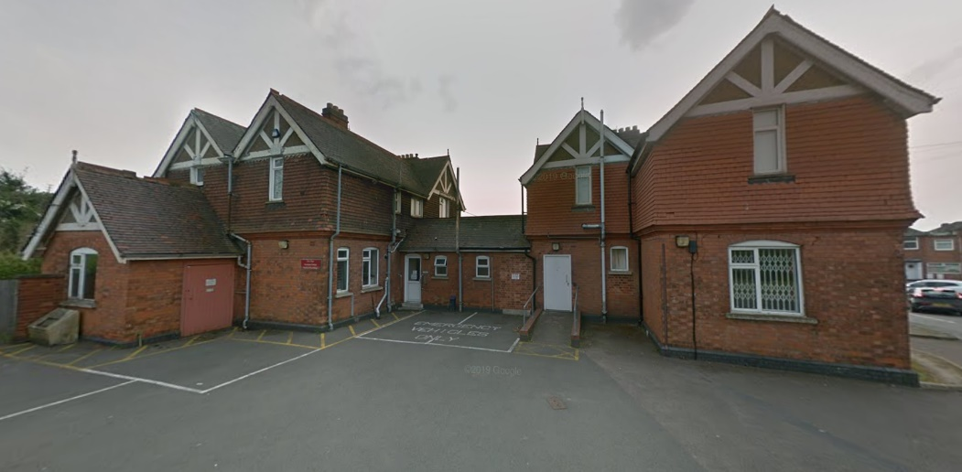



Our contact details

Telephone: 0116 258 4956 (Mon–Fri, 9am-5pm)

Email: lpt.neuropsychology.adult@nhs.net

Address: Lodge Two, Leicester General Hospital, Gwendolen Road, Leicester, LE5 4PW

How to find us
The Lodge Two is located on the Leicester General Hospital Site. It is the house immediately to your right after the Wakerley Road/Broad Avenue entrance to the hospital. There are a limited number of parking bays directly outside the building and a small layby. You are very welcome to park in these spaces if they are available. Otherwise, you will find some pay and display car parks on the hospital site.

Please note we are not an emergency service. If you need immediate help, please use the services outlined below:

Local services:
- The Mental Health Central Access Point (CAP) - 24/7 support is available over the phone, call NHS 111, mental health option. This number is open 24 hours a day and is totally free and confidential.
You can also text 0748 063 5199 and we will aim to get back to you within 12 hours.
- Your local GP
- NHS out of hours GP services – call 111
- Emergency Department (A&E) - for serious and life-threatening illnesses and injuries
- Neighbourhood mental health cafes

National services:
- Samaritans – a free and confidential telephone listening service. Call 116 123 (24/7, seven days a week) www.samaritans.org
- SHOUT – a free and confidential text messaging service for anyone who is struggling to cope. Text ‘SHOUT’ to 85258

Note. Leicestershire Partnership Trust (LPT) are not responsible for services which are not part of the Trust.

Date implemented: January 2025
Last review: January 2025
Review date: January 2026
Leaflet No: DMH/OPN/01

