

Quality Account 2024/25 in brief

Our Quality Account is a report about the quality of services that we provide. It aims to tell people about issues that can affect quality of care, how we maintain standards, and about improvements that we are making.

This is a summary of the Quality Account. You can find more information in our full Quality Account 2024/25, and our Annual Report 2024/25 which are available on the ‘what we do’ page of our website at <https://www.leicspart.nhs.uk/about/what-we-do/>

If you need help to understand this summary or would like it in a different language or format such as large print, Braille, or audio, please email lpt.feedback@nhs.net

Highlights of the year

2024/25 was a challenging year but we have a lot to be proud of, not least our staff who work hard every day to deliver high standards of care to the people of Leicester, Leicestershire, and Rutland. Below are a few highlights from the year. You can read more in our full Quality Account (QA).

Following unannounced inspections, the Care Quality Commission (CQC) published reports on our community health services for adults and our acute mental health wards for working age adults and psychiatric intensive care units. We were pleased that they recognised that both core services had made improvements since their last inspection.

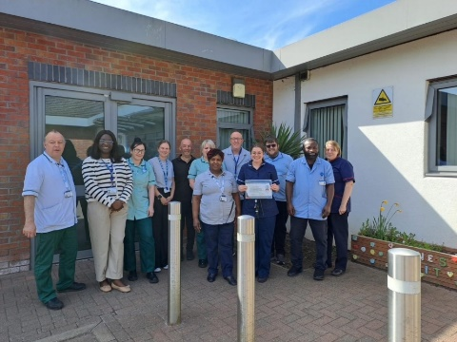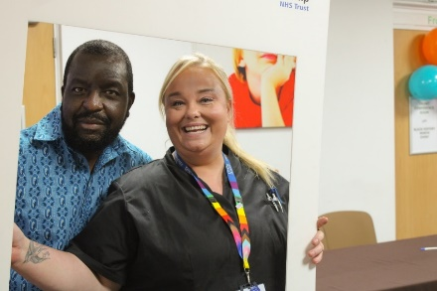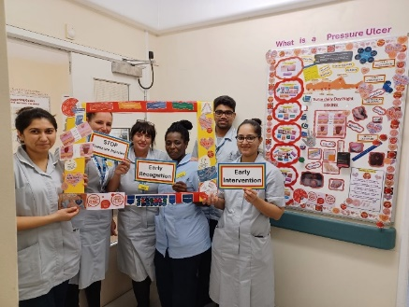We grew our 100-strong voluntary sector alliance and introduced over 25 neighbourhood mental health cafes to bring care closer to people.

Our Trust was the top mental health trust in the country for cleanliness and privacy, dignity, and wellbeing in this year’s national PLACE assessments of mental health care environments.

LPT was the second most improved mental health and community health trust in the country in the NHS staff survey. An above average proportion of our staff now recommend LPT as a place to work and deliver care.

This year we completed works to eradicate all our dormitory provision for our mental health inpatient services. This has improved safety, privacy, and dignity for patients.

Lived Experience Partners (LEPs) continued to help shape our work and ensure the voices of people who use our services are being heard. LEPs played a significant role in the successful introduction of Triangle of Care (TOC) into our adult mental health inpatient and crisis services, palliative care services and children and young people’s care navigation and therapy services. TOC is an alliance between carers, patients, and health professionals. It is helping to make sure that unpaid carers consistently have a positive experience of our services by being included, listened to, and supported.

Our ‘Step Up to Great’ strategy came to its natural end at the end of 2024/25, and we look forward to our new Group strategy ‘Together we thrive’. This will enable us to continue to build on the success of Step up to Great and increase partnership working with our colleagues in Northamptonshire Healthcare NHS Foundation Trust (NHFT).

Progress against our priorities in 2024/25

Priority one: Personalisation of Care

Personalisation of care is important because it prioritises a person’s needs, preferences, and values, fostering dignity, respect, and empowerment. This leads to better outcomes and improved quality of life. We said we would identify a number of services where we would implement plans for improvement. Improvements delivered in 2024/25 include the development of Easy Read documentation to support patients in our learning disability inpatient unit and the inclusion of information about shared decision making as part of induction for staff joining LPT and newly qualified nurses and therapists. Read more on page seven of the full quality account.

Priority two: Triangle of Care implementation and accreditation

We want unpaid carers to consistently have a positive experience of our services by being included, listened to, and supported. We said that we would progress introduction and accreditation with the national Carers Trust Triangle of Care (TOC). This will ensure that our staff work in collaboration with unpaid carers and those receiving care to make sure that they are consistently and appropriately involved and supported. We did this and as a result more than 500 staff have already received carer awareness training. We improved our carer information and introduced new areas on our electronic patient record where we can record and monitor our support for carers. Read more on page nine of the full quality account.

Priority three: Implementation of the Patient Safety Incident Response Framework (PSIRF) and the development of our safety culture

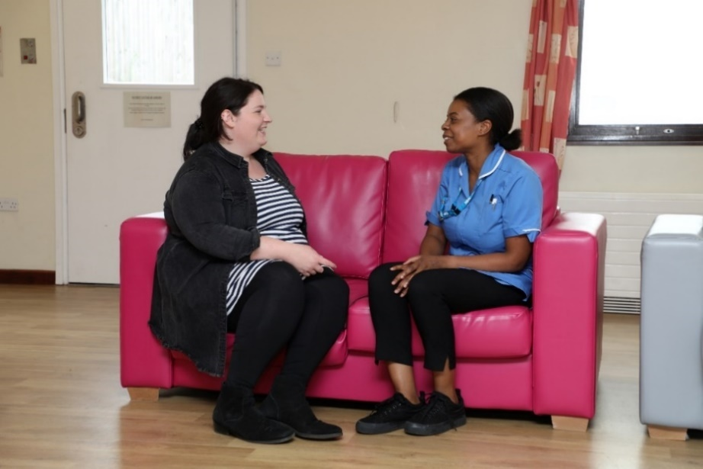We want to improve our safety culture and our capacity and capability to learn and improve patient safety within our services. PSIRF focuses on learning and improvement rather than solely on incident classification. Importantly it also promotes compassionate engagement with the patients, families, carers, and staff affected by incidents. We said we would roll out our patient safety incident response plan and review incidents where we believe the most significant learning opportunities lie to bring about improvement. Roundtable reviews were introduced which bring people together from different disciplines and professions to help identify learning from one or more incidents. We developed a sexual safety charter for our wards and enabled staff to have easier access to clinical information like blood pressure in the electronic patient record for patients who are under the care of more than one of our services. We also reduced level three and four (continuous) observations on the wards where we care for people with conditions like dementia. We did this by introducing the Enriched Model of Care which focuses on meeting people’s psychological needs. Read more on page 11 of the full quality account.

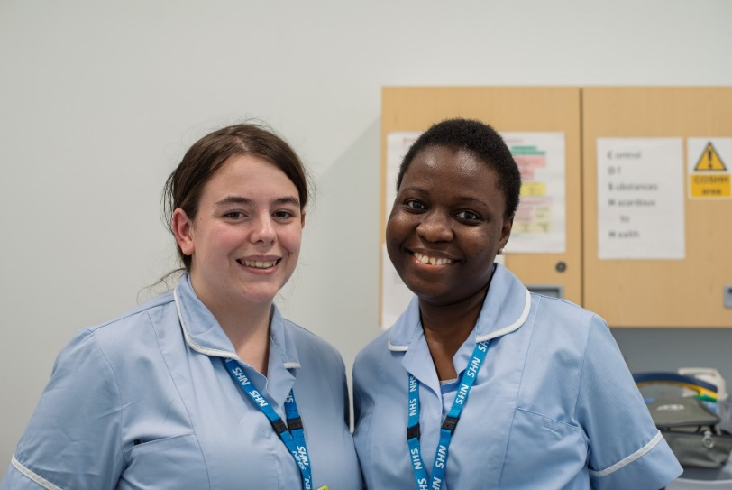Priority four: Pressure ulcer prevention through repositioning

Pressure ulcers are mainly avoidable. They can impact on the emotional, mental, physical, and social aspects of a person’s life and can be expensive to treat. We said that we would help/advise adults at risk of developing pressure ulcers who are unable to reposition themselves in our community hospitals and under the care of our community nursing teams to change their position according to their wishes and needs. We simplified bedside repositioning paperwork to improve compliance and involved the tissue viability team in producing individualised pressure ulcer prevention staff training plans. We introduced coding information in our electronic patient record to enable us to report on repositioning compliance. We created a new patient leaflet giving advice about the importance of repositioning in people’s own homes, and we introduced new pressure ulcer role-essential training for community healthcare support workers. Read more on page 13 of the full quality account.

Priorities for improvement next year (2025/26)

We chose our quality account priorities for 2025/26 following a review of information about quality. This included listening to what the people who use our services said about the care and support that we provide.

Priority one: Roll out of Triangle of Care

We recognise the valuable insight and huge role that carers play in supporting people in our care. Introducing Triangle of Care (TOC) into services will ensure that our staff are trained and equipped to provide the engagement, information and support that unpaid carers need. We will build on work already started by expanding TOC assessment and accreditation to our community mental health and learning disability services.

Priority two: Implementation of the Patient and Carer Race Equality Framework through Together Against Racism work

The Patient and Carer Race Equality Framework (PCREF) has been introduced for all NHS mental health trusts. This mandatory framework will support us in becoming an actively anti-racist organisation by ensuring that we co-produce and implement action to reduce racial inequalities within our services. We intend to build on the work already underway across the Trust. For 2025/26 we will focus on four key areas of work: workforce and cultural awareness, partnership working, co-production and lived experience and data improvement.

Priority three: Improving assessment and prevention of moisture associated skin damage (MASD) for patients in community hospitals

Pressure ulcer prevention remains a high priority for us. In 2025/26 we will extend our focus to MASD. People with MASD can experience persistent symptoms such as discomfort and/or pain, wound leaking, bleeding, and odour, all of which can negatively impact their quality of life. MASD is not caused by pressure, however many patients will have risk factors for both MASD and pressure ulcer development. We will set up a MASD community hospital community of practice group which incorporates nurses, allied health professionals, continence, and tissue viability expertise. We will share learning group work with colleagues in NHFT. We will establish our baseline measures, outcomes, and quality improvement plan, and focus interventions on process, staff training and resources.

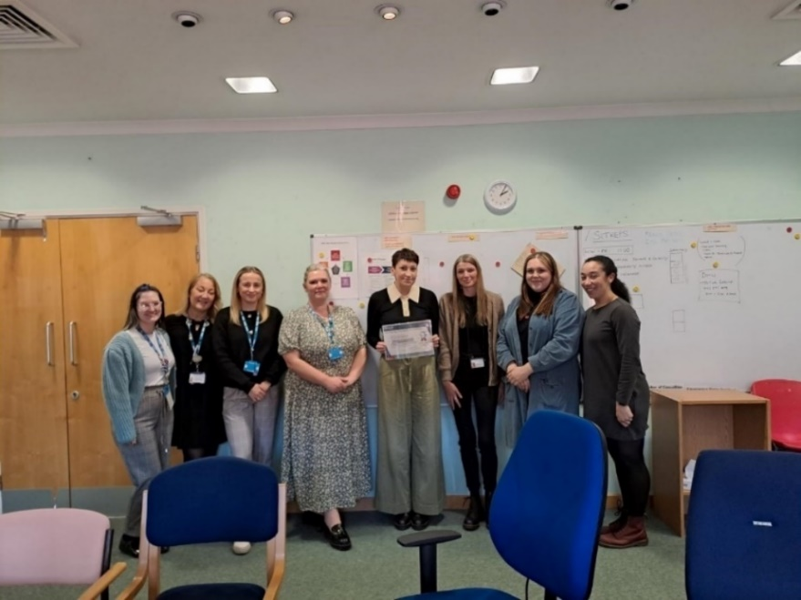Driving quality improvement

Our work to monitor standards and drive forward improvement in LPT is carried out in many ways.

Quality, compliance, and regulation

Our quality, compliance, and regulation (QCR) team continued to act as the central point of contact for organisations that check how well we are doing, such as the Care Quality Commission. The team supports trust staff to meet regulatory and best practice standards, as well as identify areas for improvement. Their work includes talking to new and existing staff about regulations and what happens when the CQC come to inspect.

The team also coordinate and carry out a range of visits to services aimed at highlighting good practice and identifying areas for improvement. Visits help staff to see services with a fresh pair of eyes and can enable escalation of issues which they may have struggled to resolve locally such as outstanding maintenance works. This year visits have also led to a focus on several Trust-wide issues including clarifying and standardising arrangements for the safe management of medicines which are taken out of bases into people’s own homes. Feedback from visits is collected and we use it to identify any themes and areas that we need to focus on.

Our Valuing High Standards Accreditation (VHSA) programme continued to develop and this year a further 11 teams reached full accreditation. Accreditation is important because it helps us to continuously improve the quality and safety of our services and share best practice across the Trust. Charnwood Older People's Community Mental Health team were awarded ‘Gold’ accreditation. Going through accreditation motivated the team to push forward several improvements including a new nurse-led clinic and an offer of non-pharmaceutical support to care home patients.

WeImproveQ

Our quality improvement (QI) programme called ‘WeImproveQ’ ensures we have a systematic approach to QI enabling all staff to be able to identify when change is needed, develop quality improvement skills, and lead improvement in patient care and outcomes. This year, 32 staff completed the Quality, Service Improvement and Redesign (QSIR) Programme and, 313 staff attended our internal QI workshops covering various QI topics such as clinical audit and quality monitoring. Overall, 1371 staff have now attended some form of QI learning.

We work in partnership with Northamptonshire Healthcare NHS Foundation Trust (NHFT) in a group model, with shared group strategic priorities. Collaboration as a group offers opportunities to make a difference together through sharing best practice and learning. In 2024/25 our group QI work continued to look at learning and improvement in three areas: pressure ulcer prevention, recognising and treating the deteriorating patient, and safe and supportive observations for mental health and learning disability. Read more on page 31 of the full quality account.

Clinical audit is an important way to find out if the services we deliver are being provided in line with standards. It can tell us and the patients we care for where a service is doing well, and where there could be improvement. We use a web-based platform to help make our audit work easier, faster, and more effective. There are 37 clinical audits, 16 national audits and 68 service evaluations currently on the system.

Examples of improvement this year because of audit includes delivering refresher training to remind staff about the importance of documenting how they have involved carers in setting goals for patients. We also standardised the process for supporting patients who ‘did not attend’ an appointment with the perinatal mental health team. Read more on page 19 of the full quality account.

Participation, co-production and patient and carer experience

Very importantly our quality improvement activity includes the involvement of patients, carers, and families in our work. We now have 27 Lived Experience Partners (LEPs). Lived experience partners are individuals who share their personal experiences with healthcare services to help improve them. They are employed to work alongside staff, patients, and carers to provide insight into the design, improvement, and delivery of our services. In addition to the Partners, our Youth Advisory Board (YAB) and People’s Council, as well as over 300 members of our Patient and Carer Involvement Network, continued to provide insight and influence the development of services.

Our YAB continued to support LPT and the wider health community to help people think about children and young people and make sure that information for them is accessible and relevant. This included creatingself-harm imagery to spread awareness internally for our staff in child and adolescent mental health services as well as helping ourMental Health in Schools Team shape their new winter wellbeing booklet to ensure young people stay healthy and well over the winter months.

Our People’s Council focused on developing relationships across the Trust. The Council got involved in providing advice on the roll out of shared decision-making, reviewing complaints about communication and making recommendations for improvement, and started to plan how the Council can help us to tackle racism and health inequalities. Read more on page 29 of the full quality account

Our research

Research is also an important part of our learning and continual improvement. Here are two examples of our research projects:

* The Eating Disorders Genetics Initiative aims to understand how genes can influence an individual's risk for developing bulimia nervosa, binge-eating disorder, and anorexia nervosa.
* The Vision-Quest study aims to develop a new measure which explores people’s beliefs about distressing visual hallucinations (visions) and the relationships between visions and other difficulties such as poor sleep quality in patients who have psychosis.

Over 2024/25 we have supported 529 participants to take part in research studies approved by the Health Research Authority. Our team develop and deliver research workshops to support staff to get involved in research. This year we appointed our first research ambassadors - a group of nurses and allied health professionals committed to inspiring a culture of research by raising awareness and educating staff. Read more on page 37 of the full quality account.

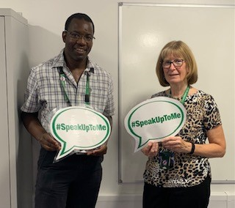Freedom to speak up

The safety of patients and staff is the number one priority for us and a vital part of this is staff feeling able to speak up about anything they have a concern about at work. Whether staff witness something that has not gone to plan, potential for harm which could be prevented or practice that could be improved upon, we value the importance of speaking up with the assurance of confidentiality, safety and without detriment.

We have two Freedom to Speak Up (FTSU) Guardians, supported by a network of 25 FTSU Champions, enabling a responsive, visible, and resilient service.

This year we undertook a series of events to promote the importance of speaking up and developed new resources to help all staff understand the speak up process. We introduced a new confidential phone line and reporting form as well as role essential speak up e-learning. This aims to empower staff to understand their role in promoting a healthy speaking up culture that safeguards patient safety and enhances employee experience.

During 2024/25 169 speak up cases were received. These covered a range of topics, including queries relating to patient care and safety, the interpretation of policies and procedures, matters affecting recruitment, retention and career development, leadership behaviour and professional relationships. Read more on page 39 of the full quality account.

Service improvement examples

When the Care Quality Commission - the regulator of health services in England - visit services they ask five key questions: is it caring? Is it responsive? Is it effective? Is it safe? and is it well-led? We aim to answer yes to all these questions. In our full quality account, we have presented lots of examples of ways in which we have developed services over the last year under each of these headings. Below are just a few. Read more from page 42 of the full quality account.

Post-incident pathway for staff support

This year we introduced a new policy and process for supporting staff following a traumatic event, including incidents of violence and aggression. This offers a structured framework for delivering evidence-based psychological support to staff. It involves immediate, follow-up and on-going support which can be personalised depending on the team and circumstances. This ranges from team huddles and support from peers, leads and managers, to post event reflection later and involvement of occupational health or counselling services.

One stop memory clinic

In November we began to trial a memory one stop clinic. This sees patients being assessed by nursing staff and supported by the medical team to create diagnosis and treatment plans, all in one appointment. The aim is to reduce the wait time between assessment and diagnosis. We are fortunate to have Age UK also attending to provide support for patients after their appointments, linking them in with voluntary sector offers tailored to their individual needs.

**Improved safety following a fall**

Following several incidents where patients had fallen, we have introduced flat lifting equipment into our community hospital wards. There are risks to a patient remaining on the floor and hoisting a patient can potentially worsen an injury. Now if a patient falls, following a head-to-toe clinical assessment we can raise them from the floor in a safe and controlled way. This has significantly reduced the risk of harm for patients who have fallen. The equipment also reduces risk of a musculoskeletal injury to staff.

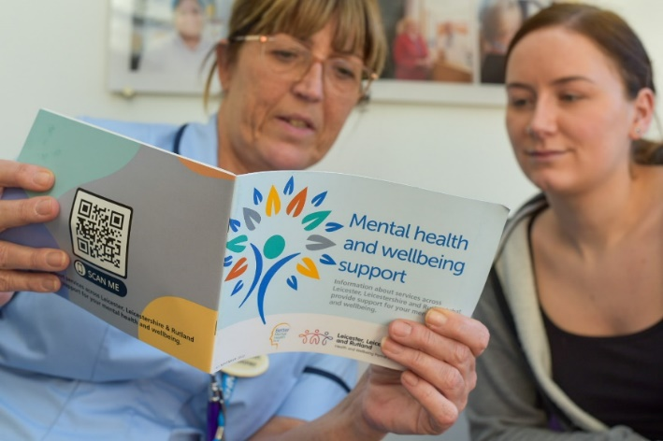Innovative headsets help treat patients with severe depression

Patients with depression are reporting significant improvements in their symptoms after using a new brain stimulation headset at home as part of a pilot project led by LPT. Our crisis mental health team, which supports patients with severe depression who are at risk of admission to hospital, was the first NHS mental health crisis service in the UK to offer the Flow Neuroscience headsets as a treatment option. The headsets work by applying a gentle electrical current to stimulate and restore activity to an area of the brain. Patients use them themselves at home. Wherever possible and when safe to do so, we want to treat people in their homes, rather than in hospital. This is often where they feel comfortable and so can provide a better environment to aid recovery.

## 

**Wellbeing and inclusion check-ins with our executive team**

All staff and volunteers are now invited to join regular online ‘check in’ sessions, led by our deputy chief executive. These open forums are an opportunity for staff to share how they and their service are doing, and/or raise any concerns or suggestions that may help them to continuously improve the way we do things.

Promoting sustainability

We have a Trust-wide sustainability and greener group and this year they have overseen a wide range of sustainability improvements, including the introduction of copiers and printers on a network which all staff can access. So far, we have been able to return 82 printers to the supplier for recycling. We have also reduced medicines waste by working with schools to provide Salbutamol inhalers and Adrenaline autoinjector supplies, avoiding the need for duplicate prescriptions for each child to keep a spare at school. Over 200 schools have signed up to centralised stock.  In addition, we have introduced the role of medicines administration technicians on wards to optimise use of patient’s own drugs and begun to recycle insulin pens with the manufacturer. This is preventing plastic, glass, and metal from ending up in landfill.

Recruitment and workforce wellbeing

Promoting health and wellbeing

The health and wellbeing of our staff is extremely important to us. Our staff support networks continued to provide a safe and non-judgemental place to talk and be heard. We have networks representing the armed forces, carers, mental and physical life experiences, men’s health, neurodiversity, race ethnicity and cultural heritage, LGBTQIA+ and women.

We held regular compassionate leadership and leading together conferences to support our leaders to create the most inclusive, compassionate culture at LPT.

As part of our ‘Our Future Our Way’ (OFOW) culture programme we co-produced and launched a definition of what psychological safety means in LPT. This will support people to have local conversations to improve experience for all. Read more about the Our Future Our Way programme and our wellbeing offer for staff in the Trust’s Annual Report 2024/25.

“Psychological safety means people feel safe in an open, supportive, and inclusive environment, where people are treated with kindness, trust, respect, compassion, and integrity. Where everyone feels that they belong and are valued when they speak up. It is a space where people always feel listened to without fear or judgement. It starts with me and builds when we work together.”

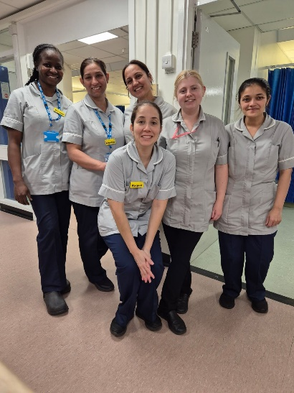

During 2024/25 we introduced a new fit for purpose recruitment IT system and increased the recruitment of substantive staff, with particular success in the recruitment of healthcare support workers. Filling substantive vacancies helps to reduce how much we spend on spend on bank and agency staff and improves continuity of care for patients. We reduced our ‘time to hire’ from a high of 63 days, to 36 days on average. We have also seen our new starter feedback improve, for example with satisfaction with communication improving from a score of 2.21 out of 5 to 4 out of 5.

We launched a reasonable adjustment clinic to help us understand and identify practical solutions to help remove barriers that some employees face relating to underlying health conditions or disability. Solutions could include changing the lighting above someone’s desk, distributing someone’s breaks more evenly across the day or providing emails and documents in an accessible format.

Further information

Thank you for reading our Quality Account in brief for 2024/25. You can read much more about our work in our full Quality Account 2024/25, and our Annual Report 2024/25 which are available on the ‘what we do’ page of our website at <https://www.leicspart.nhs.uk/about/what-we-do/>

Next year is all about making a difference together. As we go into 2025/26 we launch our new strategy: ‘THRIVE’. The six key elements of this are: technology; healthy communities; being responsive; including everyone; valuing our people; and being efficient and effective. If we do all these things, together we will thrive, building compassionate care and wellbeing for all.

If you would like to find out more about anything included in this Quality Account in brief, or you have ideas about how to make the document better in future, please don’t hesitate to get in touch on [LPT.feedback@nhs.net](mailto:LPT.feedback@nhs.net) or telephone: **0116 295 1350.**