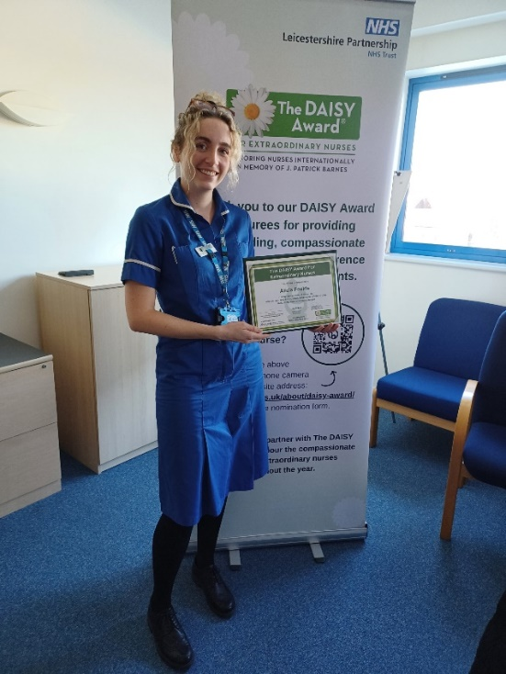Quality Account 2024/25 in brief

Community Health Services

Our Quality Account 2024/25 describes some of the great work that our staff do day in day out to deliver high quality, safe care. It also describes some of the difficulties we face in meeting increasing demand and expectations, and how we monitor and manage issues affecting quality within the organisation.

This summary gives examples of some of the many quality improvements in our Community Health Services Directorate in 2024/25.

If you need this information in another language or format, please telephone 0116 295 0903 or email: [lpt.patientinformation@nhs.net](mailto:lpt.patientinformation@nhs.net)

Personalisation of care

Personalisation of care is important because it prioritises an individual's needs, preferences, and values. This leads to better outcomes and improved quality of life. We focused on improving personalisation of care on our community hospital wards and in our integrated community specialist palliative care and long-term conditions teams. Our care record audits show that we’ve got much better at sharing information and having discussions with patients. By the end of the year, 97.8% of the care records audited for these areas showed clear evidence that the patient had been asked what was important to them in terms of quality of life. This is an improvement from 87.1%. The number of records showing clear discussion with patients about their goals while they are in our care and how they will achieve them also rose - from 82.3% to 97.8%

Supporting carers

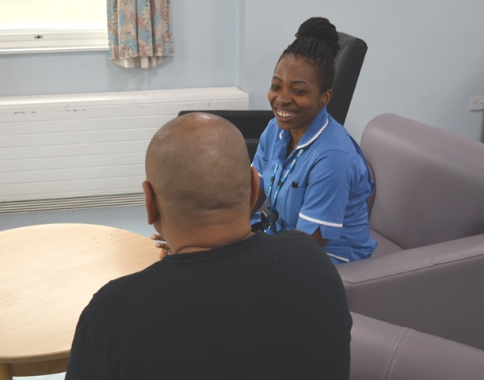Our palliative care service has worked towards accreditation with the national Triangle of Care (TOC) Programme. TOC is a therapeutic alliance between carers, patients, and health professionals. Its roll out will ensure that our staff work in collaboration with unpaid carers and those receiving care to make sure that they are consistently and appropriately involved and supported. Staff in the palliative care team have had training, know how to identify carers, and can give them support and information to help with their caring needs. All services within the CHS directorate will work towards TOC accreditation over the next two years. Read more on page nine of the full quality account.

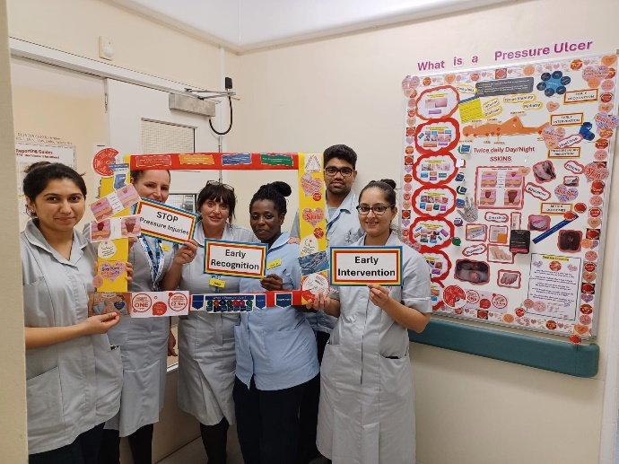Pressure ulcer prevention through repositioning

Pressure ulcers are mainly avoidable. They can impact on the emotional, mental, physical, and social aspects of a person’s life and can be expensive to treat. We said that we would help and/or advise adults at risk of developing pressure ulcers in our community hospitals and under the care of our community nursing teams who are unable to reposition themselves to change their position according to their wishes and needs. We simplified bedside repositioning paperwork to improve compliance and involved the tissue viability team in producing individualised pressure ulcer prevention staff training plans. We introduced coding information in our electronic patient record to enable us to report on repositioning compliance. We created a new patient leaflet giving advice about the importance of repositioning in people’s own homes, and we introduced new pressure ulcer role essential training for community healthcare support workers. Read more on page 13 of the full quality account.

Collaborating for better health and wellbeing

Our complex nursing service in Blaby joined up with our local mental health services to better support housebound people at risk of loneliness and isolation. They are sharing the Joy app which helps people to find local support and activities, volunteering, and social clubs. Mental health training and awareness for physical health staff has been identified and the teams will meet up to learn and plan how they can work together for the local population.

Evidence-based practice

We have three members of staff driving quality improvement in their service areas as part of the Director of Nursing and Allied Health Professions Fellowship. This is a programme that supports band five nurses and therapists to enhance the quality of care they provide using an evidence-based approach. Projects cover a wide range of subjects including two by physiotherapists - one to improve seating provision within stroke rehabilitation and another to improve staff knowledge of the community hospital remit to gain informed consent for referral. In a third project, one of our occupational therapists is looking to give patients more independence by exploring toilet ergonomics (the science of designing and arranging the environment) in community hospitals. Projects all involve people with lived experience.

Utilising technology

We listened to staff who were saying that significant clinical time was being spent capturing and uploading clinical data, and that images (for example, of wounds) were not always available to view, resulting in lack of oversight of a patient’s condition at the point of triage and between visits. As a result, our community health services have been piloting the use of the Isla digital pathway platform to support patients in their care journey. The platform allows both patients and staff to securely capture data to support clinical decision making. It is safe and secure and can be used to share documents, photos, videos, and sound recordings which can be simply saved to a patient’s care record. Isla has been piloted in district nursing, podiatry and our lymphoedema non-cancer service. It is being used in community wound care, community nursing, and in therapies to share welcome packs with new patients.

Feedback from the service has been positive, and we’ve seen improved record keeping, smarter patient prioritisation and efficiency and, very importantly, improved clinical outcomes. Patients have responded positively, saying they enjoyed being able to submit photos of wounds in between visits and that it was easy to use. In one pilot we estimate that use of Isla saved 226 hours of clinical time equating to more than £5,000 in a six-week period**.**

Going above and beyond for patients

When a highly specialist wound dressing used by a patient of our community nursing service was no longer available, our nursing team worked with the patient and family to enable an unconventional alternative to be used. No licenced product could be sourced, the patient was at risk of deterioration, and the patient’s partner wanted to digitally produce an alternative. 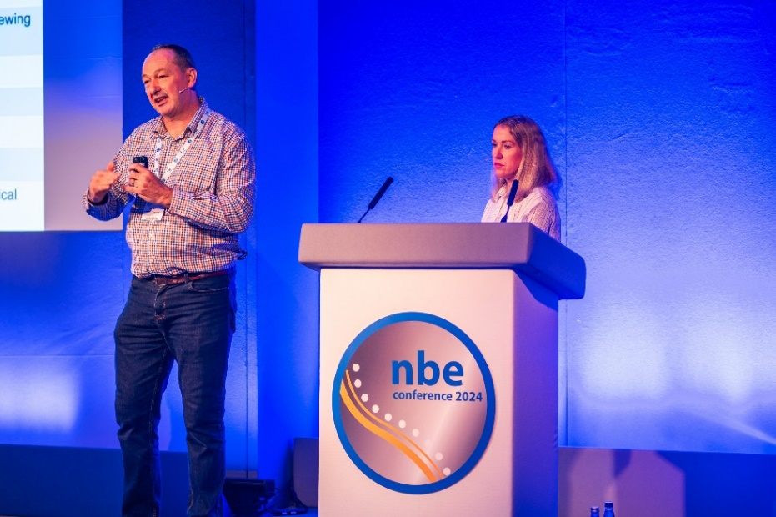Our nursing service worked extensively with specialist and legal advisors to put arrangements in place to ensure that they could continue to safely support the patient to manage this very complex wound.

**Improved safety following a fall**

Following a number of incidents where patients had fallen, we introduced flat lifting equipment into our community hospital wards. There are risks to a patient remaining on the floor and hoisting a patient can potentially worsen an injury. Now if a patient falls, following a head-to-toe clinical assessment we can raise them from the floor in a safe and controlled way. This has significantly reduced the risk of harm for patients who have fallen. The equipment also reduces risk of a musculoskeletal injury to staff. We shared our great work with the rest of the NHS at the National Back Exchange (NBE) Conference in October.

More information

You can find more information - including a look towards our future priorities - in our full Quality Account 2024/25 and our Annual Report 2024/25 which are available on the ‘what we do’ page of our website at <https://www.leicspart.nhs.uk/about/what-we-do/>

We welcome your questions or comments on this summary or our services.

Telephone: **0116 295 1350,** Email: LPT.feedback@nhs.net

Published September 2025