Quality Account 2024/25 in brief

Directorate of Adult Mental Health

Our Quality Account (QA) 2024/25 describes some of the great work that our staff do day in day out to deliver high quality, safe care. It also describes some of the difficulties we face in meeting increasing demand and expectations, and how we monitor and manage issues affecting quality within the organisation.

This summary gives examples of some of the many quality improvements in our Directorate of Mental Health in 2024/25.

If you need this information in another language or format, please telephone 0116 295 0903 or email: [lpt.patientinformation@nhs.net](mailto:lpt.patientinformation@nhs.net)

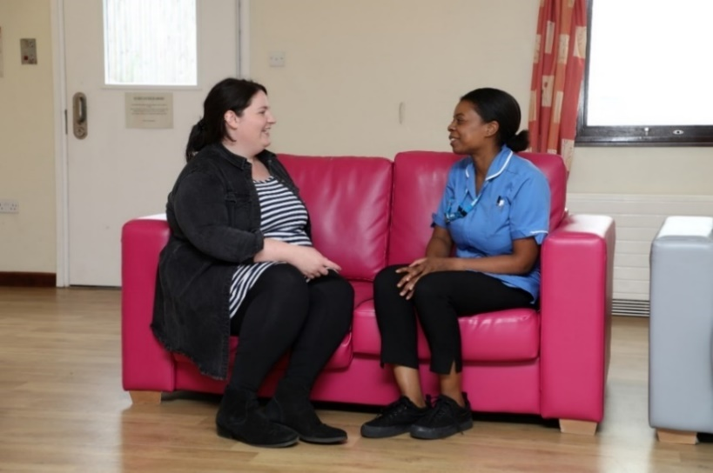Supporting carers

Our adult mental health inpatient and crisis services worked towards accreditation with the national Triangle of Care (TOC) Programme. TOC is a therapeutic alliance between carers, patients, and health professionals. Its roll out will ensure that our staff work in collaboration with unpaid carers and those receiving care to make sure that they are consistently and appropriately involved and supported. Staff in our inpatient and crisis services have had training, know how to identify carers, and can give them support and information to help with their caring needs. All services within the adult mental health directorate will work towards TOC accreditation over the next two years. Read more on page nine of the full quality account.

Evidence-based practice

We have two members of directorate staff driving quality improvement in their service area as part of the Director of Nursing and Allied Health Professions Fellowship. This is a programme that supports band five nurses and therapists to enhance the quality of care they provide using an evidence-based approach. In one project a mental health facilitator is working to improve communication between GPs and mental health clinicians in primary care. In the other a substance misuse worker is working to improve outcomes for mental health patients who use drugs as part of their sex life. Projects all involve people with lived experience.

One stop memory clinic

In November we began to trial a memory one stop clinic. This sees patients being assessed by nursing staff and supported by the medical team to formulate diagnosis and treatment plans all in one appointment. The aim is to reduce the wait time between assessment and diagnosis. We are fortunate to have Age UK also attending to provide support for patients after their appointments, linking them in with voluntary sector offers tailored to their individual needs.

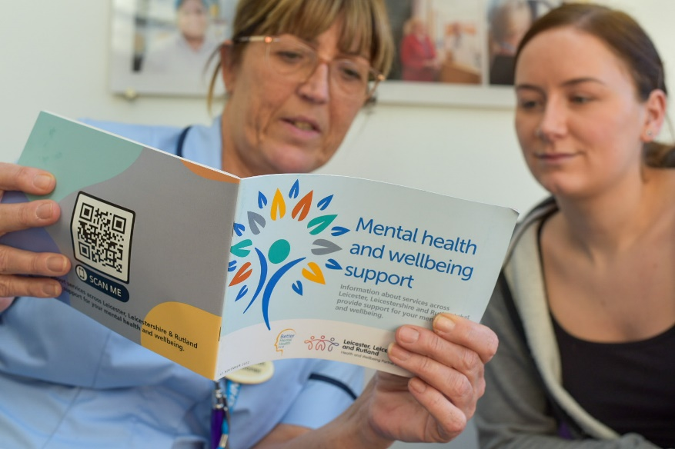Improving connection with patients

Our neighbourhood mental health teams have introduced the role of Community Connector. Service users now have contact with their neighbourhood mental health team within 72hrs of referral, ensuring early access, increased opportunity for supporting risk management and ensuring a prompt response to service user needs. Community Connectors identify and understand what matters to patients in relation to their wellbeing. They discuss any areas that may require support, for example, in respect of their health, loneliness, finance or housing. They collaboratively develop and agree a shared vision of appropriate interventions.

Innovative headsets help treat patients with severe depression

Patients with depression are reporting significant improvements in their symptoms after using a new brain stimulation headset as part of a pilot project led by LPT. Our crisis mental health team, which supports patients with severe depression who are at risk of admission to hospital, was the first NHS mental health crisis service in the UK to offer the Flow Neuroscience headsets as a treatment option.

Flow Neuroscience headsets work by applying a gentle electrical current to stimulate and restore activity to an area of the brain. Patients use Flow themselves at home. Wherever possible and when safe to do so, we want to treat people in their homes, rather than in hospital. This is often where they feel comfortable and so can provide a better environment to aid recovery. To read more about Flow’s depression treatment visit the Flow website at [www.flowneuroscience.com/](https://www.flowneuroscience.com/)

**Prioritising privacy and dignity**

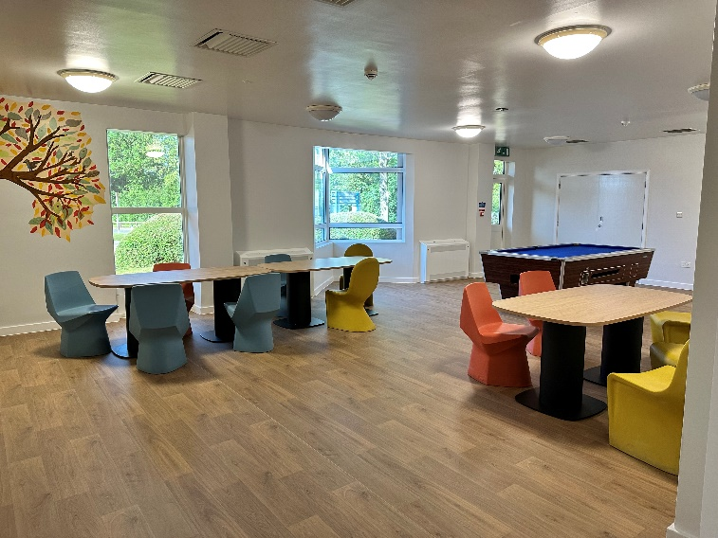Our ambitious plan to eliminate dormitory accommodation across our adult mental health inpatient wards is complete. Kirby Ward at the Bennion Centre was the last ward to be renovated, replacing dormitory accommodation with single ensuite rooms. The ward reopened in December. This has improved the safety, privacy, and dignity of patients with mental ill health.

Good care environments

Following detailed planning, our psychiatric intensive care unit for men, the Belvoir Unit, closed temporarily in January 2025 for a c. £1.7m refurbishment. The work provides a bright and fresh environment for patients, with a new tribunal facility, new windows and doors and an upgrade to the fire, personal alarm, and safety systems. The unit reopened in May 2025.

**Research informing care**

Research is an important part of our learning and continual improvement. We take part in many research studies. For example, the Restore-Life study aims to understand whether a vagal nerve stimulation (VNS) implant can help patients that have treatment resistant depression. One participant kindly shared his story with us. After struggling for years, he took a leap of faith and received a VNS implant, leading to improvements in his mental health and a renewed passion for life.

From volunteering and gardening to travelling and reconnecting with family, his story is a testament to hope and resilience. He said: “It does seem to have helped to transform my life. One of the first great improvements was feeling well enough to do some voluntary work. It started with my granddaughter and volunteering giving me a purpose in life and for the first time in years, I woke up happy and ready to face the day.”

Ensuring sound governance

We worked hard to standardise the agendas, terms of reference and escalation reporting for each of our service level and service line meetings. This is to ensure learning is communicated and key priorities and escalations are discussed and consulted on at all levels. DMH have also started a new, more robust, process to ensure standard operating procedures (SOPs) are developed, approved, and reviewed consistently in each service, with involvement from all key teams.

Non-contact patient observation

This year we introduced training to support non-contact patient observations across our services. Non-contact observation is a method of monitoring a patient’s physical condition when the normal approach of using equipment to measure blood pressure, oxygen saturation and heart rate etc is not possible. This can be for several reasons including when patients might be too distressed or confused to be able to safely use the equipment, or do not consent to such monitoring at that time.

Traditional monitoring which is used in conjunction with a recognised tool to identify deterioration will always be the first line approach. However, when this is not possible we now have training, a process and documentation to help staff to make sure that they are following the correct path of care for their patient, importantly including appropriate escalation of deterioration. Non-contact observation involves observing signs such as breathing rate and sounds, skin colour and noting intake of food and fluids as well as any change to normal behaviour.



Post-incident pathway for staff support

This year we introduced a new policy and process for supporting staff following a traumatic event, including incidents of violence and aggression. This offers a structured framework for delivering psychological support to staff following a traumatic incident. It involves immediate, follow-up and on-going support which can be personalised depending on the team and circumstances. This ranges from immediate team huddles and support from peers, leads and managers, to post event reflection later, and the involvement of occupational health or counselling services.

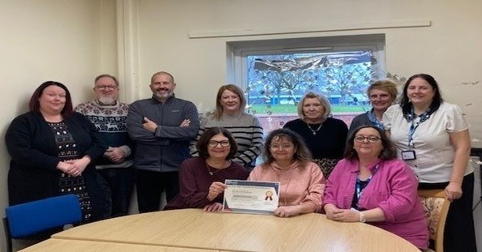Quality Accreditation

Several DMH teams have achieved accreditation with our internal Valuing High Standards accreditation programme. Accreditation is important because it helps us to continuously improve the quality and safety of our services and share best practice across the Trust. Phoenix Ward, Gwendolen Ward, Northwest Leicester Community Mental Health Team (CMHT), Maternal Mental Health Team and Charnwood Adult CMHT all achieved accreditation this year. Charnwood Older People's CMHT achieved ‘Gold’ accreditation. Going through accreditation motivated the team to push forward several improvements including a new nurse-led clinic and an offer of non-pharmaceutical support to care home patients.

More information

You can find more information about our Trust - including a look towards our future priorities - in our full Quality Account 2024/25 and our Annual Report 2024/25 which are available on our website at <https://www.leicspart.nhs.uk/about/what-we-do/>

We welcome your questions or comments on this summary or our services.

Telephone: **0116 295 1350,** Email: [LPT.feedback@nhs.net](mailto:LPT.feedback@nhs.net)

Published September 2025