Clinical Plan 2025- 2030

Contents
Introduction 3
Current context 4
Our vision 4
Core areas of focus and alignment with our Group strategy, Together We Thrive 5
A. Preparing and responding to increased demand 5
B. Patient safety and experience 6
C. Access to healthcare 7
D. Health inequalities 8
E. Sustainable workforce 9
F. Estate utilisation 10
G. Quality improvement, innovation and research 10
Our enablers 12
Year one priorities 14
Success criteria 15
Next steps 16
Conclusion 16
Governance table 17

Introduction
This Clinical Plan will describe the themes and priorities for all clinical and enabling directorates at Leicestershire Partnership NHS Trust for the next five years. It is a culmination of our ideas and ambitions, reflecting on what is most important to us on our journey to improving patient care and staff wellbeing. The material within this framework has been obtained through consultation with staff and services to support the development of our Trust within a rapidly changing and challenging environment.

We provide mental health, learning disability and community health services for the one million people of Leicester, Leicestershire and Rutland – touching the lives of all ages through our 7,800 staff (including bank staff) and over 200 volunteers. This is delivered through three directorates: Community Health Services (CHS), the Directorate of Mental Health (DMH) and the Families, Young People, Children, Learning Disabilities and Autism Services (FYPCLDA).

Our main aims are to ensure every patient receives high quality, safe and effective care that is:
- Needs led
- Person-centred
- Evidence-based
- Encouraging of self-care

The Clinical Plan aligns with:
- Our Group strategy, THRIVE.
- Fit for the Future: NHS 10 year plan
- NHS Operational Plan
- LLR ICB Clinical Strategy
- LPT Operational Plan
- LPT Financial Plan
- Directorate(s) Transformation Plans
- People Plan
- Estates Strategy, Digital Plan

Current context
Following the COVID-19 pandemic, the challenges facing the NHS have been amplified and accelerated to an unprecedented level. This includes a significant increase in waiting times, complex presentations and financial challenges. In addition, this has exacerbated the existing barriers for people to access healthcare.
Waiting lists can increase pressure on emergency services and lead to worsening social inequalities due to problems with employment, housing and social isolation. We also have a very ethnically diverse population which requires an inclusive approach to ensure everyone can access the healthcare they need. Health inequalities are a pressing issue and a key area of focus through our transformation and quality improvement projects.
We are also working through issues relating to our ageing estates. Due to financial challenges, prioritisation of work on estates and facilities has become a difficult, but extremely important, process using safety and quality domains to guide decision making.
Through consultation we have identified a list of challenges and areas of focus for the next five years at LPT as well as enablers which are the tools we will use to achieve our priorities.

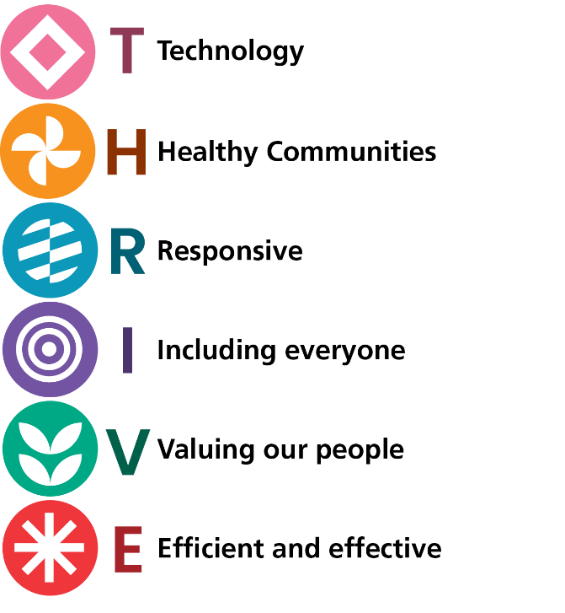
Our vision
‘Together we thrive; building compassionate care and wellbeing for all.’
The importance of THRIVE is described by the LPT Finance and Performance directorate as: ‘making a difference together by harnessing our collective skills, expertise, energy and experience to deliver excellence.’ This is our Group Strategy in partnership with Northamptonshire Healthcare NHS Foundation Trust and represents our values within our vision.
This Clinical Plan sets out the background of the national and local challenges with clear prioritisation and a solution-focused approach to meet the needs of LPT’s local population. Our patients are at the heart of our priorities and we will use these as a blueprint for the delivery of high-quality compassionate care.

Core areas of focus and our alignment with our Group strategy, Together We Thrive
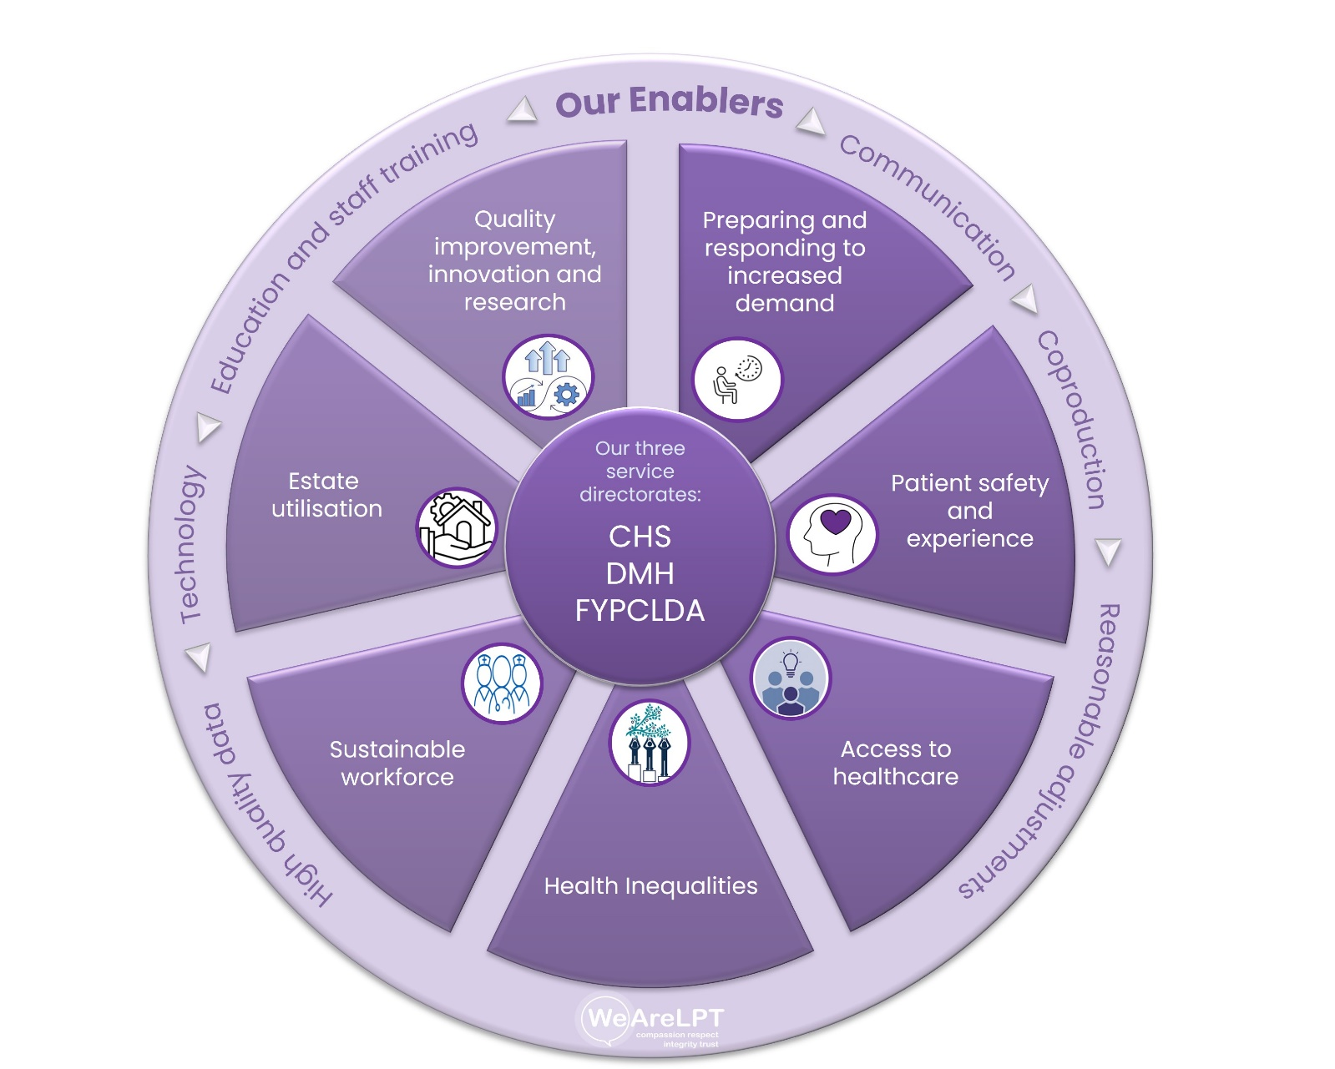

Preparing and responding to increased demand
Maintaining healthy communities is key when empowering patients to live with independence, avoiding hospital admissions and tackling health inequalities. This is also incredibly important when managing demand on healthcare services.
The NHS 10-year health plan details three shifts for reinvention: hospital to community, analogue to digital and sickness to prevention. The final shift of sickness to prevention is particularly pertinent to healthy communities as we aim to build prevention of ill health into everything we do. This includes promoting selfcare and developing specific strategies to break down barriers in areas with reduced access.
Our Community Health Services are continuing to focus on co-producing a system-owned neighbourhood model to enable care to be delivered in the right place at the right time, closer to home.
This year our Integrated Care System has collectively developed a winter plan to respond to the potential for significant pressure on urgent and emergency care. This includes a strategy with key priorities to improve communication, patient flow, mental health support and vaccination uptake.
Within the DMH, we will work with partnership organisations to promote healthier communities. Our Neighbourhood Mental Health Cafés are drop-in centres run in partnership with Voluntary and Community Sector organisations. In 2024 and 2025, 39 café sessions were delivered per week across Leicestershire and Rutland with 9,147 people attending. The team are also continuing to promote the JOY app. This is a social prescribing app for guided self-help which allows individuals to find activities and support local to them. Within secondary care, the team are further developing strategies for empowering services to deliver interventions and improve early identification. This includes the Consulter model, which involves training from specialist services for local teams, and the ‘Pull’ model. The ‘Pull’ model uses a hub and spoke approach as specialist services proactively seek referrals by attending the local multi-disciplinary team meetings. The aim is to improve early access to patients in the community and within secondary care teams.
The Community Paediatrics and CAMHS (child and adolescent mental health services) are working innovatively using multidisciplinary approach and digital technology to address the neurodevelopmental waiting lists.
The priorities for this area of focus are: the empowering of our communities to live with greater independence, avoiding unnecessary hospital stays through early identification of needs and tackling health inequalities. This will be supported by CHS using bed-based modelling to ensure patients receive care in the right setting and, wherever possible, closer to home.

Patient safety and experience
The safety of patients is the number one priority for our organisation. The NHS Patient Safety Strategy describes the strategic aims as “improving understanding of safety by drawing intelligence from multiple sources of patient safety information”, “equipping patients, staff and partners with the skills and opportunities to improve patient safety throughout the whole system” and “designing and supporting programmes that deliver effective and sustainable change in the most important areas”.
LPT has adopted the patient safety incident response framework (PSIRF) and through involvement of staff, patients and carers has developed Trust-wide and directorate-specific priorities.
All three directorates have identified prioritisation areas with commonality in themes relating to communication, access to information and care coordination. The CHS team noted areas of improvement to communication surrounding frailty and advanced disease to inform patients for advanced care planning. DMH has also identified areas of improvement within multi-agency communication and information sharing with families. Similarly, FYPCLDA are looking to improve care coordination when multiple services were involved.
In the context of mental health, people with severe mental illness (SMI) die 15-20 years earlier than the general population and this is largely due to preventable physical illnesses. These include heart disease, diabetes and cancer. We need to take urgent action to close the mortality gap. This work across directorates is focussed on awareness and digital solutions for improving the data collection and interventions.
We will have a focus on personalised care to further enhance the experience of our patients and service users, empowering individuals to take an active role in their healthcare by giving them choices and control over their treatment and support, aligning it with their values and what matters most to them, rather than following a one-size-fits-all approach. An example of this would be our valued Recovery College.
The priorities in this area are improving SystmOne functionality to ensure comprehensive information is available to all teams involved in the care of the patient, improving access to requesting and reviewing pathology results and improved care coordination through clarity of roles and responsibilities.

Access to healthcare
The current challenges facing the NHS are complex and demanding. Our health systems must be responsive to the changing needs and expectations of our patients while prioritising the delivery of high-quality care.
Due to increasing demand, waiting lists are growing and patients are not always able to access healthcare in a timely manner. This is an area in which responsiveness of systems is key as a new approach is required to tackle this issue.
An example of this is the waiting list initiative within the ‘Personality Disorder’ transformation project. With the development of a directorate-wide vision, the waiting list has significantly decreased due to the implementation of:
- A multi-professionally led weekly meeting formulating the needs of people referred to TSPPD and identification of a person-centred treatment option drawing on system-wide provision.
- Cross-service planning to reduce duplication in assessment and treatment.
- A weekly TSPPD Senior Management Task and Finish Group who work to improve flow via implementation of a guided digital self-help programme for those with milder personality difficulties.
We are keen to use technology in a positive and sustainable way with a view to improving access, experience and outcomes. A large part of this is ensuring our service users and their carers have access to digital technology and the knowledge of how to use this safely. We will address this by monitoring equitable access to services and supporting those in digital poverty to prevent isolation of individuals within our communities.
The priorities are to further develop integrated neighbourhood teams, caseload reviews to reduce community caseloads and specific clinic redesign such as clozapine and depot clinics to improve access. The FYPCLDA directorate are reviewing skill mix and role utilisation through their Northwest ADHD pilot (using reviews from primary care pharmacists to reduce the consultant clinic burden) as part of a wider package of solutions to address neurodevelopmental waits.

Health inequalities
We have worked hard to embed a culture of inclusivity at LPT where everyone’s voice matters and we aim to create a centre of excellence for mental and physical healthcare for all of our communities. However, we are aware that this cannot be achieved without addressing health inequalities.
Described as ‘unfair and avoidable’ by NHS England, health inequalities are a serious issue as communities with poorer access often experience multiple health challenges, higher rates of adult and child obesity, premature mortality and limited disease prevention. We will turn our listening into action by using lived experience from patients and families at the heart of our planning. Co-production is an extremely important tool and something we are placing a large emphasis on in our priorities for year one. We will also address barriers such as language, misinformation and trust towards health care services using our Health Inequality Framework.
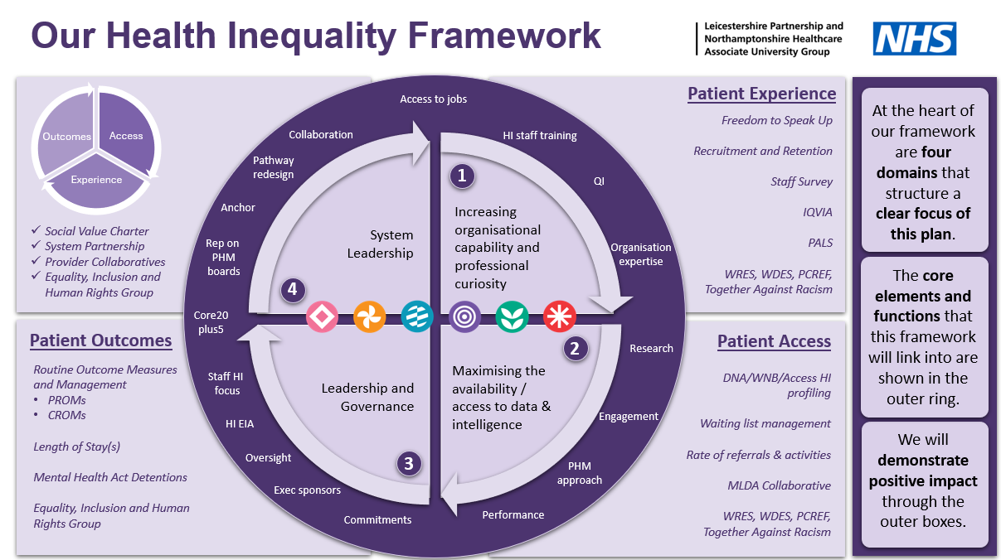
The independent review of the Mental Health Act (2018) notes the need to respect the wishes, preferences and choices of patients detained under the Mental Health Act. The report also notes the disproportionate over-representation of black African and Caribbean men in MHA detentions. The Culture of Care programme aims to improve the culture of inpatient mental health and recognises the importance of using an equity-based approach as patients from racialised and neurodivergent communities have some of the worst experiences and outcomes. We have created a Culture of Care project team and we aim to successfully embed positive changes within daily operations across all directorates.
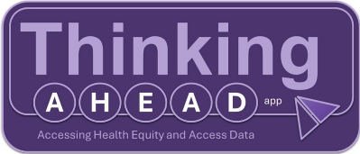
The “Thinking AHEAD” app is proving instrumental in helping us identify potential health inequalities within our appointments, disaggregating data by protected characteristics and highlighting communities and neighbourhoods that struggle and face barriers to access. The embedding of this app across all directorates will be key in addressing health inequalities.
The priorities in this area are to ensure equitable access to healthcare including vaccinations for all our communities. We will prioritise using technology to identify did not attend/ was not brought patients and innovations to improve efficiency. The Mental Health Act office identified the need for a digital solution through our information management and technology team to improve the implementation and documentation of Section 132 rights as a priority. Additionally, in line with NHS England’s Equality Delivery System, we will continue to have annual reporting of progress including the number of services graded and their improvement plans.

Sustainable workforce
According to research submitted by The King’s Fund, NHS staff are 50% more likely to experience chronic stress, which can in turn lead to burnout. This is a complicated issue that must be addressed as it can lead to significant physical and mental health impacts.
Our People Plan is designed to look after our staff by ensuring we are safe, healthy and able to work flexibly while making effective use of our full range of skills and experience. We have used feedback from staff to generate areas for improvement in line with the NHS People Plan. This includes ensuring our staff feel they belong.
In 2020, we launched our Together Against Racism programme jointly with Northamptonshire Healthcare Foundation Trust to take proactive steps towards becoming a truly inclusive and anti-racist organisation. This is supported by the REACH (Race, Ethnicity and Cultural Heritage) networks to promote wellbeing and representation for our people. We will continue to use this programme to challenge unequal and discriminatory behaviours, structures and attitudes within the Trust over the coming years.
The Directorates have also identified specific additional challenges such as recruitment, retention and new workforce models leading to reduced training pathways due to trainer capacity and experience of the new working models.
Within our Clinical Plan, we will offer visible opportunities for career development, ensure that caseloads are manageable, staff have suitable working environments and support flexible working requests such as hybrid working when appropriate. We will also make sure staff feel psychologically safe to speak up and be actively involved in decision making.
The priorities are to promote an inclusive workplace culture and staff experience, to develop our people through grow our own initiatives, ensuring they have the skills, and all staff have equitable career progression and development opportunities. In addition, the workforce agency reduction, including improving recruitment of substantive workforce, is a priority which will in turn be beneficial to the delivery of our financial plan.

Estate utilisation
Leicestershire Partnership NHS Trust has unique challenges with multiple sites and ageing estate. The Estates team have made significant progress in the timeliness of response and working through the backlog of maintenance tasks.
The focus is on maximising our estate, to help us deliver good clinical outcomes, improve staff satisfaction and help us use our financial resources efficiently. The estates strategy aligns with and supports delivery of service plans.
All three Directorates have identified Estates utilisation as a theme, the commonalities being “suitable place for the specified clinical activity”, “availability of meeting rooms” and “coordination of the necessary works to reduce disruption”. This can be achieved using technology to identify capacity and allow for an efficient booking process.
We take great pride in the achievements of our estates team as in March 2025, Leicestershire Partnership Trust was rated best Mental Health Trust for cleanliness in a Health Services Journal article, as judged by patients and staff.
The priority areas are site utilisation for an ongoing review of agile/hybrid working policies to ensure the Trust facilities are used economically, and a centralised control of meeting rooms for real-time meeting availability/staff booking system through a digital system. The focus on reducing the number of leased sites will continue to improve utilisation and contribute to the financial planning. Our Estates strategy is closely aligned with the Green plan for maximising efficiency and sustainability.

Quality improvement, innovation and research
Efficient and effective care is critical in improving access and outcomes. We will continue to use research and innovation to increase productivity and provide high quality, evidence-based care.
Evidence-based care is the “integration of best research evidence with clinical expertise and patient values.” The NHS Getting It Right First Time (GIRFT) programme is using this to improve treatment by sharing best practice between trusts and reducing unnecessary procedures. We are committed to being a part of this initiative and improving through shared learning.
Additionally, our research team aim to support the national research priorities via the NIHR portfolio and support for the Life Science industry.
We will embed clinical outcome measures and regular audits to drive improvements in quality of care while triangulating this with performance data. We also aim to become recognised leaders and partners in healthcare research and intend to achieve this through our joint working group with Northamptonshire Healthcare Foundation Trust.
The Waterlily Inpatient Prevention Programme was successfully piloted by the East Midlands NHS Provider Collaborative. The service aimed to prevent inpatient admission for adults with anorexia nervosa and received outstanding feedback in combination with improved outcome measures. We will continue to use quality improvement and research to develop our services in an efficient and effective manner.
Additionally, we aim to use technology to improve long term planning and delivery of care. This will involve embedding AI into clinical practice to increase efficiency and productivity. For example, we have already started to explore this through our DECODE research project, in collaboration with Loughborough University. This focusses on using AI algorithms and machine learning to study the prognosis of long-term conditions from existing datasets.
The priorities are to improve the safety and quality of our services through the projects developed and supported through our joint working group for shared learning and maximising benefits. We also aim to achieve university hospital status with the support of the University of Leicester to improve the quality of research and education.

Our core areas of focus and how they align to our Group strategy, Together we thrive:
 | Technology | Healthy  Communities | Responsive | Involving everyone | Valuing our People | Efficient and Effective
A  Preparing and responding to increased demand |  |  |  |  |  | 
B  Patient safety and experience |  | 
C  Access to healthcare |  | 
D
Health inequalities
E
Sustainable workforce
F
Estate utilisation
G
Quality improvement, innovation and research

Our enablers
Our enablers are the tools and skills we will use to achieve the priorities in our Clinical Plan. We have 6 key enablers.
- Communication
NHS England has identified that ‘the most common reason for complaints is poor communication’. We believe this is an essential skill in order to ensure high quality patient care and improved outcomes by empowering patients to make informed decisions. This relates to several of our core areas of focus, namely patient safety and experience, access to care, health inequalities and workforce.
- Co-production
Co-production is instrumental in delivering the best possible experience of care in systems. Collaborating with patients with lived-experience allows for enhanced patient-centred care and provides unique insight through an equal partnership. This is a key enabler for patient safety and experience, access to healthcare and health inequalities. Through our triangle of care approach we will ensure that patients and families are actively involved in their care planning and to develop a whole family approach. Additionally, we will use co-production to deliver the Patient and Carer Race Equality Framework (PCREF) on our journey to reducing racial inequalities.
- Reasonable adjustments
Reasonable adjustments are hugely important for both patients and staff. For patients, we are strengthening the reasonable adjustments digital flag which will alert staff to their individual needs. This will help our services prepare for increased demand, improve patient safety and experience and increase participation in research studies. Additionally, this is also an enabler for the focus area of a sustainable workforce. We will support staff to ensure they are able to fulfil their potential by providing the necessary adjustments to tailor their work environment to their needs.
- High quality data
Ensuring that we have timely access to high-quality data is crucial to improving patient care, supporting population health management and accurate planning within our trust. We intend to develop dashboards to help with visualisation of the data and provide early warning signs relating to quality and safety. This enabler relates to all our core areas of focus and is therefore an extremely important tool in our Clinical Plan.
- Technology
In line with the shift of analogue to digital detailed in the NHS 10-year plan, we recognise the value of technology as a key enabler across all areas of focus and it is a crucial component of our transformation and quality improvement plans. The use of technology to improve patient safety, productivity and efficiency has already been hugely successful and we are keen to build on this.

- Education and staff training
The NHS currently has the highest staffing levels in its history, however, due to increased demand and a growing ageing population, there are significant workforce shortages. Therefore, staff training and education is a major enabler in ensuring a sustainable workforce that is able to deliver excellent patient outcomes. This will be supported by our Joint Working Group and Partnership with universities. We aim to give our staff all the tools needed to excel in their professional careers and highlight opportunities for career development whilst improving job satisfaction.

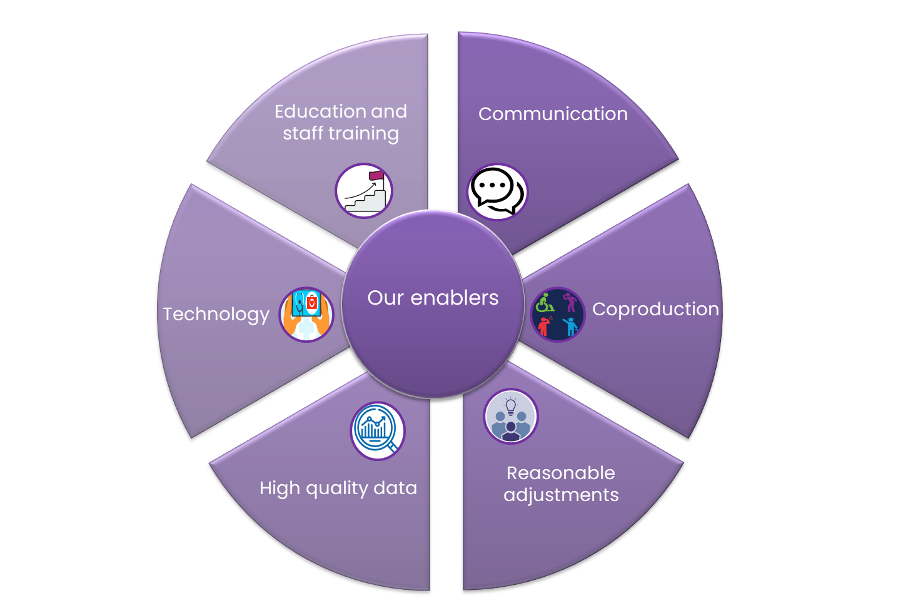

Year one priorities
Preparing and Responding to Increased Demand
- Promote neighbourhood models of care to connect people and making use of wider public services and voluntary, community sector support to improve flow through community mental health services.
Patient Safety and Experience
- Improving SystmOne functionality to ensure comprehensive information is available to all teams involved in the care of the patient.
- Improving access to requesting and reviewing pathology results and improved care coordination through clarity of roles and responsibilities.
Access to Healthcare
- Further develop integrated neighbourhood teams
- Caseload reviews to reduce community caseloads and specific clinic redesign such as clozapine and depot clinics to improve access.
Health Inequalities
- Ensure equitable access to health care including vaccinations for all our communities.
- Using technology to identify did not attend/ was not brought patients and innovations to improve efficiency.
- The Mental Health Act office identified the need for a digital solution through our information management and technology team to improve the implementation and documentation of Section 132 rights as a priority.
Sustainable Workforce
- Promote an inclusive workplace culture and staff experience, to develop our people, ensuring they have the skills, and all staff have equitable career progression and development opportunities.
- Continued progression with workforce agency reduction including improving recruitment of medical workforce, which will in turn be beneficial to the delivery of our financial plan
Estate Utilisation
- Utilisation for an ongoing review of agile/hybrid working policies to ensure Trust facilities are used economically, centralised control of meeting rooms for real-time meeting availability/staff booking system through a digital system.
- The focus on reducing number of leased sites will continue to improve utilisation and contribute to the financial planning.

Quality Improvement, Innovation and Research
- Improve the safety and quality of our services through the projects developed and supported through our joint working group for shared learning and maximising benefits.
- Continue work towards university hospital status with the support of the University of Leicester to improve the quality of research and education.

Success criteria
In order to ensure we are delivering the goals listed in this Clinical Plan, the plan will be shared with Directorates and Enabling Servies to track and report progress. The medical directorate will provide six monthly reports to be shared through EMB and Quality and Safety Committee, with an annual report being submitted to the Trust Board.
Transformation and PMO team have an excellent track record of supporting all clinical directorates to develop and deliver transformation plans including clinical priorities and pathways that will have improved access and reduced health inequalities.
To support effective delivery and transparency, a dedicated action tracker will be developed to monitor progress against the actions and priorities outlined in this Clinical Plan
This reporting will include:
    - Narrative updates on key achievements and progress to date.
    - Identification of risks and challenges to future delivery.
    - A quantitative assessment of performance against defined targets and priorities.
We will review the impact of initiatives to improve physical health monitoring, medication management and address health inequalities as part of patient safety.
Additionally, we will monitor data including (but not limited to): staff turnover rates, the average length of stay for hospital admissions and the number of missed appointments. We will combine this with patient, carer and staff feedback to achieve a comprehensive reflection of our progress.
This will be supported and evaluated through our WeImproveQ team.
“It is clear that the work undertaken by this team provides critical enabling support to services, in particular local and national clinical audits, monitoring services, QI initiatives, service evaluations and NICE compliance.” – (NED Board Service visit to WeImproveQ 27 June 2025).

Next steps
We will use the Clinical Plan to adapt to current and future challenges by using the following steps.

Conclusion
In conclusion, this Clinical Plan provides an overview of the challenges facing our population, the identified current priorities and the strategies we will use to address these. It is recognised that while some of the priorities listed in our plan may be initiated in the first year, the completion may extend beyond to achieve full realisation of the potential of some initiatives. We are dedicated to the improvement of patient and staff satisfaction and will endeavour to meet these aims by integrating the principles of this plan into all aspects of our work.
Patients are at the centre of our Clinical Plan and we will work towards demonstrating an improvement in clinical care and outcomes, using the principles from our Group strategy, ‘Together We Thrive’, to transform services.

