
Quality and Safety Committee April 2026 Updated Patient Safety Incident Response Plan (PSIRP)

Purpose of the Report
To present the updated Patient Safety Incident Response Plan (PSIRP) for formal approval. The revised plan reflects the Trust’s updated patient safety priorities, incorporates learning from recent thematic reviews from the previous plan, and outlines the three Trust‑wide Quality Improvement projects that will guide our incident response and learning approach over the next 18 months.

Analysis of the Issue
The Trust is required to maintain an up‑to‑date Patient Safety Incident Response Plan (PSIRP) that reflects both national PSIRF requirements and local learning needs. Following the closure of the previous plan this updated plan has been developed.
• Evolving patient safety priorities: The Executive Management Board has agreed revised organisational priorities based on incident trends, thematic reviews, and learning identified over the past year.
•Maturity of PSIRF implementation: As we move further into PSIRF delivery, our approach to incident response has shifted from reactive investigation to proactive learning, requiring clearer articulation of how we will target resources and measure impact.
• Emerging themes requiring Trust‑wide action: Thematic analysis has identified three areas requiring coordinated Quality Improvement (QI) programmes. These have now been developed and incorporated into the updated PSIRP to ensure a structured, system‑wide response.
• Governance and assurance needs: Feedback from the Incident Oversight Group, Safety Forum, and Executive Management Board highlighted the need for improved clarity on roles, responsibilities, and oversight arrangements to strengthen organisational assurance.
The updated PSIRP therefore sets out how the Trust will apply the Patient Safety Incident Response Framework over the next 18 months, how resources will be prioritised, and how learning will be embedded through the three Trust‑wide QI projects. The document has undergone full review through the relevant governance forums and is now presented for approval.

Decision Required
Decision required – detail below
Agree the PSIRP.

For Board and Board Committees: | Quality and Safety Committee
Paper sponsored by: | Linda Chibuzor, Chief Nurse, Executive Director of Nursing, AHPs and Quality NHFT/LPT
Paper authored by: | Tracy Ward, Head of Patient Safety
Date submitted: | 09/04/2026
State which Board Committee or other forum within the Trust’s governance structure, if any, have previously considered the report/this issue and the date of the relevant meeting(s): | Incident Oversight Group, Safety Forum and Executive Management Board
If considered elsewhere, state the level of assurance gained by the Board Committee or other forum i.e., assured/ partially assured / not assured:
State whether this is a ‘one off’ report or, if not, when an update report will be provided for the purposes of corporate Agenda planning
LPT strategic alignment: | T - Technology | x
LPT strategic alignment: | H – Healthy Communities | x
LPT strategic alignment: | R - Responsive | x
LPT strategic alignment: | I – Including Everyone | x
LPT strategic alignment: | V – Valuing our People | x
LPT strategic alignment: | E – Efficient & Effective | x
CRR/BAF considerations (list risk number and title of risk): | 3.1
Is the decision required consistent with LPT’s risk appetite: | N/A
False and misleading information (FOMI) considerations: | N/A
Positive confirmation that the content does not risk the safety of patients or the public | No
Equality considerations: | N/A



Patient safety incident response plan
(PSIRP) 2025/2027

Refreshed plan effective from 01/02/2026

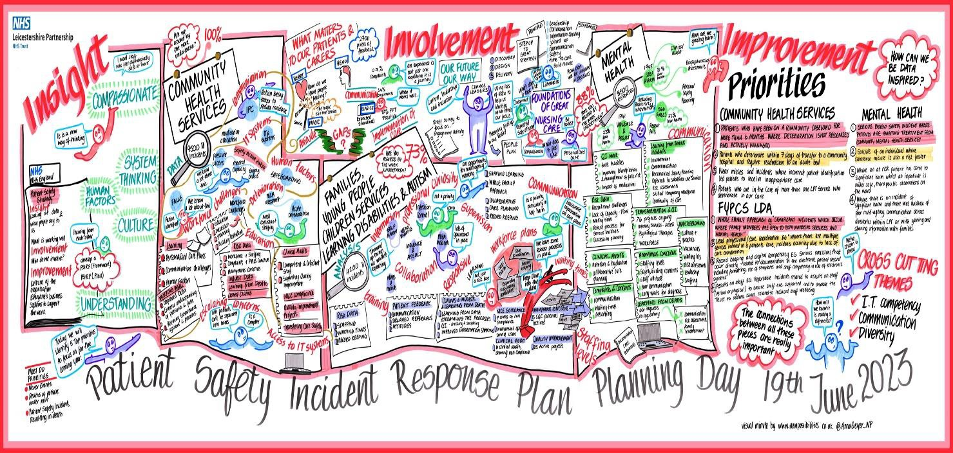

Contents

Foreword………………………………………………………………………………………. P 6

Introduction to the PSIRP……………………………………………………………………. P 8

The Scope of PSIRP and our vision……………………………………………………. …..P 10

Defining our patient safety incident profile……………………………………………….…P 12

Defining our patient safety improvement profile……………………………………………P 15

Our Patient Safety Priorities …………………………………………………………………P 21

Involvement and support of those involved in patient safety incidents……………….…P 23

Roles and responsibility under PSIRF……………………………………………………...P 24

Appendix A Glossary of terms ……………………………………………………………...P 25

Appendix B Improvement Programs………………………………………………………..P 27

Appendix C Process for local review of patient safety incidents…………………………P 29

Appendix D Non PSII priorities for review using other PSIRF methodologies.… ……..P 30
Foreword

“The introduction of this framework represents a significant shift in the way the NHS responds to patient safety incidents, increasing focus on understanding how incidents happen – including the factors which contribute to them.”
Aidan Fowler, National Director of Patient Safety, NHS England

As clinical leaders, we are proud to introduce our refreshed Patient Safety Incident Response Plan. When Leicestershire Partnership NHS Trust (LPT) began this work in November 2024, it was believed that our first plan could be delivered within a year. As the year unfolded, it became clear to us and to many organisations across the country that this was an ambitious expectation for such a significant cultural shift and change in approach. The Patient Safety Incident Response Framework (PSIRF) asks us not simply to change processes, but to think differently, to listen differently, and to learn differently. That kind of change takes time, honesty, and collective effort.

Over the past year, we have taken the opportunity to reflect. This refreshed plan is the result of reflection on what has gone well and where we need to grow. It strengthens our approach, clarifies our priorities, and ensures that our work continues to evolve in a way that is compassionate, transparent, and grounded in our values.
We have been humbled by the feedback from our colleagues. They have told us that our new way of reviewing care feels fair, respectful, and focused on learning rather than blame. They feel part of the process, able to contribute openly, and confident that their insights shape meaningful actions. This is exactly the culture we want to nurture in the Trust, a culture where people feel safe to speak up, supported to reflect, and empowered to improve care together.

Our refreshed plan reflects our commitment to the Trust’s THRIVE strategy. We are using technology and data more intelligently to support insight and learning. Our focus on understanding variation and reducing inequalities contributes to healthy communities. By refining our processes, we are becoming more responsive, ensuring that our reviews are timely, proportionate, and centred on what matters most. We are including everyone by strengthening how we involve patients, families, carers, and staff in understanding what happened and shaping what needs to change to have a safer and positive outcome. We are valuing our people by embedding a just and learning culture where colleagues feel respected, heard, and supported. By reviewing what worked well and what needed development, we are ensuring that our approach is efficient and effective, with actions that lead to sustainable improvement.
We have strengthened our processes for identifying, prioritising, and responding to patient safety incidents. This includes clearer pathways for involvement, improved visibility of learning, and a stronger focus on actions that make a real difference to the experience and outcomes of the people we serve.

As Group Chief Nurse / Executive Director of Nursing, AHP’s and Quality and Medical Director, we are united in our commitment to this work. We are proud of the progress made so far and deeply grateful to colleagues across the organisation who have embraced this new way of thinking. PSIRF is not a project with an end point, it is a continuous journey of learning, compassion, and improvement. We remain committed to supporting our teams, listening to those who use our services, and working together to create the safest possible environment for care.
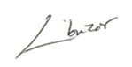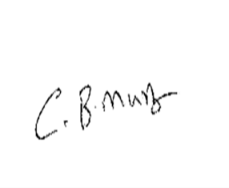

Linda Chibuzor Dr Bhanu Chadalavada
Group Chief Nurse/ Executive Director of Nursing Chief Medical Officer
/AHP’s & Quality

Introduction to the Patient Safety Incident Response Plan

The NHS Patient Safety Strategy was published in 2019 and describes the PSIRF, a replacement for the NHS Serious Incident (SI) Framework. This document is the Patient Safety Incident Response Plan (PSIRP). It describes what we have done at LPT to prepare for “go live” with PSIRF, and what comes next.

The NHS Serious Incident Framework (2015) provided a structured approach for identifying, reporting, and investigating incidents that resulted in severe harm or death. As we move further into our implementation of the Patient Safety Incident Response Framework (PSIRF), our focus has shifted from categorising incidents to understanding the systems, cultures, and conditions that shape safety. PSIRF is fundamentally a learning and improvement framework, designed to strengthen how organisations respond to patient safety incidents and how they create the conditions for continuous improvement.

A key change introduced by PSIRF is the removal of the requirement to investigate only those incidents that meet the former ‘serious incident’ criteria. This shift enables us to direct our time and expertise toward areas with the greatest potential for learning and improvement, including incidents that may not previously have triggered a formal investigation but still offer valuable insight. This more flexible and proportionate approach supports a deeper understanding of risk and a more meaningful response to the needs of patients, families, carers, and staff.

One of the core principles of PSIRF is to undertake fewer investigations, but to do them better. High‑quality, systems‑based investigations require time, skill, and the right conditions. Over the past year, we have strengthened our capability and capacity to deliver these investigations through training, supervision, and clearer processes. This plan, alongside our supporting policies and guidance, sets out how we will continue to embed this approach. The NHS Patient Safety Strategy challenges us to think differently about what learning means in practice, and this refreshed plan reflects our commitment to that challenge.

Responding proportionately does not mean doing less; it means responding in the right way. The end of the previous Serious Incident process does not equate to a reduction in scrutiny or curiosity. Instead, it enables us to tailor our response to the nature of the incident, the context in which it occurred, and the opportunities for learning. This includes thematic learning from a broader range of patient safety insights, not solely from individual investigations.

A recognised risk in implementing PSIRF is the temptation to continue old practices under a new name. To avoid this, we are deliberately embedding an approach that places investigations within a wider learning system, one that values insight from multiple sources and prioritises improvement over process. This requires discipline, cultural alignment, and a shared understanding across the organisation.

PSIRF also emphasises the importance of supporting those affected by patient safety incidents. Over the past year, we have strengthened our support structures for staff, patients, families, and carers, recognising that psychological safety is essential for open reflection and meaningful learning. This commitment is reflected in our leadership behaviours, our Trust‑wide strategy, and our reporting and learning systems.

Our understanding of PSIRF has deepened significantly over the past year. Through regular discussions at committees and groups, and through engagement with colleagues across the Trust and wider networks, we have refined our priorities and strengthened our processes.

We have worked closely with the commissioners of our services to ensure that rather than receiving assurance through individual incidents they are assured by our system, processes and learning culture.

In May 2025 directorates came together with Executives to review our learning both from the process so far and themes from the incidents reviewed. These priorities were triangulated, challenged, and refined, and they now form the basis of our patient safety priorities for this refreshed plan as well as the agreement of three trust wide improvement projects that were identified as requiring system level introduction with Director oversight.

The aim of this plan is to provide clarity on our approach while recognising the need for flexibility. Patient safety issues are complex, and our responses must be sensitive to context, opportunity, and the needs of those affected. This plan is therefore a living document—one that will evolve as we learn, adapt, and continue to strengthen our culture of continuous improvement. Our approach to continuous improvement underpins this work, ensuring that learning is translated into meaningful, sustainable change.

The scope of the PSIRP and our vision
It is recognised that there are many ways to respond to an incident. This plan covers responses conducted solely for the purpose of systems-based learning and improvement from patient safety incidents. There is no remit within this Plan or PSIRF to apportion blame or determine liability, preventability or cause of death in a response conducted for the purpose of learning and improvement. It is outside the scope of PSIRF to review matters to satisfy processes relating to complaints, human resource matters, legal claims and coroner inquests.

We will identify incidents to review through nationally and locally defined patient safety priorities.

The continued work on this supports our trust vision:

Together we thrive, building compassionate care and wellbeing for all.

Our Leadership behaviours continue to be key to the delivery of this PSIRP:

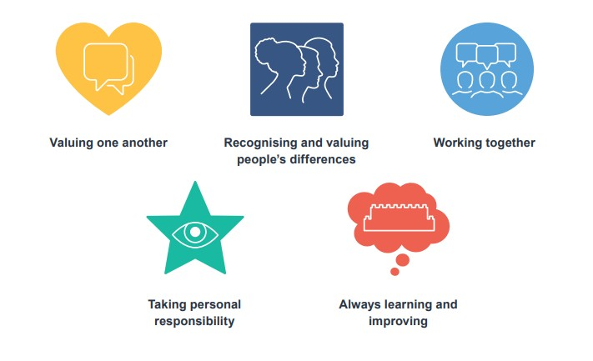

Our plan supports the development and maintenance of an effective patient safety incident response system that integrates the four key aims of the PSIRF:

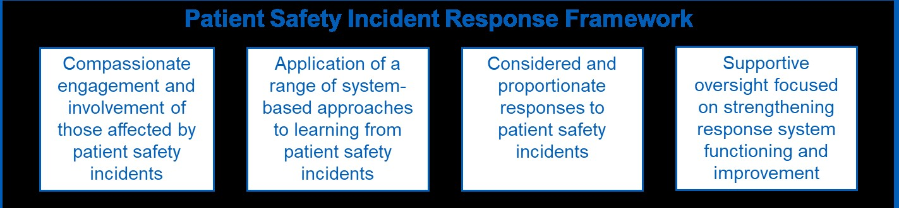

Defining our patient safety incident profile
The Trust has a commitment to continuously learn from patient safety incidents and has developed understanding and insights into patient safety activity over a period of years. We have committed to the recruitment of central patient safety investigators to ensure we have the resource, skill and expertise to undertake system reviews using investigation science. We have representation from each of our directorates into the Trust’s Patient Safety Improvement Group (PSIG), where learning is shared, and oversight and support is provided to their subgroups who are undertaking improvement work. This improvement work is designed based on national NHS and regulatory requirement or local learning. This learning activity was considered as part of our plan.

PSIRF sets no rules or thresholds to determine what needs to be learned from to inform improvement, apart from the national requirements listed on page below.

To fully implement PSIRF and to understand what needs to be learned from to improve we have reviewed both the learning from the original PSIRP and a review and triangulation of the below as appropriate:
• What types of patient safety incidents occur
• Themes from complaints
• Themes from claims
• Patient and staff feedback
• Identified risk and audit results.
This process involved:
• Identification of what is working well.
• Where there is good progress with and improvements from quality improvement (QI). projects, as well as where QI projects have stalled or not produced effective improvement.
• Where there are gaps in our understanding of why improvements in certain areas are not happening was also important for us to know.
This has led to the development of the local focus for our incident responses.

Data sources
To define our patient safety response profile, we continue to review data from a variety of sources including the Ulysses incident reporting system. Data was reviewed together with
the feedback and information provided by internal stakeholders and subject matter experts as part of our data collation process. Data and information (both qualitative and quantitative) have therefore been received from the following sources:

• Patient safety incident investigation reports
• Complaints
• Freedom to Speak Up reports
• Safeguarding reviews
• Mortality reviews and Structured Judgement Reviews
• Staff survey results
• Claims
• Trust risk profile
• Anonymous CQC concerns
• Learning from Quality Improvement projects.

Safety issues and gaps highlighted by the data
Once the data was collated and reviewed, the directorates clinical and quality governance teams reviewed this together with the learning from the PSIRF journey so far.

At the workshop on the 7th May 2025 each directorate presented the process they had used for review and analysis of the data, a summary of the data reviewed and how they identified and prioritised the priorities for review by PSII. Themes and subcategories were considered to agree the final profile.

Addressing health inequalities
As a large provider of mental health and community services, LPT has a key role to play in tackling health inequalities in partnership with our local partner agencies and services. However, most of the fundamental factors driving inequalities in health are beyond the responsibility of the health care system. For example, our education system; economic and community development in our most deprived neighbourhoods; employment levels; pay and conditions; and availability and quality of housing.

Through our implementation of PSIRF, we will seek to utilise data and learning from investigations to identify actual and potential health inequalities and make recommendations to our Trust Board and partner agencies on how to tackle these. The more holistic, integrated approach to patient safety under PSIRF will require the Trust to be more collaborative with the patient experience and inclusivity agenda and ensure investigations and learning do not overlook these important aspects of the wider health and societal agenda. Impact from health inequalities or equality, diversity issues as such will always be included in the standard terms of reference for all PSIIs.

Our engagement with patients, families and carers following a patient safety investigation, must also recognise diverse needs and ensure inclusivity for all. Investigators will consider any potential/actual inclusivity or diversity issues which may disadvantage the patient/family or our staff from engaging in the investigation process. All staff are required to consider this at all stages of the process and re-consider/visit as required.

The question of how we will evaluate whether the priorities chosen for focus have resulted in improvements in patient safety and care, was also asked. Guidance within the national patient safety strategy discourages aiming for “quick wins” as, invariably, they turn out not to address the factors within the system. Ongoing review of the data, trends and improvement work will take place regularly through oversight routes.

Whilst the final list of priorities has been agreed, it is acknowledged that where a new risk emerges or learning and improvement can be gained from a particular incident or theme (which may be from a national patient safety steer) additional Patient Safey Investigations (PSIIs) can be accommodated.
Patient safety incidents not for PSII will be reviewed using other methodologies within
PSIRF; these include initially:
- Systems Engineering Initiative for Patient Safety (SEIPS)
- After Action Reviews (AAR) for specific types of incidents such as Falls

Other methodologies can be used where staff have the training and capability, for example:
- SWARM
- Multidisciplinary meetings MDT
- Thematic Reviews.

The Corporate Patient Safety Team (CPST) are supporting the upskilling of staff to use human factors approach and system thinking to consider and review all incidents. This will require a long-term approach to develop and build on these skills and competencies across the organisation. The team have developed a one-day training program that combines both theory and some practical exercises to support staff to practice system thinking.

Defining our patient safety improvement profile

Over several years, the Trust has developed its governance processes to gain insight from patient safety incidents, and this has informed QI activity. We will continue to draw on guidance and feedback from national and regional level NHS bodies, regulators, commissioners, partner providers and other key stakeholders to identify and define the quality improvement work we need to undertake.

There is QI work being undertaken across our quality governance groups with PSIG being a key group for the professional discussion/decision and oversight of progress of QI projects. These groups including PSIG report into the Trust level Safety Forum, which will continue to provide assurance that quality improvement measures including any safety improvement plans in use currently, or which require development and implementation in the future, continue to be timely and of high standard.

The Incident Oversight Group (IOG) will be responsible for oversight of the implementation of this plan and the PSIRF approach using a QI methodology to develop and refine the plan as we learn and move forward. This group will also provide assurance during the
development of new safety improvement plans following reviews undertaken within PSIRF, to ensure they have followed robust processes during development and appropriate improvement actions have been developed and directed for the appropriate oversight to allow the Trust’s continuous improvement and risk reduction/mitigation in future patient safety.

Our clinical directorates are required to report through our quality governance routes to monitor and measure improvement activity across the organisation.

Governance and oversight
Robust local governance routes have been clearly defined by our directorates which will then feed into the corporate oversight and assurance groups. These will include:

• Weekly clinical huddles to review reported incidents
• Clinical and quality governance team reviews
• Directorate sign off groups
• Directorate management team oversight
• Oversight at directorate management team quality and safety meetings.

Under PSIRF, our commissioners the ICB, Public Health Local Authority (PHLA) and Provider Collaboratives, will be invited to attend oversight meetings; this is a shift, as currently the majority is LPT services being requested to meet with them, often linking in with ‘contract monitoring.’

Identification of incidents
Methodologies for identification of incidents have also been agreed and will be reviewed as we learn. The weekly, Trust-wide Incident Review and Learning Meeting (IRLM) will provide support and advice for directorate teams and a record of discussion and decision making to support a response to those involved in patient safety incidents.

Current patient safety related improvement
We have robust management and oversight of all QI activity within the Trust including Clinical Audit, Service Evaluation and model for improvement projects. Quality improvement methodology is fundamental to the delivery and continuous improvement of high-quality care. Our QI approach empowers all staff to identify changes needed, develop the skills to make and lead the change.

Our Patient Safety Priorities

Our patient safety incident response plan: national requirements

The Trust has finite resources for patient safety incident response, and we intend to use those resources to maximise learning and improvement. PSIRF allows us to do this, rather than repeatedly responding to patient safety incidents based on subjective thresholds and definitions of harm, from which new learning will be limited.

Some patient safety incidents, such as Never Events and deaths thought more likely than not due to problems in care, will always require a PSII through which we can learn and improve. For other types of incidents which may affect certain groups of our patients, a PSII will also be required. These have been determined nationally, and the Trust fully endorses this approach, as it fits with our aim to learn and improve within a just and restorative culture. As well as PSII, some incident types require specific reporting and/or review processes to be followed as shown below.

For clarity, all types of incidents that have been nationally defined as requiring a specific response will be reviewed according to the suggested methods and are detailed in the table below.
National event response requirements: additional to local priorities

Patient safety incident type | Required response | Anticipated improvement route
Patient safety incidents meeting the  Never Events 2018 criteria or its replacement | PSII | Create local organisational  actions and feed these into quality improvement
Deaths of patients detained under the MHA (1983) or where the MCA (2005) applies, where there is reason to think that the death may be linked to problems in care (incident meeting the learning from deaths criteria for patient safety incident investigations (PSIIs)) | PSII | Create local organisational actions and feed these into quality improvement
Patient Safety incidents resulting in death  where the death is thought more likely than not to be due to problems in care (including in patient suspected suicide) | PSII | Create local organisational  actions and feed these into quality improvement
Section 42 and other mandated  safeguarding enquiries | System based methodology | Create local organisational  actions and feed these into quality improvement

Our patient safety incident response plan: local focus

The type of response to patient safety incidents will depend on:

• The views of those affected, including patients and their families

• Capacity available to undertake a learning response

• What is known about the factors that lead to the incident(s)

• If improvement work is underway to address the identified contributory factors

• If there is evidence that improvement work is having the intended effect/benefit

• If the Trust is satisfied risks are being appropriately managed.

Approach to defined incidents
Patient safety incident type or issue | Planned response | Anticipated improvement route
Pressure Ulcers (PU)  (category 4) | MDT review of care initially and then progresses using SEIPS  Methodology  (Where appropriate) | Create local safety actions  and feed these into the quality improvement plan overseen by the trust PU group
Falls resulting in Harm  (where there is opportunity for learning) | After Action Review  (AAR) using the template from the National Falls audit | Create local safety actions  and feed these into the quality improvement plan overseen by the trust Falls group
Infection Prevention and  Control (IPC) incidents | Using SEIPs  Methodology | Inform ongoing improvement  projects
Information Governance  Incidents | Bespoke ISMR initially and then progress to SEIPS if a deeper understanding is required and where appropriate. | Identify processes to  strengthen improvement overseen by the data Privacy and Information Governance Manager – with feedback through data privacy group
Deteriorating patients | Screening and SEIPS review thematic analysis | Reviewed thorough Mortality  and Morbidity meetings and learning enacted

The table below describes our approach to a set of defined incidents (should any of these reviews below identify that a more in-depth review is required they will be escalated to the Incident Review and Learning Meeting)

PSIRF allows organisations to explore patient safety incidents relevant to their context and the populations served. Through our analysis of our patient safety insights, based on the review of incidents, engagement meetings and planning workshops, we have determined the below priorities for this period.

We will undertake four to five index case PSII in each of the types of incidents proposed (should they occur). This will allow us to apply a systems-based approach to learning from these incidents, exploring multiple interacting contributory factors. We will use the outcomes of PSII to inform our patient safety quality improvement planning and work. These in turn will be reviewed as a thematic review in Q4 2027.

As a result of learning from the previous plan the following 3 Trust wide QI projects were agreed with Executive oversight of progress through EMB.

Project 1 | SystmOne Functionality | - to include findings from investigation reviews around the visibility of other units so that staff know who else is involved in patients care – this will also extend to ensuring that the structure of units is optimised to support staff to easily document and review care (including alerts)
Project 2 | Whole Family Approach | – this will build on the principles of the whole family approach supporting staff with the skills, curiosity and tools to consider the risk of not sharing information. Developing system relationships and principles to ensure all involved in the care have the information required to make appropriate decisions
Project 3 | Care Coordination | – this is to include a process and agreement of principles where there are multiple specialist teams caring for a patient and agreement of how a ‘lead professional’ is agreed and how this can provide holistic oversight and appropriate coordination.

PSII Trust Priorities 2026/2027
Trust Priority | Directorate | Patient safety incident type | Planned response | Anticipated improvement route
1 | FYPC/LDA | Omissions in care due to communication or information sharing across services where children under 4 years and 10 months old who are open to Healthy Together and there is one or more known significant adult within children’s core network open to adult mental health services | PSII | Create local safety actions which will inform the trust quality improvement plan which will have executive oversight
2 | FYPC/LDA | Incident occurring due to lack of care coordination where there are multiple services (including external partners) involved in a patients care | PSII | Create local safety actions which will inform the trust quality improvement plan which will have executive oversight
3 | CHS | Patient Deterioration  Where omissions in care or issues related to medicines management result in unexpected patient deterioration or near misses | PSII | Create local safety actions which will inform the trust quality improvement plan which will have executive oversight
4 | DMH | Suicide of an individual where substance misuse is also a risk factor | PSII | Create local safety actions which will inform the trust quality improvement plan which will have executive oversight

Standard terms of reference have been agreed for all PSIIs. This will include the gaps that were identified during analysis of incidents from the planning workshop:
1. To review if the patient was in the care of more than one LPT service at the time of the incident.
2. To identify if any electronic systems used, impacted on the patient’s care and experience.
3. To review if the patient was on a waiting list for any LPT service at the time of the incident
4. Were any legal frameworks applied to this patient at the time of the incident and did the consideration or application of the legal framework, or decision not to use a legal framework have an impact on the patients’ care?

PSII is not the only tool we will use to respond to incidents. Our Responding to Incidents policy will describe other ways staff can respond to incidents. This will detail both how to respond to incidents thematically, but also how to respond to individual incidents. We have outlined several ways we can respond to individual incidents, including:

SEIPS model: System Engineering Initiative for Patient Safety - a human factors methodology
Safety Huddle: Triggered by an event to assess what can be learned
After Action Review (AAR): A structured facilitated debrief
Multi-disciplinary team (MDT) meetings: Structured Review (mortality/morbidity and learning from deaths)

Involvement of patients, families and carers following incidents

We recognise the significant impact patient safety incidents can have on patients, their families and carers. We are committed to being open, honest and transparent. The Statutory Duty of Candor requires a meaningful verbal and written apology for the harm resulting from a patient safety incident. Getting involvement right with patients and families in how we respond to incidents is crucial, particularly to support improving the services we provide.

As part of our new policy framework, we have developed a family liaison and engagement guide to support staff in engaging compassionately with patients and their families, during responses to incidents. We are also developing a process for gathering feedback proactively to allow us to change and develop our response as we learn.

To further support this, we have recruited a Patient and Family Liaison officer whose role is to support patients and families through the process and ensure that they can engage facilitating and supporting with signposting, advocating and ensuring that any reasonable adjustments are made.

Involvement and support for staff following incidents.

We are on an ambitious journey in the Trust to ensure it is a safe and fair place, where everyone’s voice is invited, valued and listened to, helping us to continually learn, inspire change and improve.

When a colleague reports an incident or is providing their insights into the care of a patient for an investigation, we will actively encourage a safe space to discuss the events, explore the system in which they work and listen openly without judgement.

We recognise that many staff will be involved with a patient safety incident at some point in their careers and this can be a traumatic experience. As part of our commitment to staff health and wellbeing, we have a suite of support for our staff which is always being reviewed and added to. Led by the Trust’s lead psychologist, we are developing a debrief process to support staff in the immediate aftermath of an incident.

Teams have also been implementing Schwartz rounds to allow a safe space for staff to come together to discuss how they are affected by the challenging nature of events in healthcare. This is a proven method of support used widely in healthcare across the world.

Further to this, the methodology for investigation has been developed to be very clearly focused on learning and not in any way to apportion blame.

Roles and responsibilities under PSIRF

The Trust Executive Management Team oversees the delivery of clinical services, informed by the outcomes from review meetings between Clinical Directorates and the Executive Team.

The Quality and Safety Committee is chaired by a Non-Executive Director, and this bimonthly meeting will receive the assurance of both the process of implementation, the undertaking of learning responses and the associated QI work.

Progress of PSII, risk and other types of patient safety reviews will be overseen by the IOG (Incident Oversight Group). Safety recommendations from PSIIs will be reviewed through PSIG in support of the safety priority improvement programs.
Appendix A Glossary of terms
AAR - After Action Review
A method of evaluation that is used when outcomes of an activity or event have been particularly successful or unsuccessful. It aims to capture learning from these to identify the opportunities to improve and increase the occasions where success occurs.

Never Event
Patient safety incidents that are considered to be wholly preventable where guidance or safety recommendations that provide strong systemic protective barriers are available at a national level and have been implemented by healthcare providers. https://improvement.nhs.uk/documents/2266/Never_Events_list_2018_FINAL_v5.pdf

PSIRF - Patient Safety Incident Response Framework
This is a national framework applicable to all NHS organisations commissioned outside of primary care. Building on evidence gathered and wider industry best- practice, the PSIRF is designed to enable a risk-based approach to responding to patient safety incidents, prioritising support for those affected, effectively analysing incidents, and sustainably reducing future risk.

PSIRP - Patient Safety Incident Response Plan
Our local plan sets out how we will carry out the PSIRF locally including our list of local priorities. These have been developed through a coproduction approach with the Directorates and specialist risk leads, supported by analysis of local data.

PSII - Patient Safety Incident Investigation
PSIIs are conducted to identify underlying system factors that contributed to an incident. These findings are then used to identify effective, sustainable improvements by combining learning across multiple patient safety incident investigations and other responses into a similar incident type. Recommendations and improvement plans are then designed to address those system factors and help deliver safer care for our patients effectively and sustainably.

Schwartz Rounds (NHS)
Schwartz Rounds are group reflective practice forums giving staff from all disciplines an opportunity to reflect on the emotional and social aspects of working in healthcare.

SEIPS - System Engineering Imitative for Patient Safety. A framework for understanding outcomes within complex socio-technical systems.

SR - Structured Review
Originally developed by the Royal College of Physicians. The Trust is guided by the Royal College of Psychiatrists model for best practice in mortality review. We have modified a structured review process that is based on opportunities for learning (rather than judgement) of care for each phase. This allows the Trust to identify deaths assessed as more likely than not due to problems in care. Trust to identify those deaths which may need to progress to PSII according to the national priorities.

SWARM
Used within Healthcare in the UK and US, a SWARM approach allows for the rapid review of an incident – staff swarm to a discussion and where possible the location of an incident to allow for it to be explored on a systemic basis and to support those immediately involved.

Appendix B

Improvement programs
Priority Area | Title | Type
Deteriorating patient | Management of clozapine-induced gastrointestinal hypomotility | Clinical audit
Deteriorating patient | NEWS2 assessment at initial contact (nursing) | Monitoring
Deteriorating patient | MARSI MEWS, Deteriorating Patient and Sepsis Pathway | Monitoring
Deteriorating patient | Care of the deteriorating patient 2024/690 | PDSA
MH observations | Seclusion Facilities | Monitoring
MH observations | Seclusion Quality check audit | Monitoring
MH observations | CHS community therapy clinical observations practice improvement | PDSA
MH observations | Group QI Nighttime Observations 2024/672 | PDSA
Pressure ulcers | Pressure Ulcers – Community Nursing / Hospitals / Therapy | Monitoring
Pressure ulcers | Pressure Relieving Cushions Checklist | Monitoring
Pressure ulcers | New wound incident reporting | Monitoring
Pressure ulcers | Improving Repositioning in Community Hospitals 2024/669 | PDSA

The following 3 Trust Wide improvement Projects were agreed by EMB including governance oversight and executive leadership. Next steps are also for agreement and for oversight at IOG:

Project 1 SystmOne Functionality- to include findings from investigation reviews around the visibility of other units so that staff know who else is involved in patients care – this will also extend to ensuring that the structure of units is optimised to support staff to easily document and review care (including alerts)

Project 2 Whole Family Approach – this will build on the principles of the whole family approach supporting staff with the skills, curiosity and tools to consider the risk of not sharing information. Developing system relationships and principles to ensure all involved in the care have the information required to make appropriate decisions

Project 3 Care Coordination – this is to include a process and agreement of principles where there are multiple specialist teams caring for a patient and agreement of how a ‘lead professional’ is agreed and how this can provide holistic oversight and appropriate coordination.
Appendix C

Process for local review of patient safety incidents
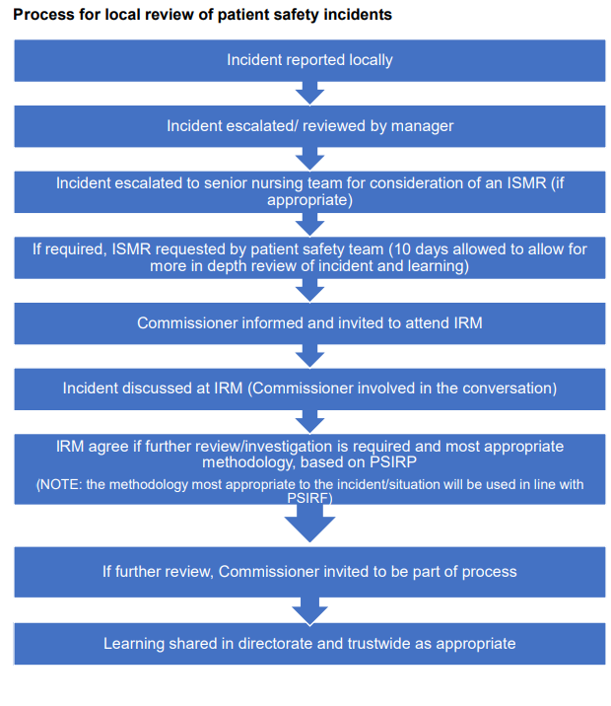
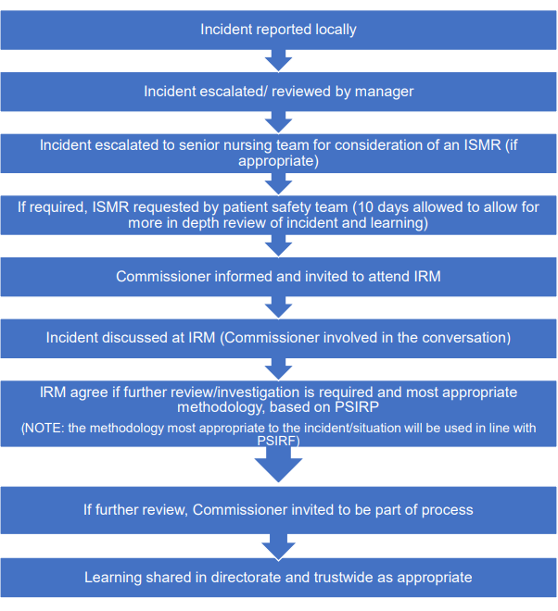
Incident escalated/ rev

Appendix D

Non PSII priorities for review using other PSIRF methodologies

Directorate local priority | Non-PSII priorities
DMH | Non-PSII 1: Patient safety incident where there is significant harm and there was evidence of poor multi-agency communication across directorates or within LPT or with gaining and sharing information with families
CHS | Non-PSII 1: Communication  Where there has been a missed opportunity to assess and communicate frailty and advanced disease to patients, families and carers resulting in poor advanced care planning which could contribute to their limited understanding of the patient's condition
FYPC/LDA | Non PSII 1 - Record Keeping and Digital Competency e.g. Serious omissions that occur directly related to documentation in the electronic patient record, including formatting, use of templates and staff competencies around use of electronic systems

